Day in the Life of the Hudson River 10/22/20
PEEBLES ISLAND
RIVER MILE: 154
Salt Front: ~ RM 75
Amanda Simmons, Aidan Mabey, Rebecca Houser plus 2 (5 total)
Latitude 42.78305 & Longitude – 73.68137 W
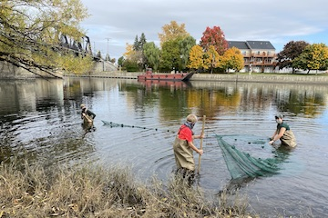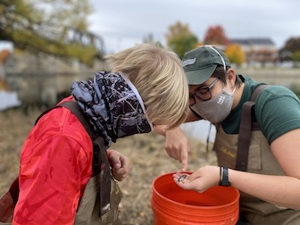
Location: Peebles Island Park, the confluence of the Hudson River and the Mohawk River, Waterford, NY
Area: Park just north of the Troy dam at the pavilion, grassy embankment, riprap
Surrounding Land Use: Forested
Sampling Site: Park land
Shoreline: 75% grassy, 25% riprap
River Bottom: Muddy and weedy bottom

ITEM | Time | Reading |  | Comments
Physical
Air Temperature | 1:45 PM  2:10 PM | 24 º C  24 º C | 76 º F  76 º F
Wind Speed: | 1:20 PM  2:10 PM | 2.8 mph  0 mph
Weather today | Cloud cover 95%.
Weather the past 3 days: | N/R
Tides- *This location is above the Troy Dam and the head of tide | Time | Rising, Falling, Unchanged | Height (in) | Rate of Tidal Change (cm/min)
Current- | Time | cm/second | North/South | Ebb/Flood/Still
Note: Flow as above the head of tide.
Water Temperature | 12:50 PM  2:40 PM | 17º C  16º C | 62.6º F  60.8º F
Turbidity- long sight tube | 1:45 PM  2:30 PM | 88.2 cm  >120 cm
Chemical
Salinity- NA – freshwater section
DO – Hach drop count | Time | Temp | ppm DO | % saturation
 | 1:45 PM  2:40 PM | 17 º C  16 º C | 12 ppm  13 ppm | 120%  120%
pH – color match kits | 1:20 PM  2:05 PM | 7.5  8
Biological
Fish | Number | Name | Length of longest
Seined: 2 seines | 4  16  42  16  16  2 | Pumpkinseed sunfish  Banded Killifish  Bluegill Sunfish  Spottail Shiners  Tessellated Darter  Smallmouth Bass
Fish Totals | TOTAL: 96 | Diversity: 6
Macroinvertebrates | Number | Name | Length of longest
 | NR
Macroinvertebrate Totals | TOTAL: | Diversity:
Sediment Core | Time | Oxidized Top | Grain Size | Other Features
 | NR
Boats | Time | Name/Color | North/South | Loaded/Light
 | NR
Observations

