Day in the Life of the Hudson River 10/22/20
HUDOSN RIVER PARK PIER 40, MANHATTAN
RIVER MILE: 2.9
Salt Front: ~ RM 75
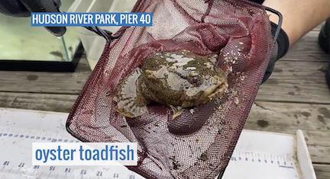
Hudson River Park – Tina Walsh and Siddi Hayes, 1200 participants onlive event
Latitude 40.72842 N & Longitude – 74.01379 W

Location: Hudson River Park, Pier 40, Manhattan, NY
Area: Off southern side of Pier 40 about 600-800 feet down the pier from shore. Large urban pier with many sports facilities: athletic fields, kayaking and boathouse, seasonal moorings available, parking, fishing on the pier, benches and picnic tables for the public
Surrounding Land Use: 50% Urban/Residential; 50% Industrial/Commercial
Sampling Site: Pier, Bulkhead, banks altered; concrete and wood piling, large pier extends into river/cement bulkhead south ~100 m
Shoreline: Rocky
River Bottom: Soft sediment habitat, muddy
Plants in area: no plants in water area
NOTE: this highly urban site is just west of the busy Westside Highway- it is the largest pier in Hudson River Park with a 14 acre footprint; Pier 40 is used for recreation, school groups using the athletic fields; there are 3 public boathouses; there are many people by the river’s edge jogging, biking, and walking.

ITEM | Time | Reading |  |  | Comments
Physical
Air Temperature | 9:43 AM | 18 º C |  | 64 º F
Wind Speed: | 9:43 AM | 6 knots
Weather today | Foggy
Weather past 3 days: | Overcast, chilly
Tides- | Low Tide | High Tide |  | Time of Sampling | Tide
 | 7:23 AM | 1:43 PM |  | 9:43 AM | Flood
Current- | Time | cm/second, Knots |  | North/South | Ebb/Flood/Still
Water Temperature- | 9:47 AM | 18 º C | 64 º F
Turbidity- Long sight tube | 9:54 AM | 95 cm
Chemical
Salinity- Hydrometer | 9:43 AM | 21 ppt
DO – Chemets | Time | Temp |  | ppm DO | % saturation
 | 9:53 AM | 18 º C |  | 7 ppm | 75
pH – Meter | 9:47 AM | 7.5
Biological
Fish | Number | Name |  | Length of longest | Length of smallest
 | 1  1  2  1 | Black sea bass  Blackfish  Oyster toadfish  Lined seahorse |  | 6 cm  23.5 cm  18.5 cm  10 cm | 2 cm
Fish Totals | TOTAL: 5 | Diversity: 4
Macroinvertebrates | Number | Name |  | Length of longest | Length of smallest
 | 2 | Blue Crab |  | 10.5 cm | 5.5 cm
Macroinvertebrate Totals | TOTAL: 2 | Diversity: 1
Sediment Core | Time | Oxidized Top |  | Grain Size | Other Features
NR
Boats | Time | Name/Color |  | North/South | Loaded/Light
NR
Observations

