Day in the Life of the Hudson River 10/22/20
PIERMONT PIER, PIERMONT
RIVER MILE: 25.4
Salt Front: ~ RM 75
Lamont Doherty Earth Observatory– Margie Turrin, Laurel Zaima
NYS DEC Hudson River Estuary Program- Rianna Scanlon
Latitude 41.043189 N & Longitude – 73.89595 W
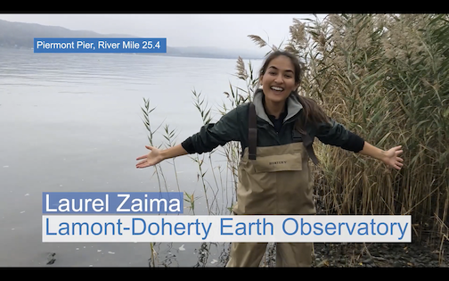
Location: Piermont Pier, Piermont, Rockland, NY
Area: Man made fishing/shipping pier at the east end, long pier with paved roadway and vegetated strip along both sides
Surrounding Land Use: 80% Urban/Residential; 20% Forested
Sampling Site: Pier, roadway in center of whole pier, parking area at the end, plants and trees along side. Shoreline riprap, collected wood in area and piping entering river on the south of sampling site
Water Depth: Varied by location on the pier and by the tide
Plants in area: 15% sumac and other plants; 85% phragmites; no submerged aquatic plants in water
River Bottom: Sandy, rocky bottom with phragmites growing in or near the water

ITEM | Time | Reading |  |  |  |  | Comments
Physical
Air Temperature | 1:20 PM | 19.9 º C |  |  | 67.8 º F
Wind Speed: | 1:20 PM | 1.1 m/s |  |  | North
Weather today | No Rain
Weather past 3 days: | Cold nights, days 50-60s, foggy
Tides- | Low Tide | High Tide |  |  | Time of Sampling |  | Tide
 | 9:05 AM | 3:20 PM |  |  | 1:20 PM |  | Flooding
Current- | Time | cm/second, Knots |  |  | North/South |  | Ebb/Flood/Still
Water Temperature- | 1:30 PM | 19 º C |  | 66.2 º F
Turbidity- Long Sight Tube | 1:20 PM | 47 cm
Chemical
Salinity- Hydrometer | 12:45 PM | 11 ppt
DO – Hach Drop count | Time | Temp |  |  | ppm DO |  | % saturation
 | 12:45 PM | 19 º C |  |  | 10 ppm |  | 108
pH – Color Match Kit | 1:00 PM | 8
Biological
Fish | Number | Name |  |  | Length of longest |  | Length of smallest
 | 71  1  1 | Atlantic Silverside  Striped Bass  Mummichog |  |  | 11 cm  9 cm  9 cm |  | 5.5 cm
Fish Totals | TOTAL: 73 | Diversity: 3
Macroinvertebrates | Number | Name |  |  | Length of longest |  | Length of smallest
5 male, 10 female | 15  1  1 | Blue Crab  Leidyi’s Comb Jelly  Moon Jelly |  |  | 7.5 cm |  | 1.2 cm
Macroinvertebrate Totals | TOTAL: 17 | Diversity: 3
Sediment Core | Time | Oxidized Top | Grain Size |  |  | Other Features
12 cm core | 12:30 PM |  | 6 cm mud on bottom  6 cm of sandy material on top
Observations

