Day in the Life of the Hudson River 10/22/20
MATTHIESSEN PARK, IRVINGTON
RIVER MILE: 25
Salt Front: ~ RM 75
Lamont Doherty Earth Observatory– Margie Turrin, Laurel Zaima
Philip Levine- Retired Irvington School teacher
Latitude 41.04164 N & Longitude – 73.87398 W
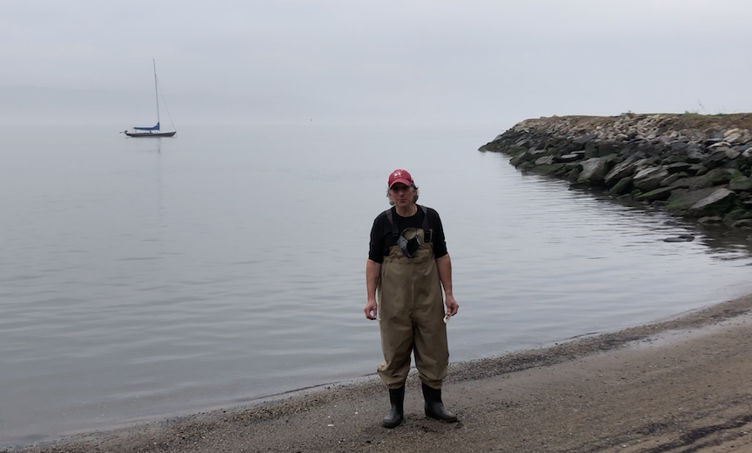
Location: Matthiessen Park, Irvington, Westchester, NY
Area: Park in Irvington along the Hudson River, off of Main Street.
Surrounding Land Use: 60% Recreation/grass and playground; 10% Beach; 30% Trees
Sampling Site: Pier, sandy beach, altered banks, riprap, wood bulkhead, pipe entering the water, area covered in vegetation, forested, grassy park used for recreation: boating, jogging, fishing, picnics, playground
Shoreline: 90% Sandy, 10% rocky.
Plants in area: No plants in the water area
River Bottom: Sandy and Rocky
ITEM | Time | Reading |  |  | Comments
Physical
Air Temperature | 9:45 AM | 18.6 º C |  | 65.4 º F
Wind Speed: | 9:45 AM | 0-0.5 m/s |  | Northeast
Weather today | No Rain
Weather past 3 days: | Cold nights, days 50-60s, foggy, rain night before last
Tides- | Low Tide | High Tide |  | Time of Sampling | Tide
 | 9:03 AM | 3:19 PM |  | 8:30 AM | Slack
Current- | Time | cm/second, Knots |  | North/South | Ebb/Flood/Still
NR
Water Temperature- | 9:41 AM | 18 º C | 64.4 º F
Turbidity- Long Sight Tube | 9:50 AM | 19.8 cm
Chemical
Salinity- Hydrometer | 9:00 AM | 11 ppt
DO – Hach Drop count | Time | Temp |  | ppm DO | % saturation
 | 9:41 AM | 18 º C |  | 11 ppm | 115
pH – Color Match Kit | 9:10 AM | 7.5
Biological
Fish | Number | Name |  | Length of longest | Length of smallest
2 Seines @ 8:45 AM | 5  7 | Atlantic Silverside  Striped Bass |  | 11 cm  12 cm | 8 cm  9.5 cm
Fish Totals | TOTAL: 12 | Diversity: 2
Macroinvertebrates | Number | Name |  | Length of longest | Length of smallest
15 Male & 15 Female  (1 softshell) | 30 | Blue Crab |  | 9 cm | 1 cm
Macroinvertebrate Totals | TOTAL: 30 | Diversity: 1

