Day in the Life of the Hudson River 10/22/20
MEMORIAL PARK, NYACK
RIVER MILE: 28
Salt Front: ~ RM 75
Rockland Soil and Water District – Nicole Liable, Brianna Rosamilia
Rockland Conservation and Service Corp: Kathy Galione, Kim Burgos
Outdoor Science Alliance- Ashley Curtis
Latitude 41.08742 N & Longitude – 73.91576 W
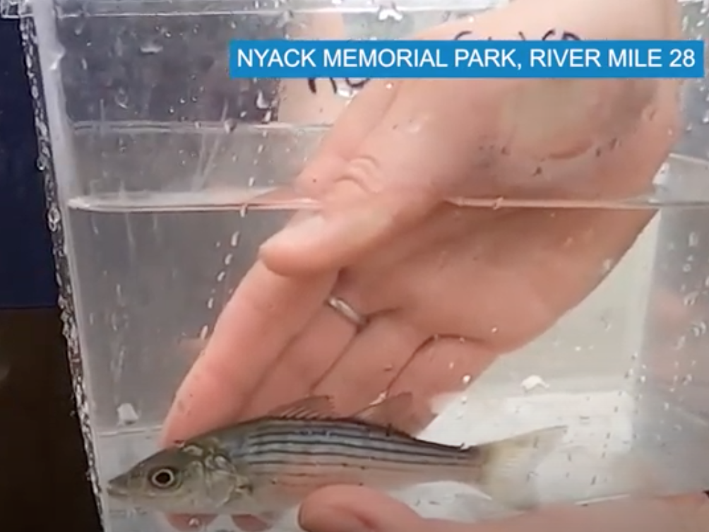
Location: Nyack Memorial Park, Nyack, Rockland, NY
Area: Open and grassy, parking lot, picnics, fishing
Surrounding Land Use: 100% parkland
Sampling Site: beach, banks altered, riprap on shoreline, bulkhead
Plants in area: no aquatic plants in water
River Bottom: Sandy, muddy

ITEM | Time | Reading |  |  | Comments
Physical
Air Temperature | 12:45 PM | 19 º C |  | 66.2 º F
Wind Speed: | 1:35 PM | 1-3 knots
Weather today | No Rain
Weather past 3 days: | Drizzle, hazy, rain, warm
Tides- | Low Tide | High Tide |  | Time of Sampling | Tide
 | 9:20 AM | 3:32 PM |  | 12:51 PM | Flooding
Current- | Time | cm/second, Knots |  | North/South | Ebb/Flood/Still
 | 12:51 PM | 16.256 cm/sec |  | North | Flooding
Water Temperature- | 1:30 PM | 17.7 º C | 63.86 º F
Turbidity- Long Sight Tube | 1:26 PM | 56 cm
Chemical
Salinity- Meter | 1:20 PM | 7.67 ppt
DO – Meter | Time | Temp |  | ppm DO | % saturation
 | 1:28 PM | 17.7 º C |  | 5.72 ppm | 62.9
pH – Color Match Kit | 1:56 PM | 8
Conductivity- Meter | 1:30 PM | 11406 microseimens/cm
Biological
Fish | Number | Name |  | Length of longest | Length of smallest
 | 9  2  12  1 | Atlantic Silverside  Striped Bass  White Perch  Mummichog |  | 7.62 cm  11.43 cm  19.05 cm  8.89 cm
Fish Totals | TOTAL: 24 | Diversity: 4
Macroinvertebrates | Number | Name |  | Length of longest | Length of smallest
Macroinvertebrate Totals | TOTAL: | Diversity:

