Day in the Life of the Hudson River 10/22/20
UPPER NYACK STATE PARK, LOWER BEACH
RIVER MILE: 30.4
Salt Front: ~ RM 75
Lamont Doherty Earth Observatory– Margie Turrin, Laurel Zaima
Latitude 41.119759 N & Longitude – 73.91243 W
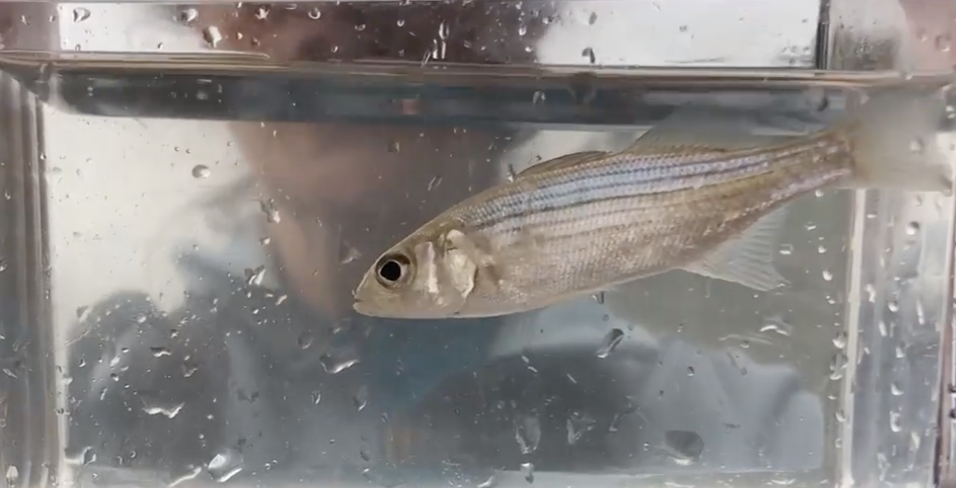
Young of year striped bass
Location: Nyack Beach State Park, Lower Beach, Upper Nyack, Rockland, NY
Area: Park/boat launch near Hook Mountain; sandy beach by the large sitting stairs
Surrounding Land Use: 40% Forested; 10% Industrial/Commercial; 40$ Beach- used for recreation and picnics
Sampling Site: Beach, covered with vegetation beyond the beach, stonewall, riprap shore, pipe coming into the river south of the sampling site
Shoreline: Sandy and rocky, muddy offshore
River Bottom: sandy inshore (<3ft depth); muddy offshore (>3ft depth), scattered large rock (<2ft length inshore)

ITEM | Time | Reading |  |  | Comments
Physical
Air Temperature | 2:30 PM | 20.3 º C |  | 68.5 º F
Wind Speed: | 2:30 PM | 0 m/s
Weather today | No Rain
Weather past 3 days: | Cold nights, days 50-60s, foggy, some rain 2 nights ago
Tides- | Low Tide | High Tide |  | Time of Sampling | Tide
 | 9:21 AM | 3:34 PM |  | 3:00 PM | Slack
Current- | Time | cm/second, Knots |  | North/South | Ebb/Flood/Still
 | NA
Water Temperature- | 2:38 PM | 19 º C | 66.2 º F
Turbidity- Long Sight Tube | 2:48 PM | 57.8 cm
Chemical
Salinity- Refractometer | 2:30 PM | 10 ppt
DO – Hach Drop count | Time | Temp |  | ppm DO | % saturation
 | 2:37 PM | 19 º C |  | 9 ppm | 95
pH – Color Match Kit | 2:37 PM | 8
Biological
Fish | Number | Name |  | Length of longest | Length of smallest
 | 22  1  1 | Atlantic Silverside  Striped Bass  Fry |  | 11 cm  9 cm | 6.5 cm
Fish Totals | TOTAL: 24 | Diversity: 3
Macroinvertebrates | Number | Name |  | Length of longest | Length of smallest
female | 1  1 | Blue Crab  Moon Jelly |  | 2 cm
Macroinvertebrate Totals | TOTAL: 2 | Diversity: 2
Observations

