Day in the Life of the Hudson & Harbor 10/22/20
Data Freshwater Hudson River from RMs 317.5-200
Doug Reed, Hudson Basin River Watch
Overall observation of Upper Hudson was that the river looked full of water – perhaps from recent rain
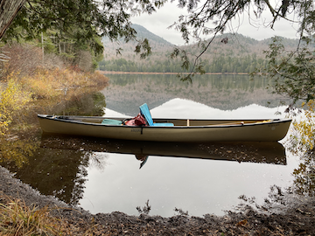 | 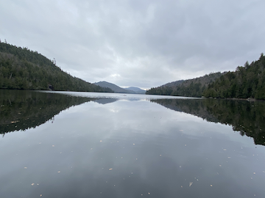

RM | Location | Time | Weather Description | Air  Temp | Water  Temp | pH | DO ppm  Oxygen
317.5 | Henderson Brook, near lean-to at north end of Henderson Lake | 6:00 AM |  |  | 47.8°F  8.8°C
315.5 | Henderson Lake outlet, dam and launch site | 3:30 AM | Broken cloud cover, scattered rain, no wind | 55°F  12.8°C | 50.5°F  10.3°C
315 | Tahawus Upper Works, Trailhead | 1:30 AM | Cloudy, no wind | 54°F  12.2°C | 50°F  10°C | 6.2 | 10.4
310 | Tahawus Road bridge, Essex Co. Rt 25, Newcomb N | 12:00 PM | Low cloud cover, scattered rain |  | 48.3°F  9.1°C
295 | Boreas River Rt 28N Minerva NY | 11:30 AM | Rain starting and stopping |  | 50.2°F  10.1°C
220 | Ice Meadows, River Rd Warrensburg NY | 10:15 AM | Dry, windy warm | 52.1°F  11.2°C | 53.3°F  11.9°C
200 | Schuylerville NY HR | 9:22 AM | Dry, windy warm |  | 57.7°F  14.3°C

