Day in the Life of the Hudson River 10/22/20
HAVERSTRAW BAY COUNTY PARK
RIVER MILE: 38
Salt Front: ~ RM 75
Rockland Soil and Water District – Nicole Liable, Brianna Rosamilia
Rockland Conservation and Service Corp: Kathy Galione, Kim Burgos
Latitude 41.212559 N & Longitude – 73.96376 W
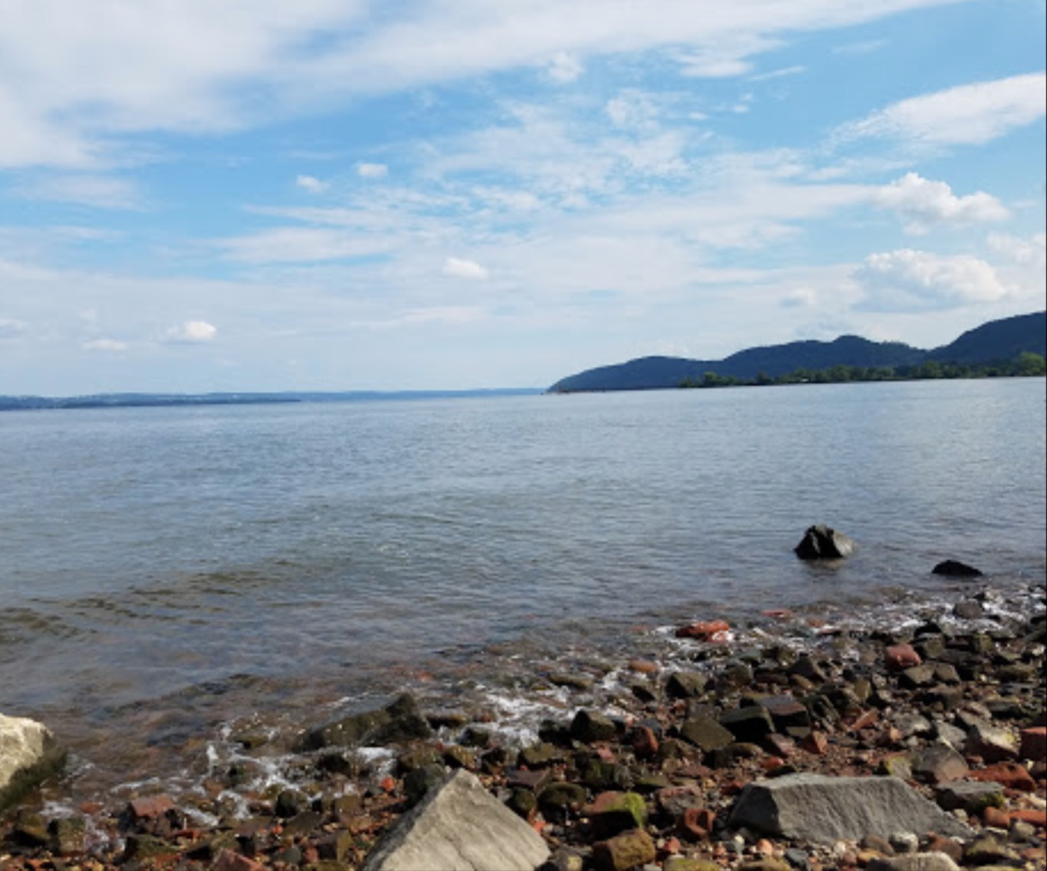
Haverstraw Bay County Park looking South; Bits of bricks cover the ground.
Location: Haverstraw Bay County Park, Village of Haverstraw, Rockland County, NY
Area: North Beach, dock/pier, grassy, forested, parking lot
Surrounding Land Use: 70% Forested; 20% Parkland; 10% Industrial/Commercial; 20% Urban/Residential
Sampling Site: small beach, banks altered, large riprap, concrete bulkhead, covered in vegetation
Shoreline: 10% sandy; 90% rocky
Plants in area: Waterchestnuts, nearby: bur-reed, wildrice, water celery
River Bottom: muddy, sandy, rocky

ITEM | Time | Reading |  |  | Comments
Physical
Air Temperature | 11:11 AM | 22.3 º C |  | 72.14 º F
Wind Speed: | 11:09 AM | 4-6 knots |  | Northeast
Weather today | Hazy
Weather past 3 days: | Rain, fog warning, mist
Tides- | Low Tide | High Tide |  | Time of Sampling | Tide
 | 10:04 AM | 4:07 PM |  | 11:10 AM | Flooding
Current- | Time | cm/second, Knots |  | North/South | Ebb/Flood/Still
 | 11:10 AM | 3.302 cm/sec |  | North | Flooding
Water Temperature- | 11:15 AM | 18.6 º C | 65.48 º F
Turbidity- Long Sight Tube | 10:37 AM | 27 cm
Chemical
Salinity- Meter | 11:15 AM | 7.43 ppt
DO – Meter | Time | Temp |  | ppm DO | % saturation
 | 11:15 AM | 18.6 º C |  | 7.72 ppm | 86.70
pH – Color Match Kit | 11:30 AM | 7
Conductivity- Meter | 11:15 AM | 11313 microseimens/cm
Biological
Fish | Number | Name |  | Length of longest | Length of smallest
 | 3  4 | Atlantic Silverside  Striped Bass |  | 8.89 cm  8.89 cm
Fish Totals | TOTAL: 7 | Diversity: 2
Macroinvertebrates | Number | Name |  | Length of longest | Length of smallest
 | 3  10 | Blue Crab  Comb Jelly
Macroinvertebrate Totals | TOTAL: 13 | Diversity: 2

