Day in the Life of the Hudson River 10/22/20
RIVERFRONT GREEN, PEEKSKILL
RIVER MILE: 43.5
Salt Front: ~ RM 75
Hudson River Estuary Program– Megan Lung and Rianna Scanlon, 3 participants
Latitude 41.28561 N & Longitude – 73.93176 W
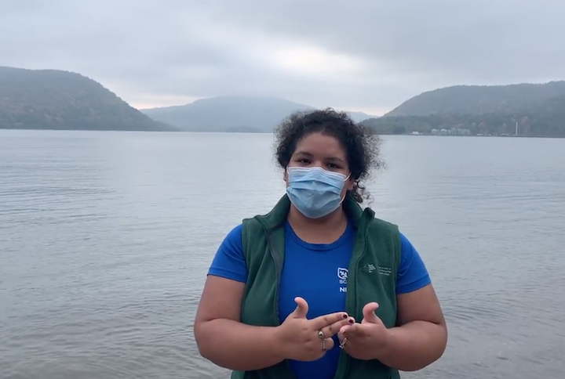
Location: Riverfront Green, Peekskill, Westchester County, NY
Area: Grassy, park area with sandy beachfront, pier, used for picnics, boating, and fishing
Surrounding Land Use: 50% grassy park; 40% industrial/commercial; 10% beach
Sampling Site: Beach with brick, charcoal, slag, and concrete bulkhead
Shoreline: Rocky, sandy, muddy with pebbles
River Bottom: Rocky

ITEM | Time | Reading |  |  | Comments
Physical
Air Temperature | 4:10 PM | 21 º C |  | 69 º F
Wind Speed: | 4:20 PM | 1.5 knots
Weather today | None
Weather past 3 days: | Some rain, foggy
Tides- | Low Tide | High Tide |  | Time of Sampling | Tide
 | 10:26 AM | 4:11 PM |  | 3:30 PM | Flooding
Current- | Time | cm/second, Knots |  | North/South | Ebb/Flood/Still
Water Temperature- | 4:00 PM | 17 º C | 62 º F
Turbidity- Long Sight Tube | 3:20 PM | 79 cm
Chemical
Salinity- Hydrometer | 4:20 PM | 14 ppt
DO – Hach Kit | Time | Temp |  | ppm DO | % saturation
 | 4:20 PM | 17 º C |  | 6 ppm | 73%
pH- Color Match Kit | 3:00 PM | 8
Biological
Fish | Number | Name |  | Length of longest | Length of smallest
 | 135  58  31 | Striped Bass  Atlantic Silverside  Spottail shiner
Fish Totals | TOTAL: 224 | Diversity: 3
Macroinvertebrates | Number | Name |  | Length of longest | Length of smallest
Macroinvertebrate Totals | TOTAL: | Diversity:
Observations

