Day in the Life of the Hudson River 10/22/20
HUDSON RIVER PARK PIER 84, MANHATTAN
RIVER MILE: 5.6
Salt Front: ~ RM 75
Hudson River Park – Toland Kister, 6 participants
Latitude 40.76392 N & Longitude – 74.00132 W
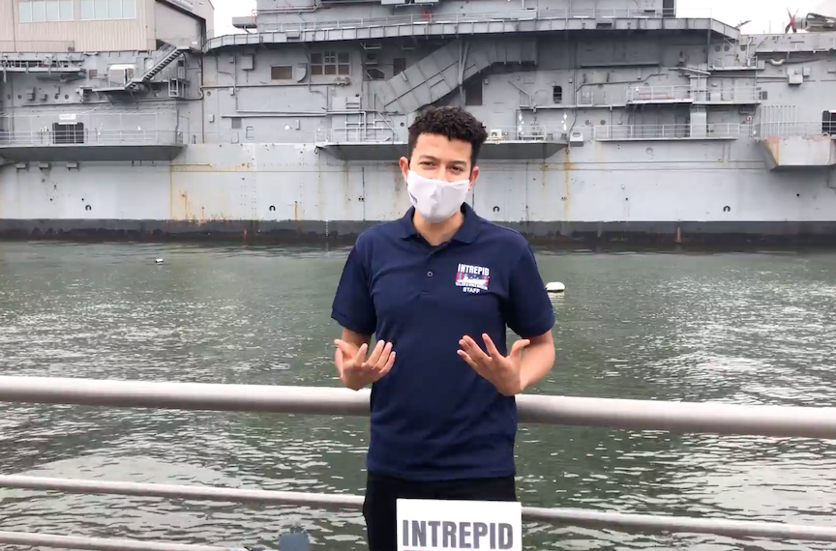
Location: Hudson River Park, Pier 84, Manhattan, NY
Area: Pier, bulkhead, mainly concrete and wood, grass on the pier.
Surrounding Land Use: 60% Urban/Residential, 40% Industrial/Commercial
Sampling Site: An educational/recreational pier used for picnics, boating, jogging, fishing. Concrete bulkhead, rocks near the edge, banks altered, all hard edged, pipe entering the water.
Shoreline: Concrete bulkhead- all hard edged Water: 609.6 cm
River Bottom: Muddy, sandy, rocky
Plants in water: No plants in water area
ITEM | Time | Reading |  |  | Comments
Physical
Air Temperature | 2:00 PM | 20.6 º C |  | 69 º F
Wind Speed: | 2:00 PM | 3 knot |  | North
Weather today | No Rain
Weather past 3 days: | Temperature varied 59-69, foggy and rainy
Tides- | Low Tide | High Tide |  | Time of Sampling | Tide
 | 8:18 AM | 1:43 PM |  | 2:00 PM | Ebb
Current- | Time | cm/second, Knots |  | North/South | Ebb/Flood/Still
Water Temperature- | 2:07 PM | 17.6 º C | 63.6 º F
Turbidity- HRECOS | 2:00 PM | 7.6 FNU
Chemical
Salinity- Refractometer | 2:09 PM | 16.3 ppt
DO – HRECOS | Time | Temp |  | ppm DO | % saturation
 | 2:00 PM | 17.6 º C |  | 6.9 ppm | 77
pH – HRECOS | 2:00 PM | 7.8
Biological
Fish | Number | Name |  | Length of longest | Length of smallest
 | Did not fish
Fish Totals | TOTAL: | Diversity:
Macroinvertebrates | Number | Name |  | Length of longest | Length of smallest
Macroinvertebrate Totals | TOTAL: | Diversity:
Sediment Core | Time | Oxidized Top |  | Grain Size | Other Features
NR
Boats | Time | Name/Color |  | North/South | Loaded/Light
NR
Observations

