Day in the Life of the Hudson River 10/22/20
GARRISON LANDING
RIVER MILE: 51.5
Salt Front: ~ RM 75
Katie Krueger Hirt, 5 participants
Latitude 41.38207 N & Longitude – 73.94799 W

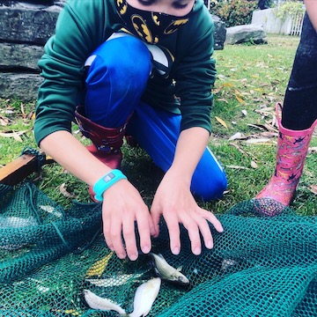 | 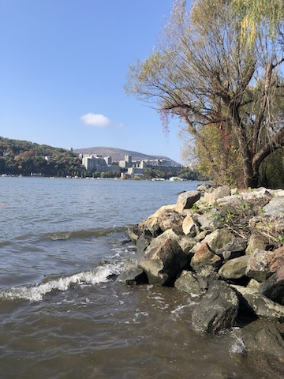 | 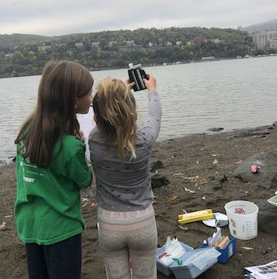
Seining at Garrison Landing Looking Northwest at West Point Checking pH
Location: Garrison Landing Park, Garrison, Putnam County, NY
Area: Waterfront beach area with a pier in front of grassy park primarily used for boating and picnics Surrounding Land Use: 60% Forested; 20% Urban/Residential; 10% Industrial/Commercial; 10% Other
Sampling Site: Rocky shoreline, pier, shore with bulkhead, riprap, grassy, parking lot
Shoreline: Sandy, muddy
Plants in area: no plants in water area
River Bottom: muddy; sandy

ITEM | Time | Reading |  |  | Comments
Physical
Air Temperature | 8:12 AM  12:45 PM  2:15 PM | 17º C  22.4 º C  22.78 º C |  | 65.5 º F  72.32 º F  73 º F
Wind Speed: | 8:12 AM  12:45 PM  2:00 PMM | 2.6 m/s  0 m/s  1.2 m/s |  | Northeast  Northeast
Weather today | No Rain
Weather past 3 days: | Temperature Highs: Mon 63F, Tues. 72F, Wed 70F. No rain the past 3 days
Tides- | Low Tide | High Tide |  | Time of Sampling | Tide
 | 10:52 AM | 4:45 PM |  | Morning  12:45 PM  3:18 PM | Ebbing  Flooding  Flooding
Current- | Time | cm/second, Knots |  | North/South | Ebb/Flood/Still
 | Morning  12:45 PM  3:18 PM | 18.3 cm/s  26.1 cm/s  13.3 cm/s |  | South  North  North | Ebbing  Flooding  Flooding
Water Temperature- | 8:12 AM  12:30 PM  2:10 PM | 18 º C  19 º C  19 º C | 64.4 º F  66.2 º F  66.2 º F
Turbidity- Secchi Disk | 8:03 AM  12:36 PM  2:06 PM | 60 cm  38 cm  56 cm
Chemical
Salinity- High Range Quantab | 8:32 AM  12:39 PM  2:20 PM | 2100 ppm Cl-  1634 ppm Cl-  1776 ppm Cl- |  | 3794 ppm total salinity  2952 ppm total salinity  3208 ppm total salinity
DO – Hach Kit | Time | Temp |  | ppm DO | % saturation
 | 8:23 AM  12:30 PM  2:20 PM | 18 º C  19 º C  19 º C |  | 12 ppm  13 ppm  12 ppm | 125%  140%  130%
pH- Color Match Kit | 8:32 AM  12:22 PM  2:23 PM | 7.5  7  8
Biological
Fish | Number | Name |  | Length of longest | Length of smallest
Seine ~12:30 PM  Seine ~2:00 PM | 3  2  1  2  3  1  1 | American shad  Atlantic silverside  Striped Killifish  White perch  Striped bass  American shad  striped killifish |  | 6.4 cm  5 cm  8.5 cm  13.7 cm  9.2 cm  4.2 cm  6.4 cm | 6.2 cm  4.9 cm  7.5 cm  4.0 cm
Fish Totals | TOTAL: 13 | Diversity: 5
Macroinvertebrates | Number | Name |  | Length of longest | Length of smallest
Macroinvertebrate Totals | TOTAL: | Diversity:
Observations

