Day in the Life of the Hudson River 10/22/20
CORNWALL LANDING
RIVER MILE: 57
Salt Front: ~ RM 75
New York State DEC – Tom Lake
Palisades Interstate Park @ Bear Mountain- Travis Cherry
Latitude 41.44384 N & Longitude – 73.99961 W
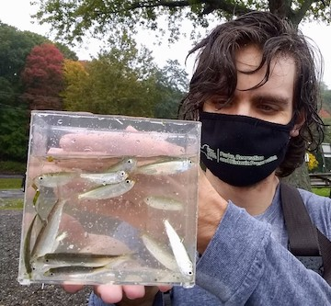  Blueback Herring | 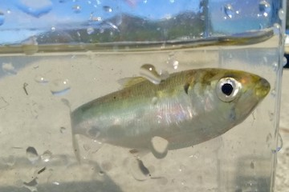  American Shad

Location: Donahue Memorial Park, Cornwall Landing, Town of Cornwall, Orange County, NY
Area: Sandy beach
Surrounding Land Use: 100% open and grassy park
Sampling Site: Pier/dock, sandy beach, altered banks, shoreline riprap, bulkhead, collected wood and debris in area
Water: Choppy
River Bottom: Muddy, rocky
Plants in water:

ITEM | Time | Reading |  | Comments
Physical
Air Temperature | 1:00 PM | 22 º C | 73 º F
Wind Speed: | 1:00 PM | 10 mph |  | South
Weather today | 1:00 PM no rain
Weather the past 3 days: | Fair, mile
Tides- | Time of Low Tide | Time of High Tide | Time | Tide at time of sampling
 | 11:15 AM | 5:14 PM | 1:00 PM | Flooding
Current- | cm/second | Knots | North/South | Ebb/Flood/Still
 | NR
Water Temperature | 1:00 PM | 12.3 º C | 65.1 ºF
Turbidity- long sight tube | 1:00 PM | 38.2 cm
Chemical
Salinity- N/R | Time | ⁻ Total Salinity
 | 1:00 PM | 3 ppt
DO – Hach drop count | Time | Temp | ppm DO | % saturation
 | 1:00 PM | 12.3 | 9 | 84%
pH – | NR
Biological
Fish | Number | Name | Length of longest | Length of shortest
Seine  All young of year | 11  10  155  6  16  4  9 | striped bass  American shad  blueback herring  bluefish  Atlantic silverside  banded killifish  spottail shiner | 9.4 cm  9.2 cm  7.2 cm  13.5 cm  9.3 cm | 8.0 cm  8.7 cm  6.7 cm  13.0 cm  8.4 cm
Fish Totals | TOTAL: 5 | Diversity: 2
Macroinvertebrates | Number | Name | Length of longest | Length of shortest
 | 20 | Bluecrab | 3.5 cm | 2.0 cm
Macroinvertebrate Totals | TOTAL: 20 | Diversity: 1

