Day in the Life of the Hudson River 10/22/20
NEWBURGH WATERFRONT- PEOPLE’S WATERFORNT
RIVER MILE: 60.5
Salt Front: ~ RM 75
Scenic Hudson- Kate Phipps and 2 others
Latitude 41.4934 N & Longitude – 74.00741 W
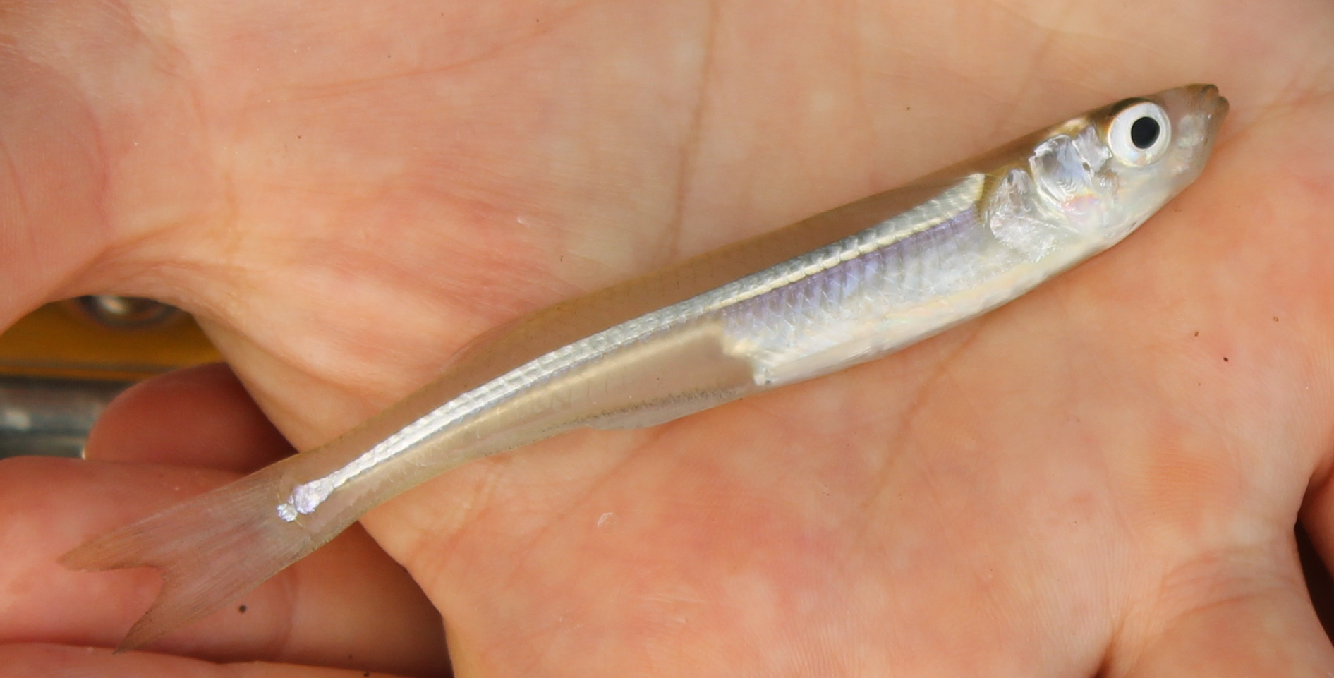 | 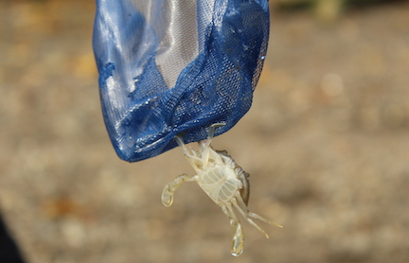 | 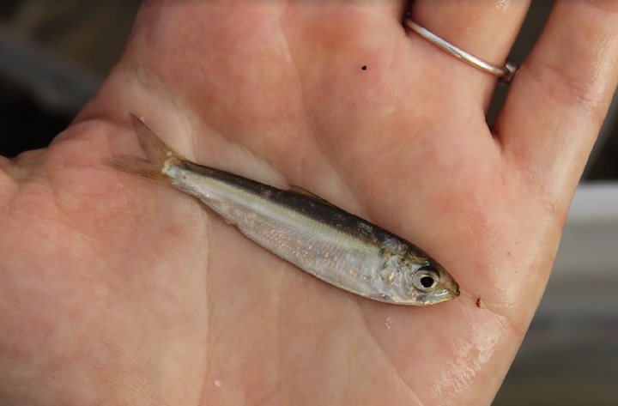
Atlantic Silverside Juvenile Blue crab Herring

Location: Newburgh Waterfront- People’s Waterfront and Boat Launch, Newburgh, Orange County, NY
Area: Pier, dock with bulkhead, riprap, and wood bulkhead d
Surrounding Land Use: 75% Industrial/Commercial; 25% Park
Sampling Site: Shore with bulkhead, banks altered with riprap, debris in area
Shoreline: rocky
River Bottom: Muddy, rocky

ITEM | Time | Reading |  |  | Comments
Physical
Air Temperature | 10:45 AM | 19 º C |  | 70 º F
Wind Speed: | 10:45 AM | Very low wind
Weather today | 9:45 AM no rain
Weather the past 3 days: | Mix of sun an clouds, some light rain, seasonably warm
Tides- | Time low tide | Time of high tide | Time | Direction of tide during sampling | Rate of Tidal Change (cm/min)
 |  | 5:06AM | 10:45 AM |  | *Should be falling all day
  11:24 AM
  ebbing
Current- | Time | Speed |  | North/South | Ebb/Flood/Still
 | NR
Water Temperature |  |  |  | 62 º F
  10:45AM
  18 º C
Turbidity- long sight tube | 11:10 AM | 23.5cm
Chemical
Salinity- | Time | Chloride |  | Total Salinity | Notes
Low Range Quantabs |  |  |  | 1097 ppm | Quantab maxed out the chart
  11:00AM
  607 ppm
DO – Hach Drop | Time | Temp |  | ppm DO | % saturation
 |  |  |  |  | 85%
  10:45AM
  18 º C
  9
pH –color match
  11:00AM
  7.4
Biological
Fish | Number | Name |  | Length of longest
 | 21  10  1 | Herring YOY  Spottail Shiner  Atlantic Silverside
Fish Totals | TOTAL: 32 | Diversity: 3
Macroinvertebrates | Number | Name |  | Length of longest
 | 1 | Blue crab
Macroinvertebrate Totals | TOTAL: 1 | Diversity: 1

