Day in the Life of the Hudson River 10/22/20 Data
LONG DOCK, BEACON, RIVER MILE: 61
Salt Front: ~RM 75
Scenic Hudson- Kate Phipps and 2 staff
Latitude 41.50312 N & Longitude – 73.98696 W
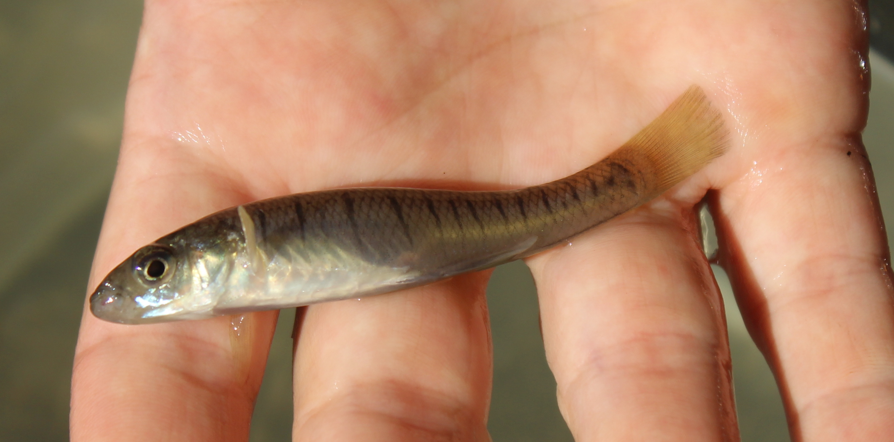
Banded Killifish

Location: Long Dock Park, Beacon, Dutchess County, NY
Area: Long Dock Park- a former brownfield now public park used for fishing, launching kayaks, picnics, fieldtrips, enjoying scenic view of the Hudson River, Hudson Highlands, and Hudson Valley. Most of the shoreline on the south side is lined with trees.
Surrounding Land Use: 25% Forested; 15% Beach; 60% Other
Sampling Site: Beach area rocky with lots of sand, water chestnut and grass
Plants in area:
River Bottom: Muddy, Rocky

ITEM | Time | Reading |  | Comments
Physical
Air Temperature: | 12:30 PM | 18 º C | 68 º F
Wind Speed: | NR
Weather Today: | 12:30 PM No rain
Weather Previous: | Mix of sun and clouds, some light rain, seasonably warm
Water Temperature | 12:40 PM | 19 º C | 65º F
Turbidity - site tube | 12:15 PM | 55.5 cm
Chemical
Salinity- Low Range Quantabs | 12:40PM | *607 ppm Cl- | 1097 ppm Total salinity | *Note the sample reached the maximum of the chart
DO – Hach drop count | Time | Temp | ppm DO | % saturation
DO – Hach drop count | 12:40 PM | 19 º C | 10 ppm | 105%
pH - color match kit | 12:50 PM | 7.6
Biological
Fish – seine – | Seine Number | Number | Name | OVERALL
Fish – seine – |  | 11  1  1  1 | Herring, YOY  Spottail Shiner  Banded Killifish  Bay Anchovy
Fish – seine – |  | TOTAL: 14 | DIVERSITY: 4
Macroinvertebrates- Seine | Number | Name | Length of longest
 | TOTAL: 0 | Diversity: 0
Tides- | Time of Low Tide | Time of High Tide | Sampling Time | Direction of tide at sampling
 | 11:26 AM | 5:29 PM | 12:30 PM | Flooding
Currents Flow | Cm/second | Knots | North/South | Ebb/Flood/Still
 | NR

