Day in the Life of the Hudson River 10/22/20
WARYAS PARK- FALLKILL CREEK, POUGHKEEPSIE
RIVER MILE: 75.5
Salt Front: ~ RM 75
Lisa DeMarzo
Latitude 41.709244 N & Longitude – 73.940203 W
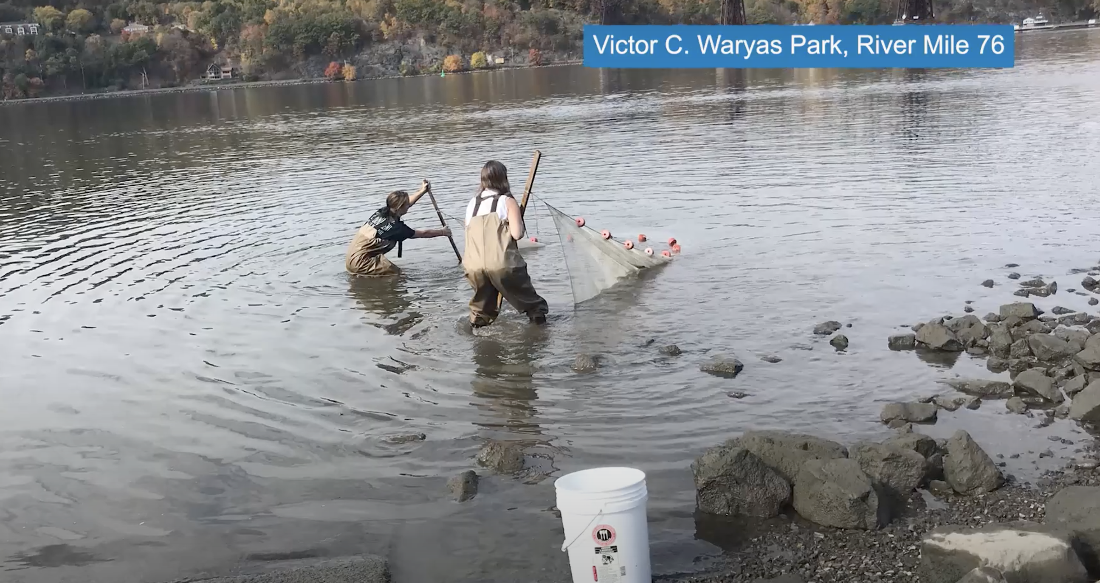
Location: Just south of the tidal mouth of the Fallkill Creek, Poughkeepsie, Dutchess County, NY
Area: N Waryas public park by the boat ramp
Surrounding Land Use: 30% Urban/Residential; 30% Park; 10% Industrial/Commercial; 30% Beach
Sampling Site: Pier at southern end, grassy park, parking lot behind. Park used for fishing, small boat launch, another pier for small boat launching.
Shoreline: Rocky inshore <1 ft depth with some scattered large rocks (<2 ft in length), sandy and rocky offshore >1 ft depth.
Water: 3-4 ft
River Bottom: rocky/muddy

ITEM | Time | Reading |  | Comments
Physical
Air Temperature | 11:50 AM | 20.5 º C | 68.9 º F
Wind Speed: | 11:50 AM | 2.67 MPH | 4.3 km/hr | 2.3 knots
Weather today | No rain
Weather past 3 days: | Foggy, drizzly, warm
Tides- | Time of Low Tide | Time of High Tide | Time | Tide during sampling
 | 12:02 PM | 6:17 PM | 11:50 AM | Ebbing
Current- | Time | cm/second | North/South | Ebb/Flood/Still
 |  |  | South | Ebb
Water Temperature- | 12:15 PM | 16 º C | 60.8 º F
Turbidity- long site tube | 12:20 PM | 13 cm
Chemical
Salinity- Low range quantabs | 12:10 PM | 175 ppm total salinity
DO – Hach drop count | Time | Temp | ppm DO | % saturation
 | 12:15 PM | 16 º C | 10 | 100%
pH – | 12:15 PM | 7.5
Biological
Fish | Number | Name | Length of longest
 | 20  7 | Spottail Shiner  Pumpkinseed sunfish
Fish Totals | TOTAL: 27 | Diversity: 2

