Day in the Life of the Hudson River 10/22/20
QUIET COVER PARK, POUGHKEEPSIE
RIVER MILE: 78
Salt Front: ~ RM 73
Cornell Cooperative Extension Dutchess County &
NCLI Program from Poughkeepsie High School
Danielle Salisbury and 13 participants
NYS DEC Fisheries - Bob Adams and Jess
Latitude 41.73506 N & Longitude – 73.93632 W
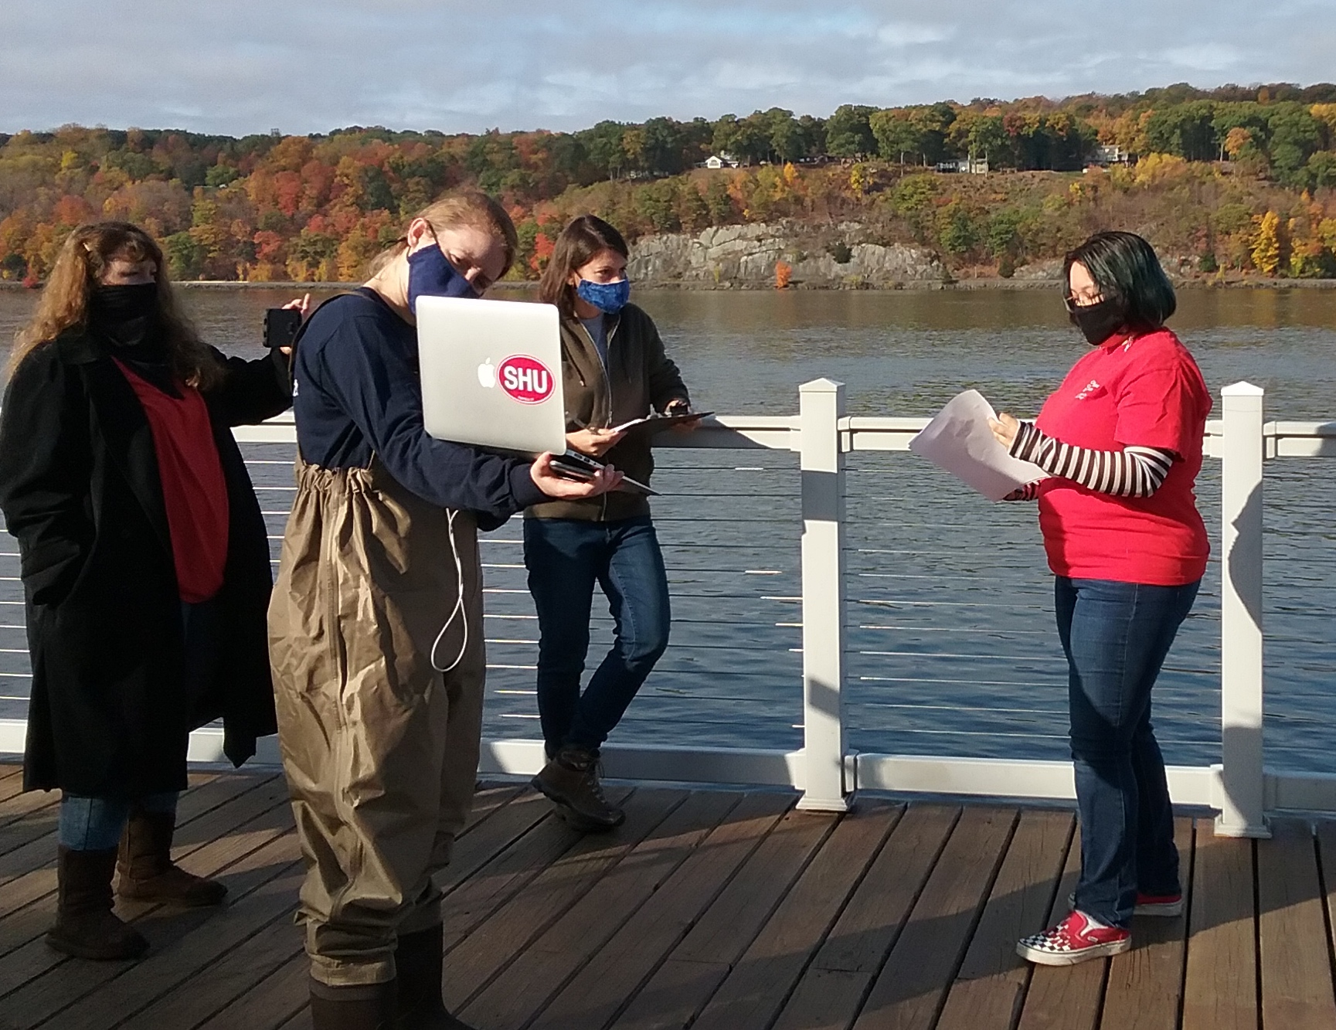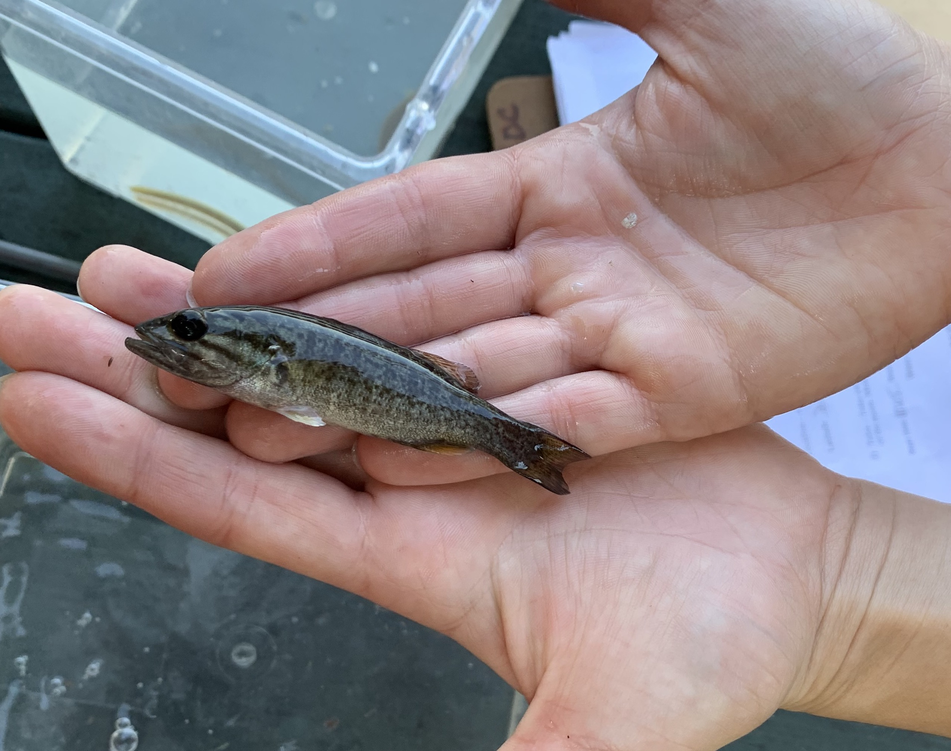

Location: Quiet Cove, Poughkeepsie, Dutchess County, NY
Area: Grassy area with parking lot, beach like waterfront
Surrounding Land Use: 60% Park, 40% Industrial/Commercial (previous industrial site)
Sampling Site: An old industrial area that has been turned into a park. Used by people for picnics, boating, and fishing. Beach with altered banks, riprap, and wooden bulkhead. Boat launch is for kayaks and canoes.
Shoreline: Rocky shoreline with altered banks
Water: 160 cm in the area with concrete embankments
River Bottom: Muddy
Water depth: 8 cm

ITEM | Time | Reading |  | Comments
Physical
Air Temperature | 10:10 AM | 64º F
Wind Speed: | 10:11 AM | <1 knot
Weather today | 10:10 AM No rain
Weather past 3 days: | Sunny no rain
Tides- | Time of Low Tide | Time of High Tide | Time | Tide during sampling
 | 12:10 PM | 6:27 PM | 10:05 AM | Ebbing tide
Current- | Time | cm/second | North/South | Ebb/Flood/Still
Water Temperature- | N/R | º C
Turbidity- short sight tube | 10:45AM | >60 cm  27 cm  26 cm (listed as JTU but the turbidity tube was actually cm)
Chemical
Salinity- LR Quantab | NR
DO – Hach drop count | Time | Temp | ppm DO | % saturation
 | 10:25 AM | º C | 11 ppm* noted this was inaccurate
pH – | N/R
Nitrates- LaMotte Estuary wide kit – low resolution | NR
Phosphates - LaMotte Estuary wide kit – low resolution | NR
Biological
Fish | Number | Name | Length of longest
Seine | 1  43  1  1 | Alewife  Spottail Shiner  Smallmouth Bass  American Eel | 9 cm  10 cm  9 cm  18 cm
Fish Totals | TOTAL: 46 | Diversity: 4
Macroinvertebrates | Number | Name | Length of longest
NR
Macroinvertebrate Totals | TOTAL: | Diversity:
Sediment Core | Time | Oxid Top | Grain Size | Other Features
 | NA
Boats | Time | Name/Color | North/South | Loaded/Light
Recreational | 10:10 AM |  | 2 Northbound  3 Southbound
Observations

