Day in the Life of the Hudson River 10/22/20
NORRIE POINT, STAATSBURG
RIVER MILE: 84.5
Salt Front: ~ RM 75
NYS DEC- Maija Niemisto
Kingston YMCA Farm Project - Susan Hereth
Latitude 41.83242 N & Longitude – 73.94129 W
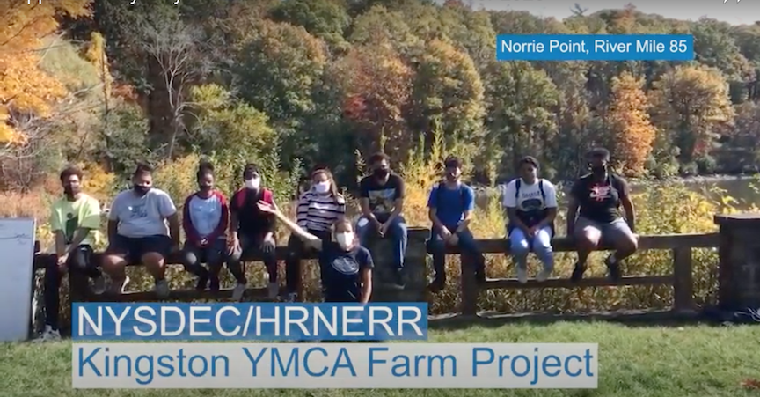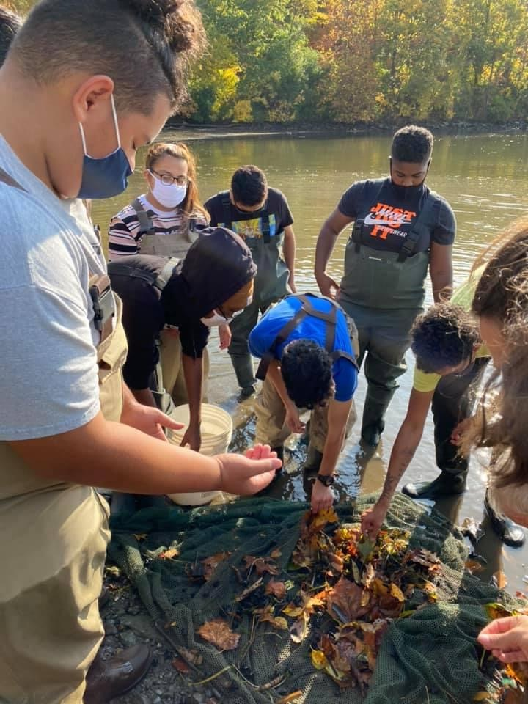
Location: Norrie Point Environmental Center, Norrie Point, Dutchess County, NY
Area: East side of the Hudson, far from the main channel in a protected cove. Substantial paved areas nearby, large environmental center building adjacent to the water. Shallow cove facing south onto the Hudson River, bordered by riprap embankment, dock
Surrounding Land Use: 90% Forested; 10% Residential
Sampling Site: Front banks altered with riprap, cove is very muddy with some riprap and the west side is rocky
Shoreline: beach area, shore with bulkhead, shoreline riprap, banks altered for DEC building, riprap along the railroad tracks, piping entering river area
River Bottom: 50% muddy, 50% rocky
Plants in water:
Water:

ITEM | Time | Reading |  | Comments
Physical
Air Temperature | 12:30 PM | 66 º F | 19º C
Wind Speed: | 12:30 PM | 0
Weather today | 12:00 PM no rain
Weather the past 3 days: | Cloudy and overcast but dry
Tides- | Time of low tide | Time of high tide | Time of Sampling | Direction of tide
 | 12:16 PM | 6:21 PM | 12:30 PM | Slack
Current- | Time | Speed | North/South | Ebb/Flood/Still
 | NR
Water Temperature | 12:30 PM | 19 º C | 63 º F
Turbidity- long sight tube | 12:49 PM | 55 cm
Chemical
Salinity- | Time | ppt
Refractometer | 12:45 PM | 1 ppt | Instrument is not accurate to this range
DO – Hach drop kit | Time | Temp | ppm DO | % saturation
 | 1:00 PM | 11 º C | 19 | 110%
pH – color match kit | 12:40 PM | 8
Biological
Fish | Number | Name | Length of longest | Length of shortest
Seine 30’ | 4  60  10  5  8  1  26  2 | Spottail Shiner  Pumpkin Seed  Blue Gill  Redbreasted sunfish  Tessellated darter  Banded Killifish  Herring  American Shad | 8 cm  7 cm  13 cm  13 cm  8 cm  5 cm  5cm | 7 cm  5 cm  4 cm  4 cm  5 cm  4 cm  4 cm
Fish Totals | TOTAL: 116 | Diversity: 8
Macroinvertebrates | Number | Name | Length of longest | Length of shortest
 | 10 | Blue Crab | 4 cm | 2 cm
Macroinvertebrate Totals | TOTAL: 10 | Diversity: 1
Sediment Core | Time | Oxid Top | Grain Size | Other Features
NR
Boats | Time | Name/Color | North/South | Loaded/Light
NR
Observations

