Day in the Life of the Hudson River 10/22/20
ESOPUS MEADOWS, ULSTER PARK RIVER MILE: 87
Salt Front: RM 75
Clearwater - Eli Schloss & total 7 adults
Latitude 41.868266 N & Longitude – 73.950724
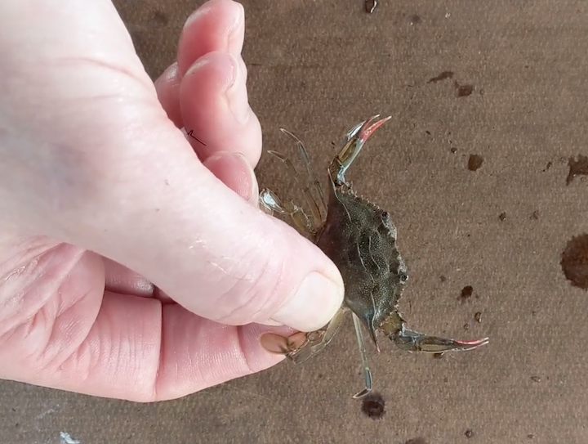 | 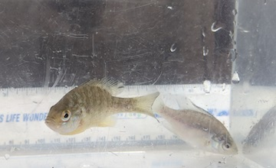
Location: Beach Lighthouse Park, Esopus Meadows Preserve, Town of Esopus, Ulster County, NY
Area: A path along the beach with rising forested hills
Surrounding Land Use: 85% Forested; 10% Beach, 5% Other
Sampling Site: Rocky shallow, sloping beach area covered with vegetation
River Bottom: muddy, rocky

ITEM |  | Time | Reading |  | Comments
Physical
Air Temperature: |  | 1:25 PM | 22 ºC | 74 ºF
Wind Speed: |  | 1:25 PM | 0-3 knots | Southeast
Weather Today: |  | 1:25 PM no rain
Weather last 3 days |  | Gusty winds, partly cloudy
Current- *measured in a cove |  | cm/second | Rising, Falling, Unchanged | Height (cm) | Rate of Change (cm/min)
Water Temperature |  | 1:25PM | 20 º C | 68 º F
Turbidity- long site tube |  | 3:10 PM | 20 cm
Chemical
Salinity- |  | Time | Chloride | Total Salinity
 |  | N/R
DO – Hach drop count |  | Time | Temp | ppm DO | % saturation
 |  | 3:45 PM | 20 º C | 8 | 100%
pH – color match |  | 2:15 PM | 7
Biological
Fish- Seine  25’ x 4’x ¼ ‘ |  | Number | Name | Length of longest | Length Shortest
 |  | 35  2  1  1  2  8 | Blueback Herring  White Perch  Banded Killifish  Spottail Shiner  Bluegill Sunfish  Pumpkinseed | 5 cm  19 cm  9 cm  7 cm  6 cm  8 cm | 4 cm  14 cm  7 cm  NA  NR  6 cm
 |  | TOTAL: 49 | Diversity: 6
Macroinvertebrates |  | Number | Name | Length of longest
 |  | 1 | Blue Crab | 4 cm
 |  | TOTAL: 1 | Diversity: 1
Tides | Time of Low Tide | Time of High Tide | Sampling Time | Tide Movement | Tides
 | 12:30 PM | 6:45 PM | 1:50 PM | Flooding
Boats | Time | Name | Color | North or South | Loaded or Light
 | NR

