Day in the Life of the Hudson River 10/22/20
KINGSTON POINT PARK
RIVER MILE: 92
Salt Front: ~ RM 75
City of Kingston Parks & Recreation- KC Keegan-Twombley, Julie Noble and 2 others
Latitude 41.930213 N & Longitude – 73.96467 W
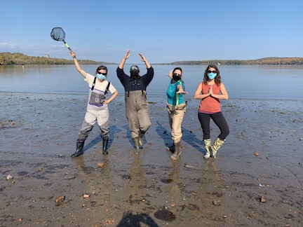

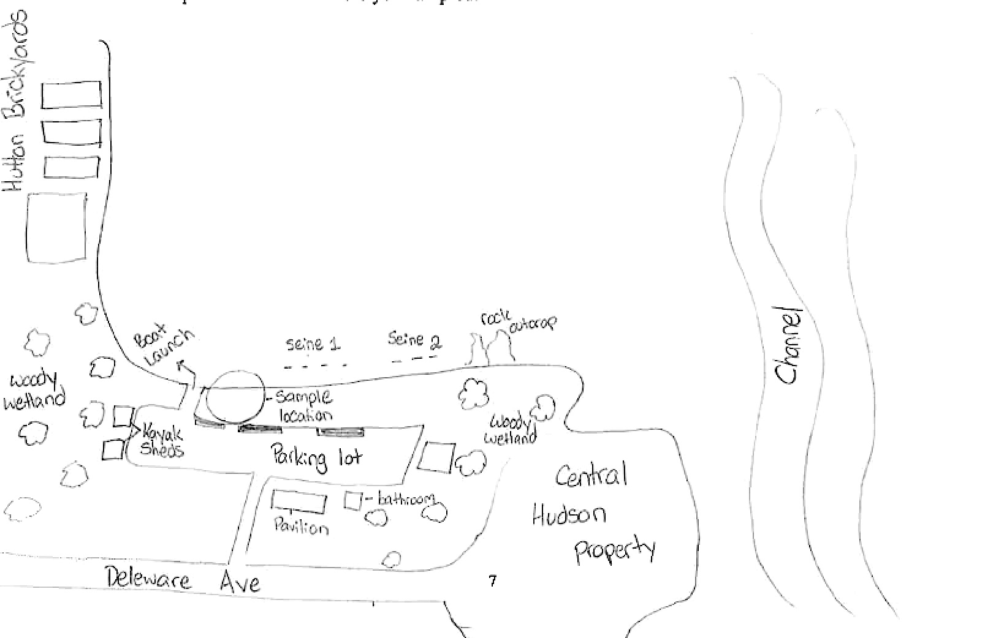
Location: Kingston Point Park, City of Kingston, Ulster County, NY
Area: Swimming beach, forested, parking lot; used for picnics, boating, fishing, swimming, jogging, kayaking
Surrounding Land Use: 5% Forested; 10% Industrial/Commercial; 85% Beach
Sampling Site: Beach Area
Shoreline: Sandy shoreline (75 ft from shoreline to parking lot and 200 ft wide); boat launch; banks are altered; riprap to north along brickyard shoreline; large amount of brick debris from prior industry
River Bottom: Sandy
Water: Calm

ITEM | Time | Reading |  | Comments
Physical
Air Temperature | 11:45 AM  12:45 PM | 21ºF  21.1 | 69.9 ºF  70
Wind Speed: | 11:45 AM | 0.7 m/sec | East
Weather today | No rain
Weather the past 3 days: | mid 60’s to low 70’s
Tides- | Time of Low Tide | Time of High Tide | Sampling Time | Tide Movement During Sampling
 | 12:57 PM | 6:41 AM | 12:15 PM  12:40 PM | Ebbing  Ebbing
Current- | Time | cm/second | North/South | Ebb/Flood/Still
 | NR
Water Temperature | 11:45 AM  12:15 PM  12:45 PM | 14 ºC  14 ºC  15 ºC | 58 ºF  58 ºF  59 ºF | Average of 3each sample time
Turbidity- short site tube | 12:08 PM | 40 JTUs
Chemical
Salinity- Hydrometer | Time | Salinity
 | 12:00 PM | Below detection of the instrument used
DO – drop count test kit | Time | Temp | ppm DO | % saturation
 | 12:30 PM | 14 ºC | 4 ppm | 32%
pH – color match kit | 12:22 PM | 7
Nitrates- (assume Lamotte estuary wide kit) | 12:25 PM | 5 ppm
Phosphates- (assume Lamotte estuary wide kit) | 12:25 PM | 1 ppm
Biological
Fish – 2 seines | Number | Name | Length of longest
 | 6  30  6  1  25 | Striped Bass  Spottail Shiner  Pumpkinseed  Bluefill sunfish  Banded Killifish | 9 cm  11.1 cm  7.4 cm  3.2 cm  11.2 cm
Fish Totals | TOTAL: 68 | Diversity: 5
Macroinvertebrates | Number | Name | Length of longest
 | 1 | Giant waterbug
Macroinvertebrate Totals | TOTAL: 1 | Diversity: 1
Sediment Core | Time | Oxid Top | Grain Size | Other Features
 | NR
Boats | Time | Name/Color | North/South | Loaded/Light
 | NR
Observations

