Day in the Life of the Hudson River 10/22/20
ULSTER LANDING PARK
RIVER MILE: 97
Salt Front: ~ RM 75
Lisa DiMarza and 2 adults
Latitude 42.00425 N & Longitude – 73.94467 W
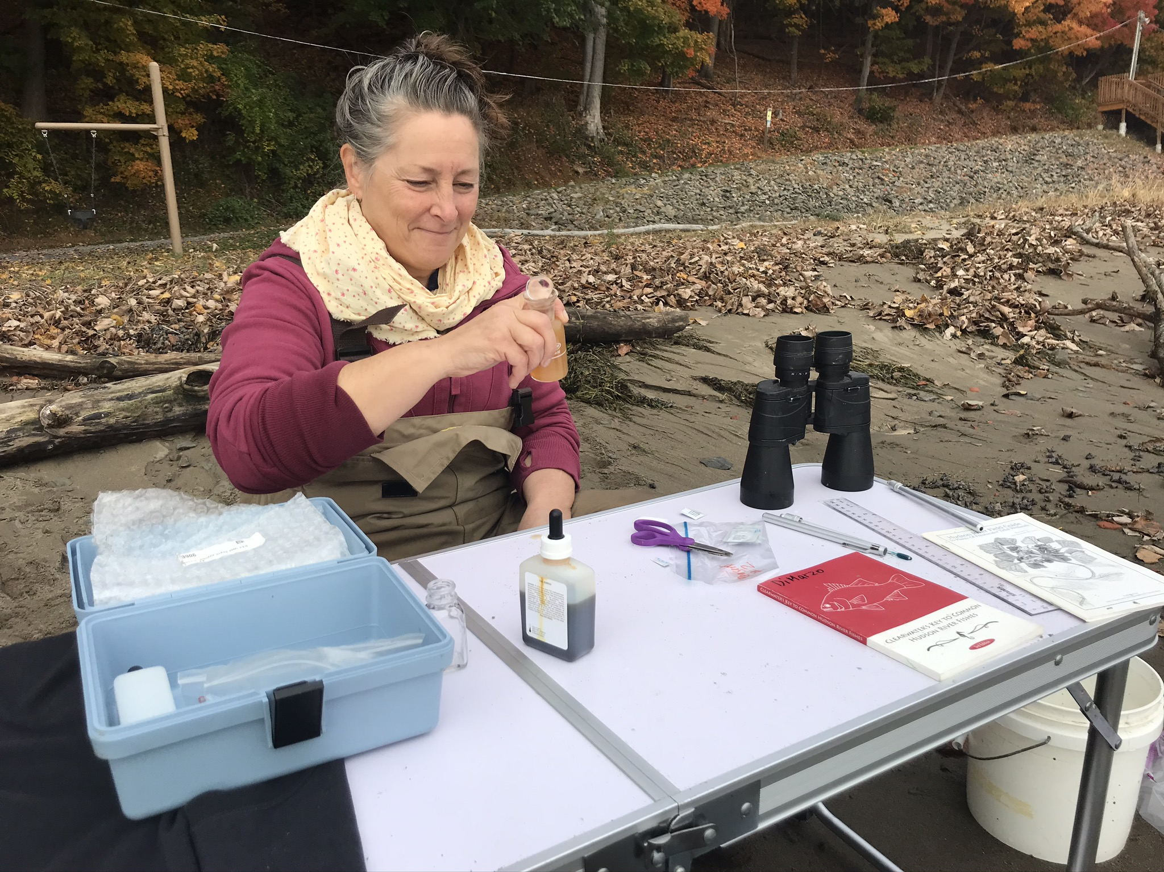
Location: Ulster Landing Park, Town of Ulster, Ulster County, NY
Area: Swimming Beach; used for fishing swimming; building with restroom
Surrounding Land Use: 90% Forested; 5% Beach; 5% Parkland with grass and picnic area
Sampling Site: Beach, altered bank with concrete bulkhead, wood debris (drift wood), slag and brick in area, drainage from bulkhead north of site
River Bottom: Sandy at edge, then very muddy

ITEM | Time | Reading |  | Comments
Physical
Air Temperature | 9:25 AM | 18.4 º C | 64.9 º F
Wind Speed: | 9:25 AM | 2.1 km/hr
Weather today | 9:25 AM no rain
Weather past 3 days: | Slight drizzle and warm
Tides- | Time | Rising, Falling, Unchanged | Water Height (cm) | Rate of Tidal Change (cm/min)
 | 9:40 AM | Ebbing
Current- | Time | cm/second, Knots | North/South | Comments
 | N/A
Water Temperature- | 9:55 AM | 11 º C | 52 º F
Turbidity – long site tube | 9:45 AM | 68 cm
Chemical
Salinity- LR Quantabs | 9:45 AM | 52 ppm Cl⁻ | 94 ppm Total Salinity
DO – Hach Drop Count | Time | Temp | ppm DO | % saturation
 | 9:50 AM | 11 º C | 13 ppm | 120 %
pH – color match | 9:50 AM | 7.5
Biological
Fish | Number | Name | Length of longest
 | 2  2 | Spottail Shiners  Striped Bass | 6.5 cm  8 cm
Fish Totals | TOTAL: 4 | Diversity: 2
Macroinvertebrates | Number | Name | Length of longest
 | 1 | Blue Crab | 4 cm
Macroinvertebrate Totals | TOTAL: 1 | Diversity: 1
Sediment Core | Time | Area | Grain Size | Other Features
 | N/A
Boats | Time | Name/Color | North/South | Loaded/Light
 | N/A
Observations | N/A

