Day in the Life of the Hudson River 10/05/2023
Ferry Point Park, Bronx, NY
EAST RIVER MILE: 13.5
Salt Front: ~RM 52
KIPP Academy-Fatima Wilson
NYSDEC HREP- Sarah Mount & Madeline McDonald
90 students, 4th grade, 15 adults
Latitude 40.804873°N & Longitude –73.832189°W

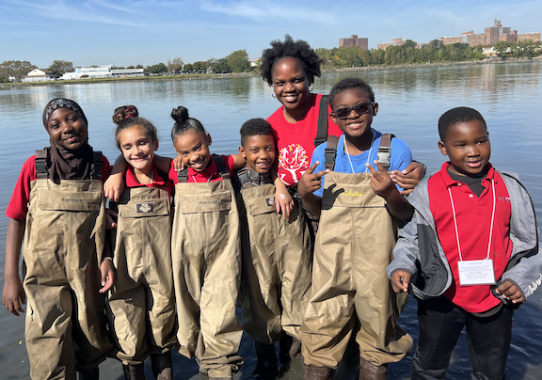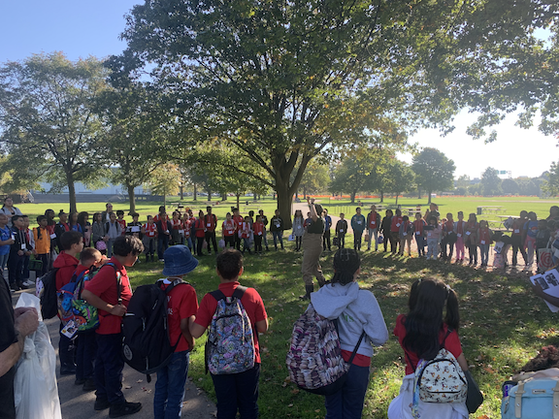
Location: Ferry Point Park Beach, Bronx, NY
Surrounding Land Use: Beach & Park
Sampling Site: Sandy beach, tidal marsh area covered with dense spartina
Shoreline: 50% Sandy & 50% Rocky
Water: NR
River Bottom: Sandy & Rocky
Plants in the water: 55% Phragmites Australis, 30% sea lettuce, 15% algae
*NR = Not read/recorded

ITEM | Time | Reading |  |  | Comments
Physical
Air Temperature | 10:13 AM  10:44 AM  11:13 AM  11:40 AM | 27°C  25°C  29°C  30°C |  | 80.6°F  77°F  84.2°F  86°F
Wind Speed: | 10:13 AM  10:44 AM  11:13 AM  11:40 AM | Anemometer  0.5 m/s  0.64 m/s  0.8 m/s  1.8 m/s  0.06 m/s |  | Beaufort  0  0  1 | Direction  Southwest  Southwest  Southwest  Southeast  Southeast
Weather today | 11:13 AM |  |  | No Rain
Weather the past 3 days: NR
Tides- Tide Stick | Time | Rising, Falling, Unchanged |  | Height (cm)
 | 10:13 AM  10:44 AM  11:13 AM  11:40 AM  12:06 PM | Falling  Falling  Falling  Rising  Rising |  | 6 cm  3 cm  2.5 cm  5 cm  19 cm
Current- | Time | Cm/sec | Knots | North/South | Ebb/Flood/Slack
 | 11:13 AM  11:40 AM  12:06 PM | 0  0  0 |  |  | Slack  Slack  Slack
Water Temperature- | 10:18 AM  10:40 AM  11:12 AM  11:37 AM | 22°C  22°C  22°C  22°C |  | 71.61°C  71.61°C  71.61°C  71.61°C
Turbidity- Long Sight Tube (120 cm) | 10:10 AM  11:05 AM | 13 cm  9 cm
Chemical

Standardized Salinity- Refractometer | 1:36 PM | 25,000 ppm |  |  | 25 ppt
Student Salinity- Hydrometer | 10:18 AM  10:40 AM  11:12 AM  11:37 AM | 23,000 pm  23,000 ppm  24,000 ppm  26,000 ppm |  |  | 23 ppt  23 ppt  24 ppt  26 ppt
DO – Hach Drop Count Kit | Time | Temp |  |  | ppm DO | % saturation
 | 10:18 AM  10:40 AM  11:12 AM  11:37 AM | 22°C  22°C  22°C  22°C |  |  | 9 ppm  8 ppm  9 ppm  7 ppm | 95%  75%  90%  60%
pH – Color Match Kit | 10:40 AM  11:12 AM  11:37 AM | 7  7.2  7.5
Biological
Fish- Seine (4 Hauls) | Number | Name |  |  | Length of longest | Notes
9:50 AM-11:30 AM | 4  1 | Mummichog  Winter Flounder
Fish Totals | TOTAL: 5 | Diversity: 2
Macroinvertebrates | Number | Name |  |  | Length of longest
 | 47  2  3  2 | Palaemonetes Shrimp  Snail spp.  Hermit Crab  Blue Crab
Macroinvertebrate Totals | TOTAL: 54 | Diversity: 4
Sediment Core | Time | Oxid Top | H₂S Smell | Oil | Grain Size | Other Features
4 cm  4 cm | 10:10 AM  10:40 AM  11:05 AM  11:38 AM | No  No | Yes  No | No  No | Abundant:  Mud, Sand, Gravel, Pebbles  Present: Mud, Sand, Gravel  Present: Mud, Sand, Gravel, Pebbles  Present: Mud, Sand, Gravel | Present: Shells

Boats-NR
Commercial/  Recreational | Time | Name | Color | Southbound/  Northbound | Light/  Loaded

