Day in the Life of the Hudson River 10/05/2023
East River State Park Promenade,
EAST RIVER MILE: 3
Salt Front ~RM52
NEST + m (01M539) -Joan Christou
57 students, 5th grade, 12 adults
Latitude N & Longitude –W
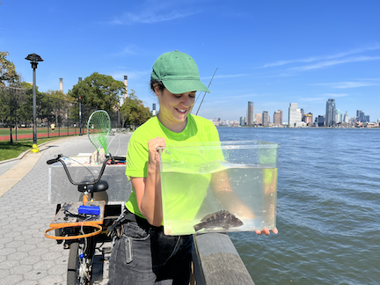
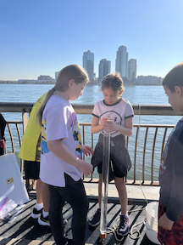 | 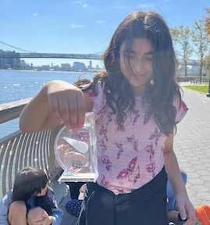 | 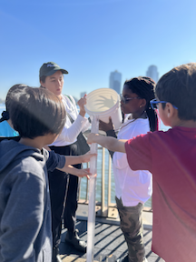

Location: East River State Park/ John V. Lindsay East River Park Promenade at East 7th St.,
Surrounding Land Use: 50% Urban/Residential, 50% Industrial/Commerce
Sampling Site: Concrete Bulkhead
Shoreline: 95% Rocky, 5% Muddy
Water: NR
River Bottom: Muddy & Rocky
Plants in the water: No Plants in the water
*NR = Not read/recorded
ITEM | Time | Reading |  |  | Comments
Physical
Air Temperature | 10:00 AM  12:47 PM | 21.7°C  29.3°C |  | 71°F  84.7°F
Wind Speed: NR |  | Anemometer |  | Beaufort | Direction
Weather today | 10:00 AM | <25% Cloud Cover |  | No Rain
Weather the past 3 days: | Mix of rain and clouds in the last few days but sampling day was clear and warm
Tides- NR | Time | Rising, Falling, Unchanged |  | Height (cm)
Current- NR | Time | Cm/sec | Knots | North/South | Ebb/Flood/Slack
Water Temperature- | 10:00 AM  12:30 PM  12:47 PM | 20°C  21°C  21°C |  | 68°F  69.8°F  69.8°F
Turbidity- Secchi Disk (cm)  Long Sight Tube (120 cm) | 10:00 AM  12:48 PM  9:45 AM | 85.3 cm  80.6 cm  85 cm
Chemical

Standardized Salinity- Refractometer |  | 23,000 ppm |  |  | 23 ppt
Student Salinity- Hydrometer | 9:45 AM  10:00 AM  12:47 PM | 22,000 ppm  22,000 ppm  21,500 ppm |  |  | 22 ppt  22 ppt  21.5 ppt
DO – Chemets Kit | Time | Temp |  |  | ppm DO | % saturation
 | 10:00 AM  10:25 AM  12:30 PM  12:55 PM | 20°C |  |  | 6 ppm  6 ppm  6 ppm  7 ppm | 65%
pH – pH Pen  Meter/Probe | 10:00 AM  12:47 PM  10:00 AM | 7.7  7.9  7.6
Biological
Fish- Rod & Reel | Number | Name |  |  | Length of longest | Notes
12:00 PM-1:15 PM | 2 | Black Seabass |  |  | 19 cm | 15.25 cm smallest
Fish Totals | TOTAL: 2 | Diversity: 1
Macroinvertebrates | Number | Name |  |  | Length of longest
Macroinvertebrate Totals | TOTAL: 0 | Diversity: 0
Sediment Core -NR | Time | Oxid Top | H₂S Smell | Oil | Grain Size | Other Features

Boats
Commercial/  Recreational | Time | Type | Color | Southbound/  Northbound | Light/  Loaded
Commercial  Commercial  Commercial  Recreational | 12:25  12:27  12:25  12:32 | Ferry  Barge  Tug Boat  Speed Boat | White & Black  Brown  White & Red  Green | Northbound  Northbound  Southbound  Northbound | Loaded  Loaded  Light  Light

