Day in the Life of the Hudson River 10/05/2023
Andrew Haskell Green Park, East River FDR N by 62nd Street, Manhattan, NY
EAST RIVER MILE: 6
Salt Front: ~ 52
Manhattan International High School-Athena Theodoris
88 students, 12th grade, 8 adults
Latitude N & Longitude –W
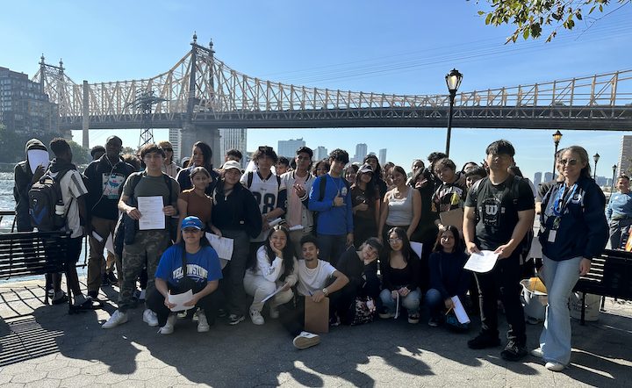
Location: John Finley Walk, Andrew Haskell Green Park, East River FDR N by 62nd Street, Manhattan, NY
Surrounding Land Use: 100% Urban/Residential
Sampling Site: Banks altered, wooden bulkhead, concrete
Shoreline: 60% Muddy
Water: 136 cm deep, Choppy
River Bottom: Muddy
Plants in the water: NR
*NR = Not read/recorded
ITEM | Time | Reading |  |  | Comments
Physical
Air Temperature | 10:54 AM | 22°C |  | 72°F
Wind Speed: | 11:00 AM  1:01 PM | Anemometer  3 mph  6 mph |  | Beaufort | Direction  South/Southeast  South/Southeast
Weather today | 10:54 AM | <25% Cloud Cover |  | No Rain
Weather the past 3 days: | Warm Temperatures
Tides- Tide Chart | Time | Rising, Falling, Unchanged |  | Height (ft)
 | 12:12 PM | Rising |  | 3.5 ft | HT @ 3:07 PM  LT @ 8:14 AM
Current- | Time | Cm/sec | Knots | North/South | Ebb/Flood/Slack
 |  | 89.6  85 | 1.74  1.65
Water Temperature- | 11:15 AM | 20.1 °C |  | 68.7°F
Turbidity- Long Sight Tube (120 cm) | 11:15 AM  NR | 76.4 cm  86.9 cm
Chemical

Student Salinity- Hydrometer | 11:00 AM | 24,000 ppm |  |  | 24 ppt
DO – Chemets Kit | Time | Temp |  |  | ppm DO | % saturation
 | 11:15 AM | 20.1°C |  |  | 7 ppm | 77%
pH – LaMotte Precision | 11:16 AM  12:00 PM | 7.5  7.5
Biological –Did not Fish
Fish | Number | Name |  |  | Length of longest | Notes
Fish Totals | TOTAL: | Diversity:
Macroinvertebrates | Number | Name |  |  | Length of longest
Macroinvertebrate Totals | TOTAL: | Diversity:
Sediment Core -unable to core this site | Time | Oxid Top | H₂S Smell | Oil | Grain Size | Other Features

Boats
Commercial/  Recreational | Time | Type | Color | Southbound/  Northbound | Light/  Loaded
Commercial  Commercial  Recreational | 1:01 PM  1:03 PM  11:55 AM |  | White  Red  White | Southbound  Southbound  Southbound | Light  Loaded  Light

