Day in the Life of the Hudson River 10/05/2023
Randall’s Island, NYC
HARLEM RIVER MILE: 1
Salt Front ~ RM52
Randall’s Island Park Alliance- John Butler & Chris Girgenti
Central Park East 2-Clarissa Lynn
22 students, 8th grade, 9 adults
Latitude 40.786015°N & Longitude –73.934763°W
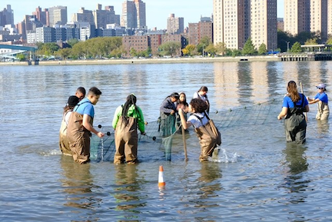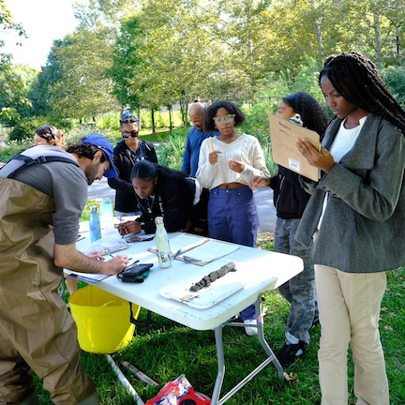
Location: Randall’s Island waterfront, NYC
Surrounding Land Use: 45% Urban/Residential, 5% Industrial/Commercial, 25% Beach, 25% Open Park
Sampling Site: Beach, Altered Banks, Pipe entering the water, grassy, covered in vegetation, Rip Rap
Shoreline: 45% Sandy, 10% Muddy & 45% Rocky
Water: Calm
River Bottom: Muddy, Sandy & Rocky
Plants in the water: No Plants in the water
*NR = Not read/recorded
ITEM | Time | Reading |  |  | Comments
Physical
Air Temperature | 10:01 AM  10:42 AM  11:29 AM | 21.17°C  23.83°C  23.83°C |  | 70.1°F  74.9°F  74.9°F
Wind Speed: | 10:02 AM | Anemometer  1.5 mph |  | Beaufort  0 | Direction  South
Weather today | 10:33 AM | <25% Cloud Cover |  | No Rain
Weather the past 3 days: | Clear and warm for early October
Tides- Tide Stick | Time | Rising, Falling, Unchanged |  | Height (cm)
 | 9:15 AM  9:58 AM  10:30 AM  11:05 AM  11:35 AM  11:50 AM | -  Rising  Rising  Rising  Rising  Rising |  | 25 cm  29 cm  36 cm  50 cm  53.5 cm  59 cm
Current- | Time | Cm/sec | Knots | North/South | Ebb/Flood/Slack
 | 10:25 AM  11:15 AM  11:20 AM  11:49 AM | 19.13  32.48  33.83  64.72 | 0.37  0.63  0.66  1.26 |  | Flood  Flood  Flood  Flood
Water Temperature- | 9:43 AM  10:20 AM  11:00 AM | 19.6°C  20.3°C  20.5°C |  | 67.3°F  68.5°F  68.9°F
Turbidity- Long Sight Tube (120 cm) | 10:20 AM  11:00 AM | 36.4 cm  24.2 cm
Chemical

Student Salinity- Meter/Probe | 9:43 AM  10:20 AM  10:55 AM | 21,700 ppm  21,700 ppm  22,200 ppm  22,400 ppm |  |  | 21.7 ppt  21.7 ppt  22.2 ppt  22.4 ppt
DO – Meter/Probe | Time | Temp |  |  | ppm DO | % saturation
 | 9:43 AM  10:20 AM  11:00 AM | 19.6°C  20°C  20.5°C |  |  | 8.47 ppm  7.9 ppm  9.35 ppm | 95%  90%  100%
pH – Color Match Test Kit  Meter/Probe | 9:43 AM  10:20 AM  11:00 AM  9:43 AM  10:20 AM  11:00 AM | 7  7  7  7.4  7.19  7
Biological
Fish- Seine (3 Hauls) | Number | Name |  |  | Length of longest | Notes
9:47 AM-11:05 AM | 104  9  1  1 | Atlantic Silverside  Menhaden  Bluefish  Tautog (Blackfish) |  |  | 8 cm  9.5 cm  11 cm  14 cm
Fish Totals | TOTAL:  115 | Diversity: 4
Macroinvertebrates | Number | Name |  |  | Length of longest
 | 2 | Blue Crab |  |  | 12 cm
Macroinvertebrate Totals | TOTAL: 2 | Diversity: 1
Sediment Core | Time | Oxid Top | H₂S Smell | Oil | Grain Size | Other Features
29 cm | 9:10 AM | No | Yes | No | Abundant: Sand  Common: Clay & Mud

Boats
Commercial/  Recreational | Time | Name | Color | Southbound/  Northbound | Light/  Loaded
Commercial  Recreational  Recreational  Recreational | 11:15  9:45  9:50  10:45 | Circle Line  NYPD  NYPD  NYPD | White  Silver  Silver  Silver | Northbound  Northbound  Southbound  Southbound | Loaded  Light  Light  Light

