Day in the Life of the Hudson River 10/05/2023
Swindler Cove, Manhattan, NYC
HARLEM RIVER MILE: 13
Hudson River Salt Front: ~RM 52
Dos Puentes-Kristen Minno-Bingham and team
NYSDEC-Chris Bowser, NYSDEC and team
New York Restoration Project – Edwards Santos and team
76 students, 5th grade, 15 adults
Latitude 40.85784°N & Longitude –73.92201°W
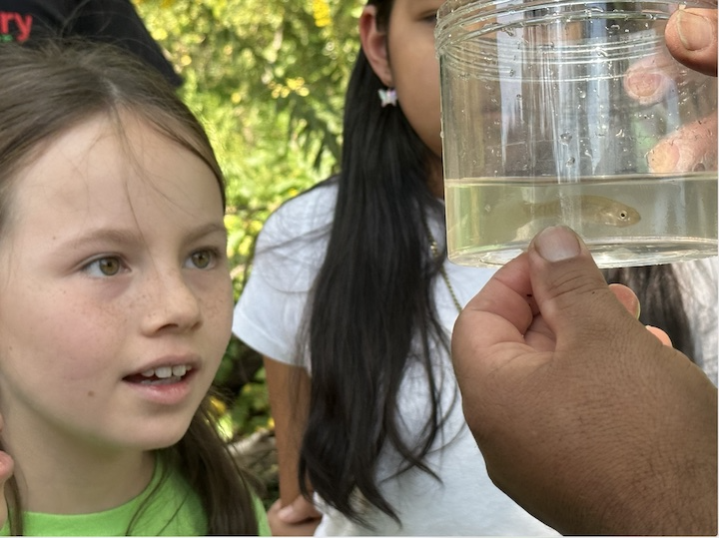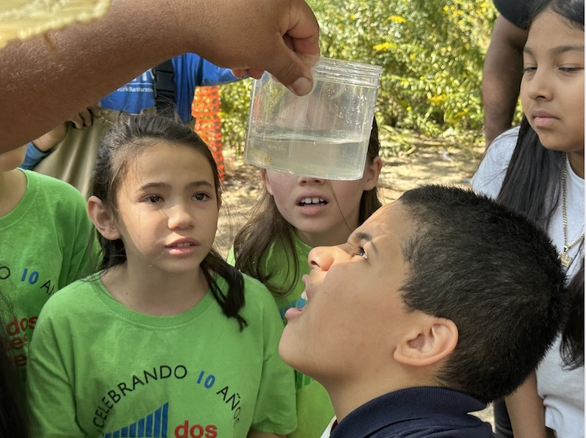

Location: Swindler Cove Park, Harlem River, Manhattan, NYC
Surrounding Land Use: 50% Beach, 50% Industrial/Commercial
Sampling Site: Sandy & muddy beach area, covered with vegetation, riprap banks
Shoreline: Sandy & Muddy
Water: NR
River Bottom: Muddy
Plants in the water: NR
*NR = Not read/recorded

ITEM | Time | Reading |  |  | Comments
Physical
Air Temperature-NR |  | °C |  | °F
Wind Speed: | 11:09 AM  11:38 AM  12:44 PM  1:00 PM | Anemometer |  | Beaufort  2  2  1  2 | Direction
Weather today-NR |  | % Cloud Cover |  | No/yes rain
Weather the past 3 days: NR
Tides- NR | Time | Rising, Falling, Unchanged |  | Height (cm)
Current- | Time | Cm/sec | Knots | North/South | Ebb/Flood/Slack
 | 10:35 AM  11:01 AM  11:32 AM  12:37 PM  1:00 PM | 400  700  800  300  600 |  |  | Ebb  Ebb  Ebb  Ebb  Ebb
Water Temperature-  NR |  | °C |  | °F
Turbidity- NR
Chemical

Standardized Salinity-NR
Student Salinity- NR
DO – NR | Time | Temp | ppm DO | % saturation
 |  | °C
pH – NR
Biological
Fish- Seine | Number | Name | Length of longest | Notes
 | >50  10  1 | Atlantic Silversides  Mummichog  Striped Bass
Fish Totals | TOTAL: 61 | Diversity: 3
Macroinvertebrates | Number | Name | Length of longest
 | 10 | Blue Crab
Macroinvertebrate Totals | TOTAL: 10 | Diversity: 1

