Day in the Life of the Hudson River 10/05/2023
New Rochelle, Neptune Island, Long Island Sound
100 Fort Slocum Rd.
Hudson River Salt Front ~RM52
International High School for Health Sciences-Mirela Shpuza-Shurdha
13 students,9th-10th grade, 2 adults
Latitude N & Longitude –W
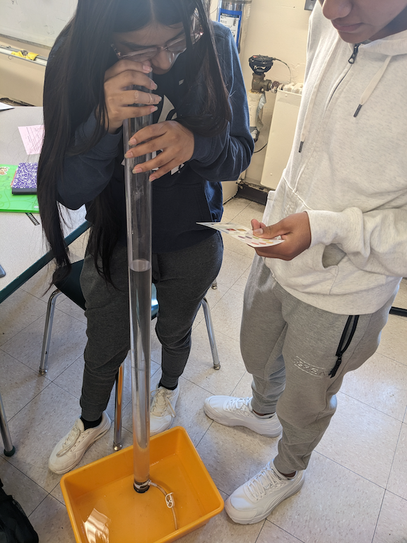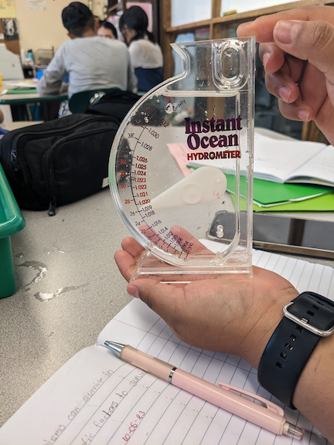
For this year since the students did not have a bus the principal brought water to the students in the AM

ITEM | Time | Reading |  |  | Comments
Physical
Air Temperature-NR |  | º C |  | º F
Wind Speed: NR |  | Anemometer |  | Beaufort | Direction
Weather today | 6:00 AM |  |  | No Rain
Weather the past 3 days: NR
Tides- NR | Time | Rising, Falling, Unchanged |  | Height (cm)
Current- NR | Time | Cm/sec | Knots | North/South | Ebb/Flood/Slack
Water Temperature- | 6:00 AM | 20°C |  | 68°F
Turbidity- Long Sight Tube (120 cm) | 6:00 AM | 120 cm
Chemical

Student Salinity- Hydrometer | 6:00 AM | 26,000 ppm |  |  | 26 ppt
DO – NR | Time | Temp |  |  | ppm DO | % saturation
pH – Color Match Kit | 6:00 AM | 7
Biological-Did not Fish
Fish | Number | Name |  |  | Length of longest | Notes
Fish Totals | TOTAL: | Diversity:
Macroinvertebrates | Number | Name |  |  | Length of longest
Macroinvertebrate Totals | TOTAL: | Diversity:
Sediment Core | Time | Oxid Top | H₂S Smell | Oil | Grain Size | Other Features

Boats-NR
Commercial/  Recreational | Time | Name | Color | Southbound/  Northbound | Light/Loaded

