Day in the Life of the Hudson River 10/05/2023
Schoharie Creek, Middleburgh, NY
MOHAWK RIVER MILE: 53
Hudson River Salt Front ~RM 52
Middleburgh Jr/Sr Highschool -Mollie Burgett
Stamford DEC- Scott Wells
5 students, 12th grade, 2 adults
Latitude 42.82672 °N & Longitude –74.26272 °W
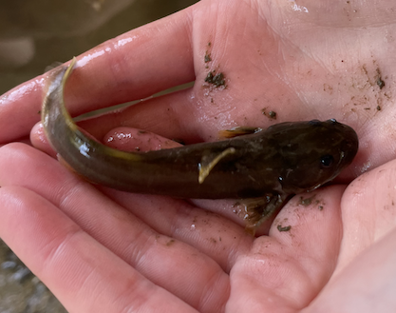
Location: Schoharie Creek, Middleburgh, NY
Surrounding Land Use: 50% Industrial & 50% Forested
Sampling Site: Covered in vegetation, Ripraps (large rocks) and a pipe entering into the water
Shoreline: 25% Muddy & 75% Rocky
Water: Calm with light riffles
River Bottom: Muddy & Rocky
Plants in the water: 15% of plants growing in water
*NR = Not read/recorded
ITEM | Time | Reading |  |  | Comments
Physical
Air Temperature | 9:42 AM  12:00 PM | 13 º C  25º C |  | 55 º F  77 º F
Wind Speed: | 9:45 AM | Anemometer  4-6 knots |  | Beaufort  2 | Direction  NR
Weather today | 10:30 AM | 26-50% Cloud Cover |  | No rain
Weather the past 3 days: | Cloudy Foggy mornings, with light fog, warmer temperature in afternoon
Tides- NA above the head of tide | Time | Rising, Falling, Unchanged |  | Height (cm)
Current- | Time | Cm/sec | Knots | North/South | Ebb/Flood/Slack
 |  | 17.27  23.10  23.73 |  |  | N/A
Water Temperature- NR
Turbidity- Short Sight Tube (cm) | 11:00 AM | *60 cm |  | *This would be at the limit of the tube so >60 cm visibility
Chemical

Standardized Salinity- Low Range Quantabs | 9:30 AM | Below Detection
DO – Lamotte Drop Count Kit | Time | Temp | ppm DO | % saturation
 | 12:06 PM | 26°C | *2 ppm (expect reagent failure) | NR
pH – Test Strips | 11:00 AM | 7
Nitrates- Freshwater Test Kit | 11:00 AM | 0 ppm
Phosphate-Drop Count Kit | 11:00 AM | 0 ppm
Biological
Fish- Electroshocking | Number | Name | Length of longest | Notes
 | 6  2  1  8  31  25 | Fathead Minnow  Fallfish  Brown Bullhead  Rainbow Darter  Fantail Darter  Tessellated Darter | 8 cm  22 cm  10 cm  7.5 cm  5.3 cm  6 cm
Fish Totals | TOTAL: 73 | Diversity: 6
Macroinvertebrates | Number | Name | Length of longest
 | 10  75  1  11 | Dobsonfly  Mayfly nymph  Stonefly nymph  Caddisfly larvae
Macroinvertebrate Totals | TOTAL: 97 | Diversity: 4
Sediment Core | Time | Oxid Top | Grain Size | Other Features
 | NR | NR | Abundant: Mud Common: Clay & Pebbles  Rare: Sand & Gravel | Abundant: Macroinvertebrates & Living Vegetation  Common: Leaves & Wood  Rare: Brick

Boats-NR
Commercial/Recreational | Time | Name | Color | Southbound/Northbound | Light/Loaded

