Day in the Life of the Hudson River 10/05/2023
Bush Terminal Park, Brookyln, NY
RIVER MILE: -3.7
Salt Front: ~ RM 52
Sunset Park High School-Katie McCarthy
Billion Oyster Project-Shinara Sunderlal
48 students, 11th grade, 11 adults
Latitude 40.654525°N & Longitude –74.018978°W
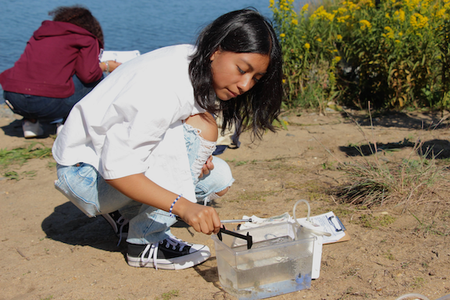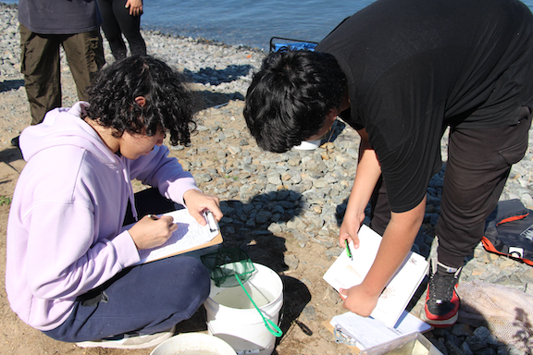
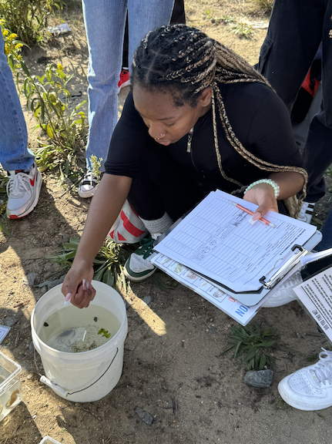
Location: Bush Terminal Park, Brooklyn, NY. East side of the Hudson River, NY Harbor
Area: Old industrial waterfront area surrounding a small marshy bay with a rocky shoreline, by the water, with grassy hills in Bush Terminal Park.
Surrounding Land Use: 80% Abandoned Industrial, 20% reestablishing park use
Sampling Site: RipRap/rocky shoreline
Shoreline: 50% concrete/asphalt; 20% dirt/gravel; 30% grass/trees
*NR = Not read/recorded

ITEM | Time | Reading |  |  | Comments
Physical
Air Temperature | 10:08 AM  11:00 AM | 22.8°C  21.7°C |  | 70°F  70.7°F
Wind Speed: | 10:08 AM  10:30 AM  NR  11:00 AM | Anemometer  3 mph  3-6 mph  4 mph  3 mph |  | Beaufort | Direction  South  Southeast  Southeast
Weather today | 11:00 AM | <25% Cloud Cover |  | No Rain
Weather the past 3 days: | No Rain, high 70s
Tides- | Time | Rising, Falling, Unchanged |  | Height (cm)
HT @ 1:44 PM
LT @ 7:14 AM
Current- NR | Time | Cm/sec | Knots | North/South | Ebb/Flood/Slack
Water Temperature- | 12:47 PM  11:11 AM  NR | 24°C  21.7°C  21.7°C |  | 75.3°F  71°F  71°F
Turbidity- Long Sight Tube (120 cm) | NR  10:32 AM  11:09 AM | 75.4 cm  93 cm  96.4 cm
Chemical

Standardized Salinity- Refractometer | 11:30 AM | 20,000 ppm |  |  | 20 ppt
Student Salinity- Hydrometer  Refractometer | 10:08 AM  10:30 AM  11:00 AM  10:08 AM | 24,500 ppm  23,000 ppm  23,000 ppm  24,500 ppm |  |  | 24.5 ppt  23 ppt  23 ppt  24.5 ppt
DO – Chemets Kit | Time | Temp |  |  | ppm DO | % saturation
 | 10:08 AM  10:22 AM  10:54 AM | 21°C  21.7°C |  |  | 10 ppm  8 ppm  8 ppm | 96%
pH – Color Match Test Kit | 10:58 AM  12:54 PM  NR | 7.5  7.5  7.5
Nitrates- Test Kit | 10:33 AM  11:04 AM  12:58 PM | 0 ppm  0 ppm  5 ppm
Biological
Fish-Seine (1 Haul) | Number | Name |  |  | Length of longest | Notes
10:00 AM | 1  20  1  1  1 | Striped Killifish  Atlantic Silverside  Lined Seahorse  Naked Goby  Winter Flounder |  |  | 3 cm  15 cm  8.2 cm  3 cm  8 cm | Male
Fish Totals | TOTAL: 24 | Diversity: 5
Macroinvertebrates | Number | Name |  |  | Length of longest
 | 7  5  15 | Blue Crab  Hermit Crab  Eastern Mud Snail |  |  | 10 cm  5 cm  2 cm
Macroinvertebrate Totals | TOTAL: 27 | Diversity: 3
Sediment Core -NR | Time | Oxid Top | H₂S Smell | Oil | Grain Size | Other Features

Boats
Commercial/  Recreational | Time | Type | Color | Southbound/  Northbound | Light/  Loaded
Commercial  Commercial  Commercial  Recreational  Commercial  Recreational  NR  Commercial  Commercial  Recreational  Commercial  Commercial  Recreational | 10:10  10:10  10:20  10:20  11:13  11:15  11:18  11:20  12:42  12:43  12:44  12:44  12:45 | Cargo  Ferry  Ferry  Sailboat  Cargo  Fishing Boat  -  Ferry  Water Taxi  Motorboat  Tug Boat  Tug Boat  Sailboat | Brown/Orange  Orange  White  White  Red  Grey  Blue  Yellow  Yellow  White  Light Blue  White  White | Northbound  Northbound  Northbound  Northbound  West/Southbound  West/Southbound  West/Southbound  West/Southbound  Northbound  -  Southbound  Southbound  Northbound

