Day in the Life of the Hudson River 10/05/2023
Jamaica Bay, Rockaways, Queens
Riis Landing (Gateway National Recreation Area
RIVER MILE: -3.78
Salt Front: ~ RM52
Scholars Academy-Melissa Redden
NYS DEC - Ron Gelardi
100 students, 7th grade, 9 adults
Latitude 40.5684°N & Longitude 73.8844°W
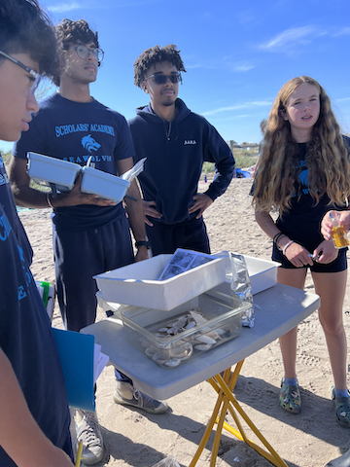 | 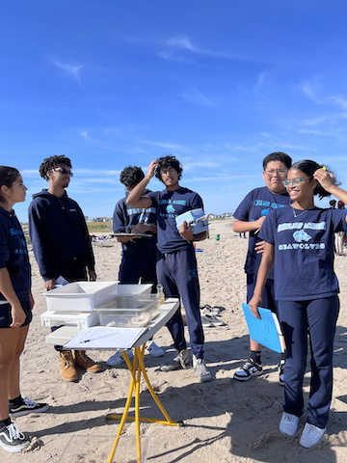 | 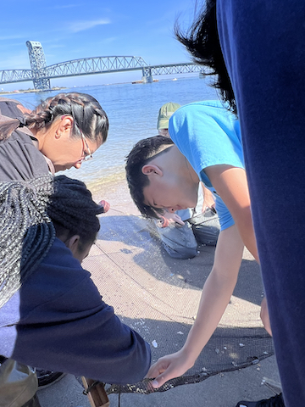

Location: Riis Landing, Beach 169th St & Beach Channel Drive, Jamaica Bay, Rockaways, Queens, NY
Surrounding Land Use: Coastguard Station in Roxbury, under the Marine Park Bridge on the Rockaway Side.
Sampling Site: Area is a kayak launch, beach area
Shoreline Sandy beach
Water
River Bottom:
Plants in the water:
*NR = Not read/recorded
ITEM | Time | Reading |  |  | Comments
Physical
Air Temperature | 11:22 AM | 27°C |  | 80.6°F
Wind Speed: | 11:23 AM | Anemometer  0.53 m/s |  | Beaufort | Direction  East
Weather today | 11:40 AM | <25% Cloud Cover |  | No Rain
Weather the past 3 days: | Clear, No Rain
Tides- NR | Time | Rising, Falling, Unchanged |  | Height (cm)
Current- NR | Time | Cm/sec | Knots | North/South | Ebb/Flood/Slack
Water Temperature- | 11:40 AM | 21°C |  | 71°F
Turbidity- Long Sight Tube (120 cm) | 11:22 AM | 73.67 cm
Chemical

Student Salinity- Hydrometer | 11:42 AM | 30,000 ppm |  |  | 30 ppt
DO – Hach Drop Count Kit | Time | Temp |  |  | ppm DO | % saturation
 | 11:30 AM | 21°C |  |  | 8 ppm | 70%
pH – Color Match Kit | 11:47 AM | 7.5
Biological
Fish-Seine (6 Hauls) | Number | Name |  |  | Length of longest | Notes
11:00 AM | 4 | Atlantic Silverside |  |  | 5 cm
Fish Totals | TOTAL: 4 | Diversity: 1
Macroinvertebrates | Number | Name |  |  | Length of longest
 | 9  2 | Hermit Crab  Ctenophore spp. |  |  | 2.3 cm  3.1 cm
Macroinvertebrate Totals | TOTAL: 11 | Diversity: 2
Sediment Core | Time | Oxid Top | H₂S Smell | Oil | Grain Size | Other Features
10 cm |  | No | No | No | Abundant: Sand | Abundant: Shells

Boats-NR
Commercial/  Recreational | Time | Type | Color | Southbound/  Northbound | Light/  Loaded

