Day in the Life of the Hudson River 10/05/2023
Pier 1 Lighthouse Museum, Staten Island, NY
RIVER MILE: -4.5
Salt Front: ~ 52
Curtis High School-Edita O’Brien & Dave Scheffler
64 students, 10th-12th grade, 4 adults
Latitude 40.640951°N & Longitude –74.073463°W
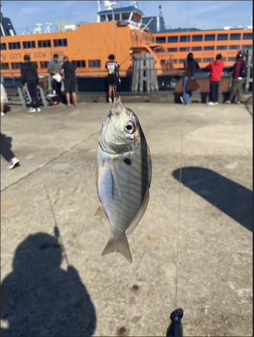
Scup (Porgy) caught rod & reel

Location: Pier 1 Light House Museum, Staten Island Pier, Staten Island, NY
Surrounding Land Use: 50% Urban/Residential, 50% Industrial/Commercial
Sampling Site: Pier, Wood Bulkhead, Rip Rap, Parking Lot, Grassy
Shoreline: Rocky
Water: Calm, Depth around 200 cm
River Bottom: Muddy& Weedy
Plants in the water: No Plants in the water
*NR = Not read/recorded

ITEM | Time | Reading |  |  | Comments
Physical
Air Temperature | 10:20 AM | 24°C |  | 75.2°F
Wind Speed: NR |  | Anemometer |  | Beaufort | Direction
Weather today | 10:00 AM | <25% Cloud Cover |  | No Rain
Weather the past 3 days: | Cloudy & Rainy for past 3 days
Tides- NR | Time | Rising, Falling, Unchanged |  | Height (cm)
Current- NR | Time | Cm/sec | Knots | North/South | Ebb/Flood/Slack
Water Temperature- | 9:24 AM  9:49 AM  12:13 PM  12:14 PM  12:24 PM | 22°C  21°C  21°C  21°C  21.5°C |  | 71.6°F  69.8°F  69.8°F  69.8°F  70.7°F
Turbidity- Long Sight Tube (120 cm) |  | 55 cm
Chemical

Student Salinity- Hydrometer | 9:29 AM  9:32 AM  9:35 AM  12:29 PM | 17,000 ppm  18,000 ppm  17,000 ppm  17,667 ppm |  |  | 17 ppt  18 ppt  17 ppt  17.7 ppt | Each reading is an average of 3
DO - | Time | Temp |  |  | ppm DO | % saturation
Hach Drop Count Kit  Meter/Probe | 9:20 AM  12:35 PM  9:40 AM | 21°C  21.5°C  22°C |  |  | 7.2 ppm  7.8 ppm  11 ppm | 85%  85%  125%
pH –  *test strips do not work well in a marine environment | 9:25 AM  12:39 PM | Color Match Kit  7.5  7 |  |  | 9:25 AM  12:35 PM | *Test Strips  5  4.7
Nitrates- | 9:47 AM | 0 ppm
Phosphates-Test Stripes | 9:47 AM | 30 ppm* |  |  |  | *Misread/Issue with equipment
Biological
Fish- Rod & Reel | Number | Name |  |  | Length of longest | Notes
9:30 AM-2:00 PM | 1  30  6 | Striped Bass  Tautog (Blackfish)  Porgy (Scup) |  |  | 40 cm  29 cm  22 cm
Fish Totals | TOTAL: 37 | Diversity: 3
Macroinvertebrates | Number | Name |  |  | Length of longest
 | 3  1  1 | European Sea Squirt  Chain Tunicates  Red Sponge |  |  | 1.5 cm  2.3 cm
Macroinvertebrate Totals | TOTAL: 5 | Diversity: 3
Sediment Core -NR | Time | Oxid Top | H₂S Smell | Oil | Grain Size | Other Features

Boats
Commercial/  Recreational | Time | Name | Color | Southbound/  Northbound | Light/  Loaded
Commercial  Commercial  Commercial  Recreational  Commercial  Commercial  Commercial  Commercial  Commercial  Recreational | 9:22  9:23  9:33  9:35  -  -  9:21  9:51  9:30  9:53 | Grim  Staten Island  One  Speed Boat  Grima lot  One  -  -  SI Ferry  - | Blue & White  Orange  Red  Grey  Green & White  Pink  Blue & Red  Blue  Orange  White & Grey | -  Southbound  Southbound  Northbound  Northbound  Southbound  Southbound  Southbound  Northbound  Northbound | Light  Light  Loaded  Light  Loaded  Loaded  Loaded  Light  Light  Light

