Day in the Life of the Hudson River 10/05/2023
Canarsie Pier-Gateway National Rec Area, Jamaica Bay, Brooklyn, NY
RIVER MILE: -5.3
Salt Front: ~ 52
P2G @ LAGCC-Julie Vattamala
10 students, 12th grade, 5 adults
Latitude 40.62927°N & Longitude –73.88449°W
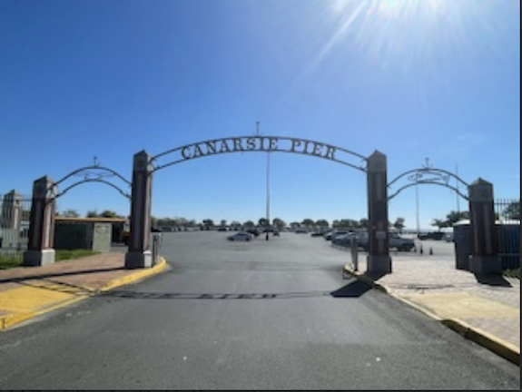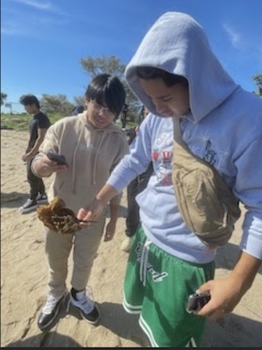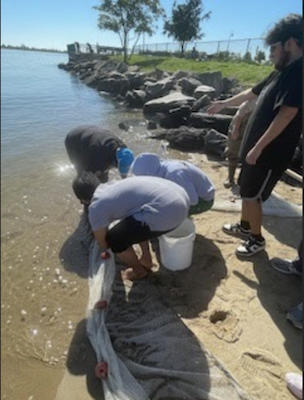
Location: Jamaica Bay, Canarsie Pier, Brooklyn, NY
Surrounding Land Use: 10% Beach, 40% Park, 40% Parking lot, 10% Grassy Area, Belt Parkway
Sampling Site: Concrete Pier, Beach covered with vegetation, Parking lot, Pipe entering the water
Shoreline: 90% Sandy & 10% Rocky
Water: Calm
River Bottom: Sandy
Plants in the water: No Plants in the water
*NR = Not read/recorded

ITEM | Time | Reading |  |  | Comments
Physical
Air Temperature | 11:20 AM  12:00 PM | 25.5°C  26.1°C |  | 77.9°F  79°F
Wind Speed: | 11:45 AM | Anemometer  0.9 m/s |  | Beaufort | Direction
Weather today | 11:30 AM | <25% Cloud Cover |  | No Rain
Weather the past 3 days: | There has been no rain and it has been sunny and hot
Tides- NR | Time | Rising, Falling, Unchanged |  | Height (cm)
Current- NR | Time | Cm/sec | Knots | North/South | Ebb/Flood/Slack
Water Temperature- | 11:30 AM | 21°C |  | 69.8°F
Turbidity- Long Sight Tube (120 cm) | 12:00 PM | 78 cm
Chemical

Standardized Salinity- Refractometer | 12:30 PM | 29,000 ppm |  |  | 29 ppt
Student Salinity- Hydrometer | 12:00 PM | 28,000 ppm |  |  | 28 ppt
DO – Hach Drop Count Kit | Time | Temp |  |  | ppm DO | % saturation
 | 12:15 PM | 21°C |  |  | 8 ppm | 90%
pH – NR
Biological
Fish- Seine (3 Hauls) | Number | Name |  |  | Length of longest | Notes
11:30 AM-12:00 PM | 105 | Atlantic Silverside |  |  | 12 cm
Fish Totals | TOTAL:  105 | Diversity: 1
Macroinvertebrates | Number | Name |  |  | Length of longest
 | Several  Several  Several | Mud snails  Hermit Crabs  Moon Jellies
Macroinvertebrate Totals | TOTAL: | Diversity: 3
Sediment Core | Time | Oxid Top | H₂S Smell | Oil | Grain Size | Other Features
14 cm | 12:15 PM | No | No | No | Abundant: Sand  Rare: Gravel | Common: Oyster Shells Rare: Coal

Boats- None Seen
Commercial/  Recreational | Time | Name | Color | Southbound/  Northbound | Light/  Loaded

