Day in the Life of the Hudson River 10/05/2023
Fort Wadsworth Beach, Staten Island, NY
RIVER MILE: -7.5
Salt Front: ~ 52
St. Clare School-Mary Lee
National Parks Service-Kathy Garofalo
DEP-Rob Brauman
60 students, 7th grade, 14 adults
Latitude 40.59905° N & Longitude –74.0527°W
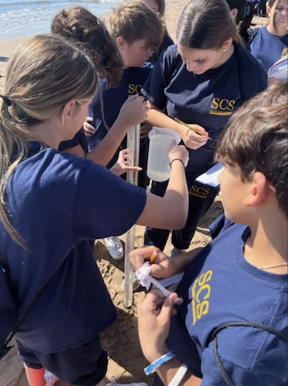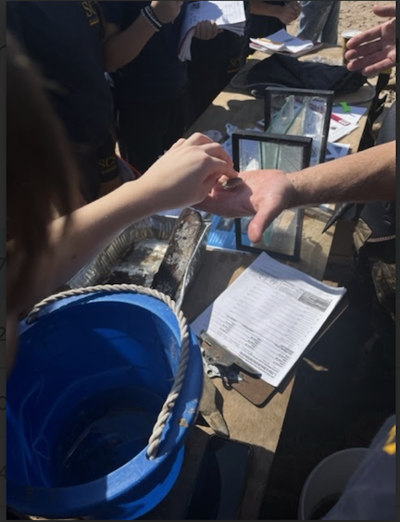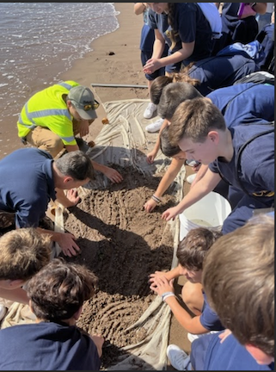
Location: Fort Wadsworth Beach, Staten Island, NY
Surrounding Land Use: 65% Beach, 35% Forested
Sampling Site: Forested, Grassy, Rip Rap, Wood Bulkhead
Shoreline: 90% Sandy & 10% Rocky
Water: Calm
River Bottom: Muddy, Sandy & Rocky
Plants in the water: No Plants in the water
*NR = Not read/recorded

ITEM | Time | Reading |  |  | Comments
Physical
Air Temperature | 11:00 AM | 23°C |  | 73.4°F
Wind Speed: | 11:00 AM  11:50 AM | Anemometer  5 mph  10 mph |  | Beaufort | Direction  Northwest
Weather today | 11:00 AM | <20% Cloud Cover |  | No Rain
Weather the past 3 days: | It was between 60-70 degrees Fahrenheit. It was clear those days (following some bout with rain prior to that)
Tides- Tide Stick | Time | Rising, Falling, Unchanged |  | Height (cm)
 | 10:56 AM  11:39 AM  11:54 AM | -  Rising  Falling |  | 80 cm  92 cm  65 cm
Current- | Time | Cm/sec | Knots | North/South | Ebb/Flood/Slack
 | 11:28 AM  11:42 AM  11:58 AM  NR | 3.6  0.42  3.7  0.08 | 0.07  0.008  0.072  0.002 |  | Flood  Ebb* should all be flooding  Flood
Water Temperature- | 11:00 AM | 20°C |  | 68°F
Turbidity- Long Sight Tube (120 cm) | 10:48 AM | 27 cm
Chemical

Standardized Salinity- Refractometer | 12:05 PM | 25,000 ppm |  |  | 25 ppt
Student Salinity- Hydrometer | 11:11 AM | 23,000 ppm |  |  | 23 ppt
DO – Chemets Kit | Time | Temp |  |  | ppm DO | % saturation
 | 11:05 AM | 20°C  19°C |  |  | 9 ppm  8.5 ppm | 100%  92%
pH – Color Match Kit | 11:18 AM | 8
Nitrates- Color Match Test Kit | 11:17 AM | 0 ppm
Phosphate- Color Match Test Kit | 11:17 AM | 0.5 ppm
Ammonia | 11:18 AM | 0.25 ppm
Biological
Fish- Seine (5 Hauls) | Number | Name |  |  | Length of longest | Notes
10:45 AM-12:00 PM | 1  1  17 | Summer Flounder  Atlantic Menhaden  Atlantic Silverside |  |  | 7 cm  4.5 cm  9 cm
Fish Totals | TOTAL: 19 | Diversity: 3
Macroinvertebrates | Number | Name |  |  | Length of longest
 | 92  1 | Mole Crab  Asian Shore Crab |  |  | 3 cm  7 cm
Macroinvertebrate Totals | TOTAL: 93 | Diversity: 2
Sediment Core | Time | Oxid Top | H₂S Smell | Oil | Grain Size | Other Features
25 cm | 10:56 AM | No | No | No | Abundant: Sand  Common: Mud & Gravel  Rare: Pebbles | Common: Coal

Boats
Commercial/  Recreational | Time | Type | Color | Southbound/  Northbound | Light/  Loaded
Recreational  Recreational  Recreational | 11:30  11:31  11:36 | Speed Boat  Spped Boat  Yacht | White/Blue  Red  White | Southbound  Northbound  Northbound | Light  Light  Loaded

