Day in the Life of the Hudson River 10/05/2023
Coney Island Steeplechase Pier, Coney Island, NY
RIVER MILE: -9.1
Salt Front: ~ 52
IS 240-Deborah Sarria
90 students, 6th grade, 10 adults
Latitude 40.571754°N & Longitude –73.983712°W
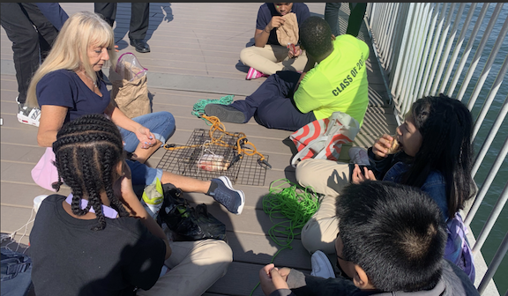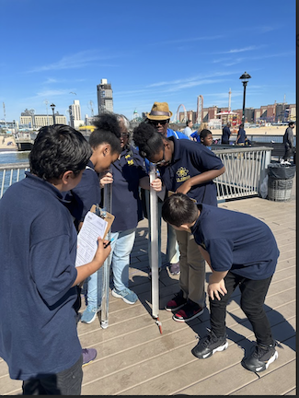
Location: Steeplechase Pier, Coney Island, Brooklyn, NY
Surrounding Land Use: 15% Urban/Residential, 15% Industrial/Commercial, 70% Beach
Sampling Site: Pier, Beach
Shoreline: 100% Sandy
Water: Calm
River Bottom: Sandy
Plants in the water: No Plants in the water
*NR = Not read/recorded

ITEM | Time | Reading |  |  | Comments
Physical
Air Temperature | 11:35 AM  11:42 AM  11:53 AM | 32°C  29.5°C  30.6°C  30.5°C |  | 89.6°F  85.1°F  87°F  86.9°F
Wind Speed: | 11:32 AM | Anemometer  0.9 mph |  | Beaufort  0 | Direction  South
Weather today | 11:35 AM | <25% Cloud Cover |  | No Rain
Weather the past 3 days: | Clear, warm
Tides- Dock to water | Time | Rising, Falling, Unchanged |  | Height (cm)
 | 11:30 AM  12:00 PM  12:30 PM | -  Rising  Falling |  | 490 cm  445 cm  475 cm
Current- NR | Time | Cm/sec | Knots | North/South | Ebb/Flood/Slack
Water Temperature- | 11:35 AM | 19.85°C  19.55°C  19.7°C |  | 67.7°F  67.2°F  67.5°F
Turbidity- Long Sight Tube (120 cm) | 11:25 AM  12:30 PM | 116.5 cm  120 cm
Chemical

Standardized Salinity- Refractometer | 12:12 PM | 30,000 ppm |  |  | 30 ppt
Student Salinity- Hydrometer | 11:35 AM  11:50 AM  12:12 PM | 26,000 ppm  26,700 ppm  24,700 ppm |  |  | 26 ppt  26.7 ppt  24.7 ppt
DO – NR | Time | Temp |  |  | ppm DO | % saturation
pH – Color Match Kit | 12:16 PM | 7
Biological
Fish-Traps | Number | Name |  |  | Length of longest | Notes
*Did not catch anything
Fish Totals | TOTAL: 0 | Diversity: 0
Macroinvertebrates | Number | Name |  |  | Length of longest
Macroinvertebrate Totals | TOTAL: 0 | Diversity: 0
Sediment Core -NR | Time | Oxid Top | H₂S Smell | Oil | Grain Size | Other Features

Boats
Commercial/  Recreational | Time | Type | Color | Direction | Light/  Loaded
Commercial  Commercial  Commercial  Recreational | 11:38  11:45  12:30  11:48 | Ferry  Barge  Ferry  Jet Ski | Blue/White  Black  Blue/White | Eastbound  Eastbound  Westbound  Westbound | Loaded  Loaded  Light

