Day in the Life of the Hudson River 10/05/2023
Morris Canal Basin, Jersey City, NJ
RIVER MILE: 0.5
Salt Front: ~ 52
Hudson Montessori School-Grace Sanvictores & team
Liberty State Park NJDEP- Ray Baylon & Sarajane Bruno
58 students, 1st-8th grade, 9 adults
Latitude 40.707725°N & Longitude –74.03447°W
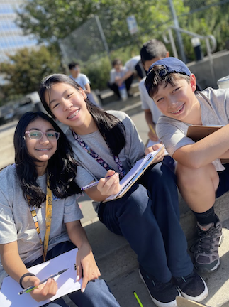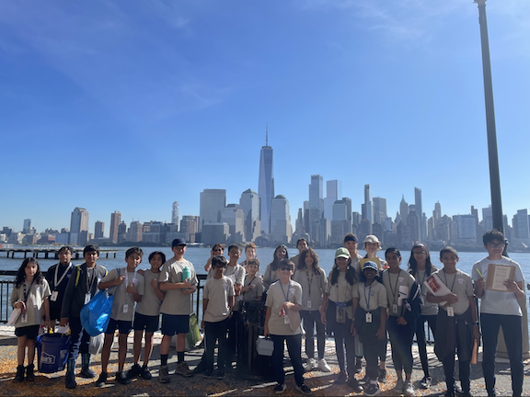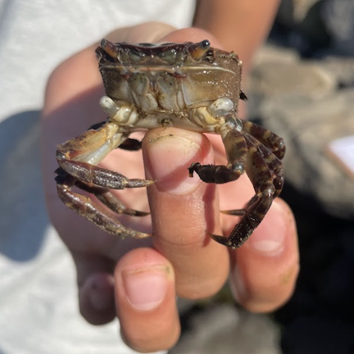
Location: Morris Canal Basin, Jersey City, NJ
Surrounding Land Use: Urban/Residential, Industrial/Commercial
Sampling Site: Pier, Rip Rap, Concrete Bulkhead
Shoreline: Sandy & Rocky
Water: Calm
River Bottom: Muddy & Sandy
Plants in the water: No Plants in the water
*NR = Not read/recorded
ITEM | Time | Reading |  |  | Comments
Physical
Air Temperature | 11:00 AM | 24°C |  | 75°F
Wind Speed: | 11:00 AM | Anemometer  6 mph |  | Beaufort  1 | Direction  South
Weather today | 11:00 AM | <25% Cloud Cover |  | No Rain
Weather the past 3 days: | Average of 80s, clear skies, warmer temperatures at this time of the year
Tides- Dock to water | Time | Rising, Falling, Unchanged |  | Height (cm)
 | 10:20 AM-10:35 AM | Rising |  | 106.68 cm  121 cm
Current- | Time | Cm/sec | Knots | North/South | Ebb/Flood/Slack
 | 11:05 AM | 7 | 0.15 |  | Ebb
Water Temperature- | 10:15 AM  NR  NR  NR | 22°C  25°C  25°C  24.5°C |  | 71.3°F  77°F  77°F  76°F
Turbidity- Secchi Disk (cm) | 11:00 AM | 80 cm  75 cm
Chemical

Standardized Salinity-Refractometer | 11:00 AM | 11,000 ppm |  |  | 11 ppt
Student Salinity-  Refractometer/Hydrometer | 10:10 AM  10:12 AM  10:15 AM | 12,000 ppm  12,000 ppm  11,000 ppm |  |  | 12 ppt  12 ppt  11 ppt
DO – Hach Drop Count Kit | Time | Temp |  |  | ppm DO | % saturation
 | 10:20 AM | 22°C |  |  | 9 ppm | 110%
pH – Color Match Test Kit | 11:00 AM | 7.8
Biological
Fish-Traps | Number | Name |  |  | Length of longest | Notes
Fish Totals | TOTAL: 0 | Diversity: 0
Macroinvertebrates | Number | Name |  |  | Length of longest
9:30-11:30 AM | 9  1 | Asian Shore Crabs  Blue Crab |  |  | 6 cm  15.24 cm
Macroinvertebrate Totals | TOTAL: 10 | Diversity: 2
Sediment Core -NR | Time | Oxid Top | H₂S Smell | Oil | Grain Size | Other Features

Boats
Commercial/  Recreational | Time | Type | Color | Southbound/  Northbound | Light/  Loaded
Commercial  Recreational  Recreational | 10:15  10:00  10:30 | Ferry  Ferry | Black & White  Yellow  Yellow | Eastbound  Southbound  Northbound | Loaded  Loaded  Loaded

