Day in the Life of the Hudson River 10/05/2023
The Baylander @ W 125th St, NYC
RIVER MILE: 10
Salt Front: ~ 52
P.S. 36-Shari Fine
The Baylander- Scott Koen
14 students, 5th grade, 2 adults
Latitude 40.819303°N & Longitude –73.961445°W
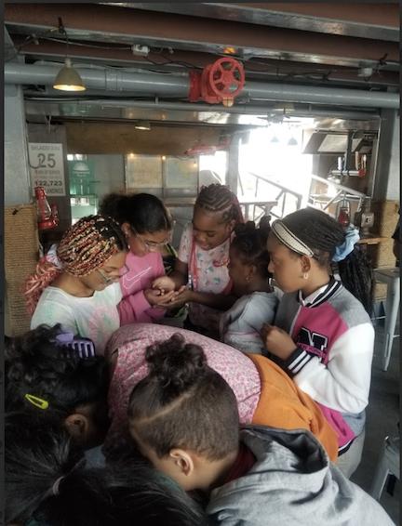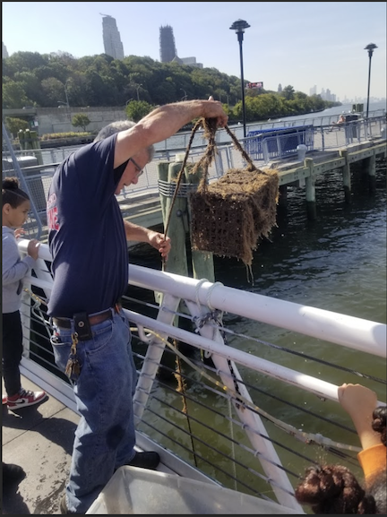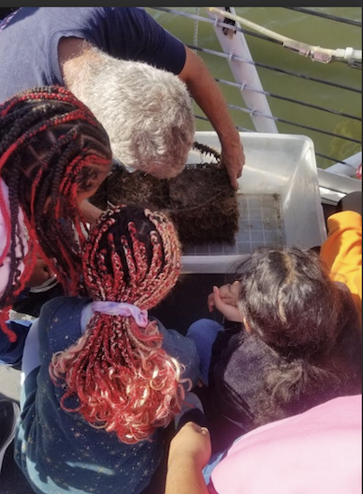
Location: The Baylander (125th St Pier) @ W 125th St, NYC
Surrounding Land Use: 100% Urban/Residential
Sampling Site: Pier, Pipe entering the water
Shoreline: 20% Muddy & 80% Rocky
Water: Calm
River Bottom: NR
Plants in the water: No Plants in the water
*NR = Not read/recorded

ITEM | Time | Reading |  |  | Comments
Physical
Air Temperature | 10:16 AM  10:27 AM  10:45 AM | 26°C  19°C  20°C |  | 78.8°F  66.2°F  68°F
Wind Speed: | 10:16 AM  10:36 AM  10:56 AM | Anemometer  3.4 knots  3.6 knots  3.1 knots |  | Beaufort  #2 | Direction  South  South  South
Weather today | 10:01 AM | 26-50% Cloud Cover |  | No Rain
Weather the past 3 days: | No rain, warmer than normal
Tides- NR | Time | Rising, Falling, Unchanged |  | Height (cm)
Current- NR | Time | Cm/sec | Knots | North/South | Ebb/Flood/Slack
Water Temperature- | 10:06 AM | 19°C |  | 66.2°F
Turbidity- Secchi Disk (cm) | 10:00 AM  10:24 AM  10:45 AM | 115.57 cm  125.1 cm  139.07 cm |  | Avg of all measurements: 124.97 cm
Chemical

Standardized Salinity- High Range Quantabs – 8.0 QT units | 10:08 AM | 6,670 ppm total salinity |  |  | 6.7 ppt TS | 3692 ppm Cl-
Student Salinity- Hydrometer | 9:48 AM  9:50 AM  9:53 AM  10:24 AM  10:27 AM  10:30 AM  10:45 AM  10:48 AM  10:51 AM | 13,700 ppm  13,300 ppm  6,700 ppm  12,000 ppm  15,700 ppm  12,300 ppm  13,300 ppm  16,300 ppm  8,600 ppm |  |  | 13.7 ppt  13.3 ppt  6.7 ppt  12 ppt  15.7 ppt  12.3 ppt  13.3 ppt  16.3 ppt  8.6 ppt | Avg of all salinities: 12.7 ppt or 12,700 ppm
DO – Lamotte Drop Count Kit | Time | Temp |  |  | ppm DO | % saturation
 | 10:15 AM  10:30 AM  10:50 AM | 19°C  19°C  20°C |  |  | 8 ppm  8 ppm  9 ppm | 84%  84%
pH – Color Match Kit | 10:36 AM | 8
Biological – oyster cages
Fish | Number | Name |  |  | Length of longest | Notes
Fish Totals | TOTAL: 0 | Diversity: 0
Macroinvertebrates- Oyster Cage | Number | Name |  |  | Length of longest
10:00-10:30 AM | NR | Harris Mud Crabs  Blue Crabs  Palaemonetes Shrimp  Isopods
Macroinvertebrate Totals | TOTAL:  NR | Diversity: 4
Sediment Core -NA | Time | Oxid Top | H₂S Smell | Oil | Grain Size | Other Features

Boats
Commercial/  Recreational | Time | Type | Color | Southbound/  Northbound | Light/  Loaded
Commercial  Recreational  Recreational  Recreational  Recreational | 10:10  10:11  10:32  10:36  11:00 | NYC Rockaway  Sailboat  Yacht  Sailboat  Sailboat | Gray  White  White  White/Black  White w/ Black stripe | Northbound  Southbound  Northbound  Northbound  Northbound | Loaded  Light  Light  Light  Light

