Day in the Life of the Hudson River 10/05/2023
Henry Hudson Riverfront Park, Columbia County, NY
RIVER MILE: 117
Salt Front: ~ RM 52
Chatham High School-Sandra Fischer
Cary Institute of Ecosystem Studies- Ashley Alred
32 students, 11th & 12th grade, 4 adults
Latitude 42.25369°N & Longitude –73.79935°W
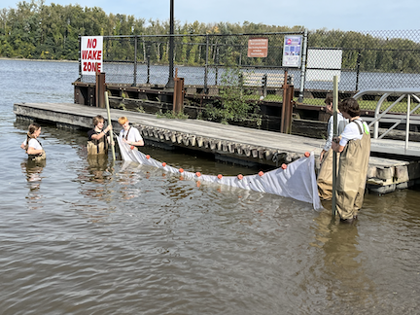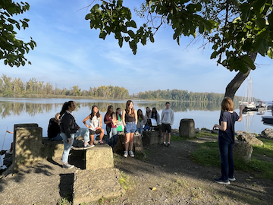
Location: Henry Hudson Riverfront Park, City of Hudson, Columbia County, NY
Surrounding Land Use: 100% Industrial/Commerical
Sampling Site: Waterfront with banks altered to include wooden & concrete bulkheads and large riprap on shoreline.
Shoreline: 100% Rocky
Water: Calm
River Bottom: 100% Rocky
Plants in the water: 5% Water Chestnuts & 5% Duckweed
*NR = Not read/recorded
ITEM | Time | Reading |  |  | Comments
Physical
Air Temperature | 8:56 AM  9:26 AM  12:30 PM  12:42 PM | 17.5 º C  18.2 º C  25.7 º C  25.7 º C |  | 64.04 º F  64.76 º F  78.26 º F  78.26 º F
Wind Speed: | NR  12:41 PM | Anemometer  1.5 mph |  | Beaufort  2  1 | Direction  North
Weather today | 10:30 AM | <25% Cloud Cover |  | No Rain
Weather the past 3 days: | Warm and clear; foggy in mornings
Tides- Tide Stick | Time | Rising, Falling, Unchanged |  | Height (cm)
 | 12:10 PM  12:15 PM  12:20 PM  12:25 PM  12:30 PM  12:35 PM | N/A  Falling  Falling  Falling  Falling  Falling |  | 57 cm  50 cm  48 cm  47 cm  45 cm  44 cm
Current- | Time | Cm/sec | Knots | North/South | Ebb/Flood/Slack
 | 9:26 AM  9:59 AM  10:00 AM  10:40 AM  12:33 PM  12:40 PM | 43.29  11.18  18.28  30.48  25.4  25.4 | 0.84  0.22  0.49  0.49 |  | Ebb  Ebb  Ebb  Ebb  Ebb  Ebb
Water Temperature- | 10:49 AM  10:50 AM  12:38 PM | 20.9°C  20.65°C  20.45°C |  | 69.62°F  69.17°F  68.81°F
Turbidity- Long Sight Tube (120 cm)  Secchi Disk (cm) | 9:35 AM  10:36 AM  12:36 PM | 33.93 cm  37 cm  57.6 cm
Chemical

Standardized Salinity- Low Range Quantabs | 12:50 PM | 30 ppm Cl- |  |  | 54 ppm Total Salinity | 1.4 quantab reading
DO – Meter/Probe | Time | Temp |  |  | ppm DO | % saturation
 | 9:55 AM  10:54 AM  12:02 PM | 19°C  21.8°C  20.4°C |  |  | 8.31 ppm  8.25 ppm  8.31 ppm | 89.7%  90%  90%
pH – Meter  Test Stripes | 10:42 AM  10:46 AM | 7.6  7
Biological
Fish-Seine (6 Hauls) | Number | Name |  |  | Length of longest | Notes
9:00 AM-11:00 AM  & 12:00 PM-1:00 PM | 17  1  25  77 | Banded Killifish  Striped Bass  Pumpkinseed  Bluegill |  |  | 9.5 cm  7.3 cm  14 cm  7.5 cm
Fish Totals | TOTAL:  120 | Diversity: 4
Macroinvertebrates | Number | Name |  |  | Length of longest
 | 2 | Blue Crab (M)
Macroinvertebrate Totals | TOTAL: | Diversity:
Sediment Core | Time | Oxid Top | H₂S Smell | Oil | Grain Size | Other Features
7.62 cm |  | No | No | No | Abundant: mud Common: gravel & pebbles | Abundant: Brick  Rare: Wood

Boats
Commercial/Recreational | Time | Name | Color | Southbound/Northbound | Light/Loaded
Recreational  Recreational  Commercial  Commercial  Commercial | 9:10 AM  9:26 AM  9:26 AM  12:31 PM  12:44 PM |  | White  White  White  Black  Black | Southbound  Southbound  Southbound  Southbound  Southbound | Light  Loaded  Light

