Day in the Life of the Hudson River 10/05/2023
Nutten Hook, Green County, NY
RIVER MILE: 124.5
Salt Front: ~ 52
Averill Park High School-Elena Oldendorf & Christie Johnson
60 students, 9th –10th grade, 8 adults
Latitude 42.358271°N & Longitude –73.788178°W
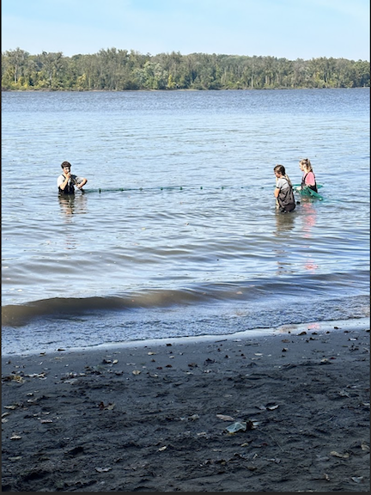
Location: Nutten Hook, Green County, NY
Surrounding Land Use: 75% Forested, 15% Beach & 10% Train tracks
Sampling Site: Beach, Forested, Covered in vegetation, banks altered, Rip Rap, Wood Bulkhead
Shoreline: 80% Sandy, 5% Muddy & 15% Rocky
Water: Calm, about 12 cm deep
River Bottom: Muddy, Sandy & Rocky
Plants in the water: No Plants in the water
*NR = Not read/recorded
ITEM | Time | Reading |  |  | Comments
Physical
Air Temperature | 10:16 AM  10:17 AM  11:04 AM  12:16 PM  12:30 PM | 17.2°C  17°C  19°C  19°C  20.6°C |  | 63°F  63°F  66.2°F  66.2°F  69°F
Wind Speed: | 10:20 AM  10:20 AM  11:15 AM  12:24 PM  12:24 PM  12:25 PM | Anemometer  1 mph  0.2-1.2 mph  1.5 mph  1.5 mph  1 knot  1.5 mph |  | Beaufort  1  1  1  1  1 | Direction  South  South  South  South  South
Weather today | 10:10 AM  10:23 AM  11:00 AM  12:16 PM  12:32 PM | 26-50% Cloud Cover  26-50% Cloud Cover  <25% Cloud Cover  <25% Cloud Cover  26-50% Cloud Cover |  | No Rain  No Rain  No Rain  No Rain  No Rain
Weather the past 3 days: | Unusually warm temperatures with little cloud cover. No Rain.
Tides- Tide Stick | Time | Rising, Falling, Unchanged |  | Height (cm)
 | 10:10 AM  10:14 AM  10:18 AM  10:22 AM  10:26 AM  10:32 AM  10:45 AM  11:10 AM  11:15 AM  11:20 AM  11:25 AM  12:16 PM  12:21 PM  12:26 PM  12:31 PM  12:36 PM  12:41 PM | -  Falling  Falling  Falling  Unchanged  Falling  Falling  -  Falling  Falling  Falling  -  Falling  Falling  Falling  Falling  Falling |  | 20 cm  18 cm  16 cm  14 cm  14 cm  10 cm  8 cm  16 cm  13 cm  12 cm  11 cm  15 cm  11.5 cm  10 cm  8 cm  7 cm  4.5 cm
Current- NR | Time | Cm/sec | Knots | North/South | Ebb/Flood/Slack
Water Temperature- | 10:17 AM  10:20 AM  10:49 AM  11:05 AM  12:20 PM | 14°C  20.5°C  24.2°C  24.1°C  25.9°C |  | 57°F  68.9°F  75.6°F  76.4°F  78.6°F
Turbidity- Long Sight Tube (120 cm) | 10:20 AM  10:25 AM  10:50 AM  11:16 AM  11:45 AM  12:40 PM | 59.1 cm  59 cm  65 cm  57.8 cm  54 cm  41.2 cm
Chemical

Student Salinity- Meter/Probe* | 10:31 AM  10:47 AM  11:10 AM  11:19 AM | 162 ppm  163 ppm  164 ppm  164 ppm |  |  | *Very high compared to Quantab reading and other sites
1 LR Quantab read by students | 12:20 PM | 37 ppm Cl- |  |  | 67 ppm Total Salinity | 1.6 QT unit
DO – Meter/Probe | Time | Temp |  |  | ppm DO | % saturation
 | 10:20 AM  10:45 AM  10:45 AM  11:10 AM  11:14 AM  12:20 PM  12:25 PM | 24.2°C  24.3°C  24.1°C  24.1°C  25.9°C |  |  | 9.43 ppm  9.05 ppm  9.03 ppm  8.80 ppm  8.8 ppm  8.68 ppm  8.63 ppm | 100%  100%  110%  105%  110%  105%  105%
pH – Meter/Probe | 10:26 AM  10:52 AM  11:07 AM  11:10 AM  12:20 PM | 6.3  7.34  6.62  7.4  7.05
Biological
Fish- Seine | Number | Name |  |  | Length of longest | Notes
10:10-1:00 PM | 4  28  1  8  1 | Blueback Herring  Bay Anchovy  Spottail Shiner  Banded Killifish  Striped Bass |  |  | 10.16 cm
Fish Totals | TOTAL: 42 | Diversity: 5
Macroinvertebrates | Number | Name |  |  | Length of longest
 | 2 | Crab sp.
Macroinvertebrate Totals | TOTAL: 2 | Diversity: 1
Sediment Core | Time | Oxid Top | H₂S Smell | Oil | Grain Size | Other Features
20 cm  13 cm  20.3 cm  25 cm  15 cm  NR | 12:33 PM  11:50 AM  NR | No  No  No  No  No  Yes | No  No  No  No  No  Yes | No  No  No  No  No  No | Abundant: Sand  Rare: Mud, Gravel, Pebbles  Abundant: Sand  Rare: Gravel  Common: Sand, Gravel  Rare: Pebbles  Abundant: Sand  Rare: Mud, Pebbles  Abundant: Sand  Common: Gravel  Rare: Mud, Pebbles  Abundant: Sand  Common: Mud, Gravel, Pebbles | Common: Shells  Rare: Shells  Rare: Shells, Living vegetation  Rare: Wood, Shells  Rare: Leaves, wood, shells  Rare: Leaves, shells

Boats
Commercial/  Recreational | Time | Name/Type | Color | Southbound/  Northbound | Light/  Loaded
Recreational  Recreational  Recreational  Recreational  Commercial  Recreational | 10:39  10:49  10:58  11:15  11:48  12:21 | Speedboat  Speedboat  NR  Sailboat  Edwin A. Polino  NR | White  White  White & Black  NR  Black  Red & White | Northbound  Southbound  Southbound  Southbound  Southbound  Southbound | Light  Light  Loaded  NR  Light  Light

