Day in the Life of the Hudson River 10/05/2023
Hudson Shore Park, Watervliet, NY
RIVER MILE: 152
Salt Front: ~ RM 52
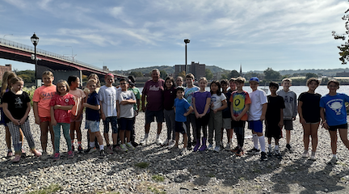
North Colonie Central School District-Amy Parks
63 students, 5th grade, 6 adults
Latitude 42.73074°N & Longitude –73.69759°W
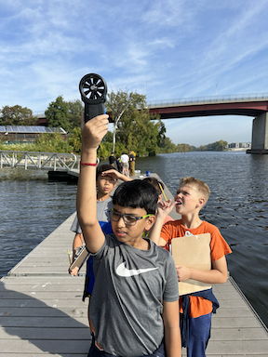 | 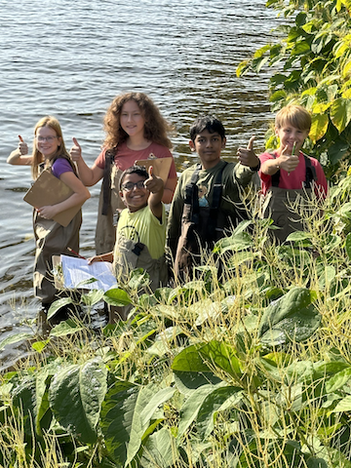

Location: Hudson Shores Park, Watervliet, Albany County, NY
Surrounding Land Use: Fishing launch, Rocky with weedy vegetation and a few small shrubs (gravelly)
Sampling Site: 10% beach at low tides, 70% park/parking area, 20% planted/forested, across the river land use is 100% industrial/commercial
Shoreline: Rocky & Muddy
Water: NR
River Bottom: NR
Plants in the water: NR
*NR = Not read/recorded
ITEM | Time | Reading |  |  | Comments
Physical
Air Temperature | 10:55 AM | 20.5 º C |  | 69 º F
Wind Speed: | 10:57 AM | Anemometer  6.9 mph |  | Beaufort  2 | Direction  South
Weather today | 10:53 AM | 26-50% Cloud Cover |  | No Rain
Weather the past 3 days: | Very hot, sunny, mornings very foggy
Tides- Tide Stick | Time | Rising, Falling, Unchanged |  | Height (cm)
 | 10:06 AM-10:20 AM  11:09 AM-12:40 PM | Rising  Falling |  | 228 cm  243 cm  213 cm  152 cm
Current- | Time | Cm/sec | Knots | North/South | Ebb/Flood/Slack
 | 11:00 AM  11:20 AM  11:50 AM | 12.9  17.6  12.4 |  | South | Ebb  Ebb  Ebb
Water Temperature- | 10:58 AM | 21°C |  | 69.8°F
Turbidity- Long Sight Tube (120 cm) | 10:35 AM  10:49 AM  11:05 AM | 113 cm  >120 cm  >120 cm
Chemical

Standardized Salinity- Low Range Quantabs | 9:00 AM | Below Detection
DO – Hach Drop Count Kit | Time | Temp | ppm DO | % saturation
 | 11:08 AM | 21°C | 9 ppm | 100%
pH – Color Match Kit | 10:34 AM  10:49 AM  11:04 AM | 7.3  7.5  6.9
Biological
Fish-Seine (24 hauls) | Number | Name | Length of longest | Notes
9:30 AM-1:00 PM |  |  |  | * Did not catch anything
Fish Totals | TOTAL: 0 | Diversity: 0
Macroinvertebrates | Number | Name | Length of longest
9:30 AM-1:00 PM
Macroinvertebrate Totals | TOTAL: 0 | Diversity: 0
Sediment Core -NR | Time | Oxid Top | Grain Size | Other Features

Boats-NR
Commercial/Recreational | Time | Name | Color | Southbound/Northbound | Light/Loaded

