Day in the Life of the Hudson River 10/05/2023
Peebles Island, Cohoes, NY
RIVER MILE: 154
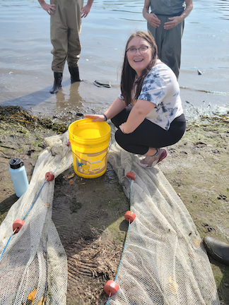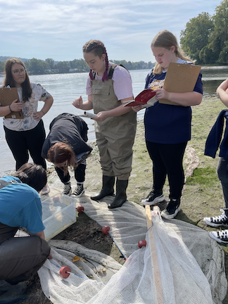
Salt Front: ~RM RM 52
Cohoes High School-Laura Murawski
25 students, 11th grade, 4 adults
Latitude 42.78305°N & Longitude –73.68137°W
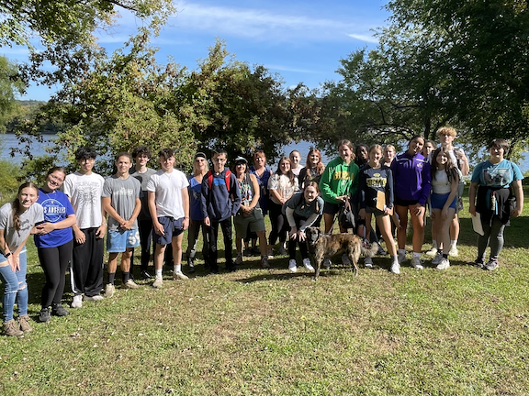

Location: Peebles Island State Park, Cohoes, NY. At the confluence of the Hudson River and the Mohawk River, Waterford, NY.
Surrounding Land Use: 25% Forested, 75% Grassy
Sampling Site: Pavilion and grassy areas at Pebbles Island State Park just north of the Troy Dam at the pavilion, grassy embankment, rip rap
Shoreline: Rip Rap
Water: NR
River Bottom: Muddy
Plants in the water: NR
*NR = Not read/recorded

ITEM | Time | Reading |  |  | Comments
Physical
Air Temperature | 10:59 AM | 22.8 º C |  | 73 º F
Wind Speed: | 10:09 AM | Anemometer |  | Beaufort  3 | Direction  Southeast
Weather today | 10:56 AM | 26-50% Cloud Cover |  | No Rain
Weather the past 3 days: NR
Tides- NA | Time | Rising, Falling, Unchanged |  | Height (cm)
Current- | Time | Cm/sec | Knots | North/South | Ebb/Flood/Slack
 | 10:35 AM  10:56 AM | 5.3  14.1
Water Temperature- | 10:15 AM | 16°C |  | 60.8°F
Turbidity- Long Sight Tube (120 cm) | 9:27 AM | >120 cm
Chemical

Standardized Salinity- Low Range Quantabs | 11:57 AM | 30 ppm Cl⁻ |  |  | 54 ppm total salinity
Student Salinity- Low Range Quantabs | 10:15 AM | 1.2 ppm* |  |  | *expect this is the quantab reading which would put it below detection
DO – Hach Drop Count Kit | Time | Temp |  |  | ppm DO | % saturation
 | 10:39 AM | 16°C |  |  | 11 ppm | 105%
pH – Color Match Kit | 12:30 PM | 8
Biological
Fish- Seine (4 Hauls) | Number | Name |  |  | Length of longest | Notes
10:11 AM-12:34 PM | 49  3  1  1 | Banded Killifish  Smallmouth Bass  Tessellated Darter  Northern Log Perch
Fish Totals | TOTAL: 54 | Diversity: 4
Macroinvertebrates | Number | Name |  |  | Length of longest
 | 1 | Zebra Mussel
Macroinvertebrate Totals | TOTAL: 1 | Diversity: 1
Sediment Core -NR | Time | Oxid Top | H₂S Smell | Oil | Grain Size | Other Features

Boats-NR
Commercial/  Recreational | Time | Name | Color | Southbound/  Northbound | Light/Loaded

