Day in the Life of the Hudson River 10/05/2023
Center for the Urban River at Beczak, Yonkers, NY
RIVER MILE: 18.3
Salt Front: ~ 52
Sarah Lawerence College Center for the Urban River at Beczak (CURB)-Christina Edsall
MLK Elementary School-Jennifer Vizcaino
25 students, 4th grade, 9 adults
Latitude 40.938483°N & Longitude –73.90291°W
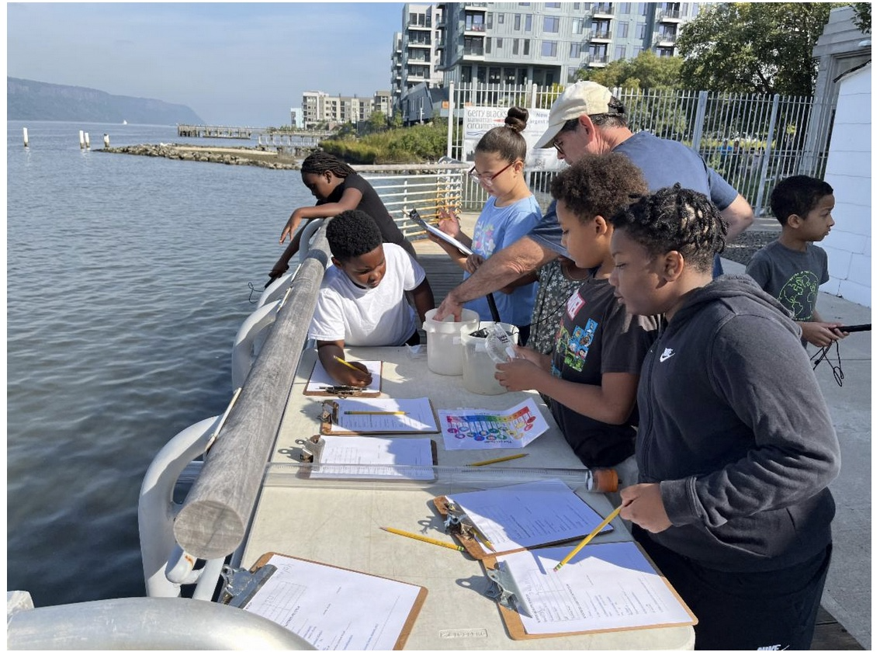

Location: Sarah Lawerence College Center for the Urban River at Beczak, Yonkers, Westchester County, NY
Surrounding Land Use: 90% Urban/Residential, 10% Beach
Sampling Site: Sandy Beach, Rip Rap, Concrete Bulkhead, Marshy
Shoreline: 10% Sandy, 80% Muddy, 10% Rocky
Water: Calm, 120 cm deep
River Bottom: Muddy & Sandy
Plants in the water: NR
*NR = Not read/recorded

ITEM | Time | Reading |  |  | Comments
Physical
Air Temperature | 10:30 AM  11:00 AM  11:30 AM | 20.5°C  21.6°C  22°C |  | 69°F  71°F  72°F
Wind Speed: | 10:45 AM | Anemometer |  | Beaufort  1 | Direction  North
Weather today | 10:30 AM | <25% Cloud Cover |  | No Rain
Weather the past 3 days: | Mostly Sunny, Temperatures in the high 70s
Tides- Tide Stick | Time | Rising, Falling, Unchanged |  | Height (cm)
 | 10:30 AM  11:00 AM  12:00 PM | -  Rising  Rising |  | 60 cm  73 cm  97 cm
Current- | Time | Cm/sec | Knots | North/South | Ebb/Flood/Slack
 | 10:30 AM  11:00 AM  11:30 AM | 10  0  20 | 0.19  0  0.38
Water Temperature- | 10:30 AM  11:00 AM  11:30 AM | 20°C  20°C  20°C |  | 68°F  68°F  68°F
Turbidity- Long Sight Tube (120 cm)  Turbidimeter (NTU) | 10:30 AM  11:00 AM  11:30 AM  11:10 AM | 58 cm  56 cm  52 cm  9.5
Chemical

Standardized Salinity- High Range Quantabs 7.8 QT units | 9:30 AM | 6,095 ppm total salinity |  |  | 6.1 ppt total salinity | 3374 ppm Cl-
Student Salinity- Hydrometer | 10:30 AM  11:00 AM  11:30 AM | 6,000 ppm  7,000 ppm  8,000 ppm |  |  | 6 ppt  7 ppt  8 ppt
DO – | Time | Temp |  |  | ppm DO | % saturation
Meter/Probe  Chemets Kit | 12:00 PM  11:05 AM | 20°C  20 °C |  |  | 7.5 ppm  7.4 ppm
pH – Test Stripes  Color Match Kit | 10:30 AM  11:00 AM  11:30 AM  11:10 AM | 6  7  7  7.8
Biological
Fish- Seine (12 Hauls) | Number | Name |  |  | Length of longest | Notes
10:30-11:45 AM | 2  18  2  10  1  2 | Atlantic Menhaden  Atlantic Silverside  Bay Anchovy  Mummichog  Northern Pipefish  Striped Bass |  |  | 6.5 cm  10 cm  7.5 cm  10 cm  13 cm  15 cm
Fish Totals | TOTAL: 35 | Diversity: 6
Macroinvertebrates | Number | Name |  |  | Length of longest
 | 1  7 | Moon Jelly  Blue Crab |  |  | 8 cm
Macroinvertebrate Totals | TOTAL: 8 | Diversity: 2
Sediment Core | Time | Oxid Top | H₂S Smell | Oil | Grain Size | Other Features
6 cm |  | No | Yes | No | Abundant: Clay, Mud  Common: Sand, Gravel, Pebbles | Abundant: Macroinvertebrates  Rare: Wood, Mussel Shells

Boats
Commercial/  Recreational | Time | Type | Color | Southbound/  Northbound | Light/  Loaded
Commercial | 11:30 | Barge |  | Northbound

