Day in the Life of the Hudson River 10/05/2023
Hudson River Park Pier 40, Manhattan, NYC
RIVER MILE: 2.9
Salt Front: ~ 52
NYC Museum School--Scott Wassmuth
Hudson River Project-Toland Kister
30 students, 9th-12th grade, 2 adults
Latitude 40.72842°N & Longitude –74.01379°W
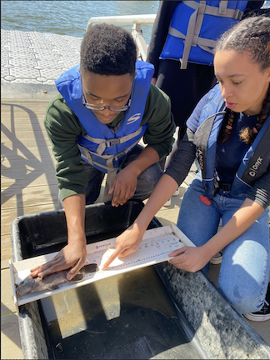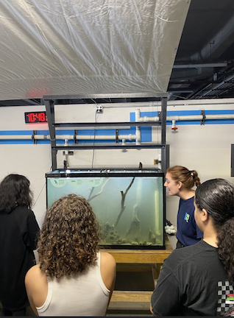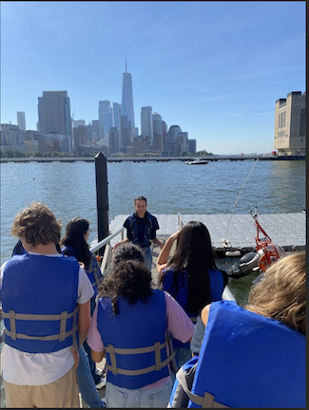

Location: Pier 40, Hudson River Park, NYC
Surrounding Land Use: 100% Urban/Residential
Sampling Site: Pier, Concrete Bulkhead
Shoreline: Bulkhead
Water: Choppy
River Bottom: Muddy,400-100 cm deep
Plants in the water: No Plants in the water
*NR = Not read/recorded

ITEM | Time | Reading |  |  | Comments
Physical
Air Temperature | 10:21 AM  10:40 AM  11:21 AM | 20°C  21.1°C  22.2°C |  | 68°F  70°F  72°F
Wind Speed: | 11:21 AM | Anemometer  4-6 knots |  | Beaufort  2 | Direction
Weather today | 11:21 AM | <25% Cloud Cover |  | No Rain
Weather the past 3 days: | Clear, Warm
Tides- | Time | Rising, Falling, Unchanged |  | Height (cm)
 | 10:21 AM  10:40 AM  11:00 AM  11:25 AM | -  Slack  Rising  Rising |  | 170 cm  170 cm  155 cm  162 cm* | *Measurement Error
Current- | Time | Cm/sec | Knots | North/South | Ebb/Flood/Slack
*Pier structure reduces water flow | 10:21 AM  10:40 AM  11:00 AM  11:33 AM | 0  0  0  8.7 | 0.17 |  | Slack  Slack  Slack  Flood
Water Temperature- | 10:27 AM  10:49 AM  11:06 AM  11:27 AM | 22.5°C  23°C  21.5°C  24°C |  | 72.5°F  73.4°F  70.7°F  75.2°F
Turbidity- Long Sight Tube (120 cm) | 10:20 AM  10:41 AM  11:00 AM | 41.2 cm  40 cm  46.5 cm
Chemical

Standardized Salinity- Refractometer | 5:30 PM | 18,000 ppm |  |  | 18 ppt
Student Salinity- Hydrometer | 10:32 AM  10:53 AM  11:06 AM  11:21 AM | 15,670 ppm  16,000 ppm  15,670 ppm  16,300 ppm  13,670 ppm |  |  | 15.7 ppt  16 ppt  15.7 ppt  16.3 ppt  13.7 ppt
DO – Lamotte Drop Count Kit | Time | Temp |  |  | ppm DO | % saturation
 | 11:00 AM | 21.5°C |  |  | 6.2 ppm | 68%
pH – NR
Biological
Fish-Eel Mop & Traps | Number | Name |  |  | Length of longest | Notes
10:20-11:30 AM | 1  1 | Black Seabass  Tautog (Blackfish) |  |  | 5 cm  26 cm
Fish Totals | TOTAL: 2 | Diversity: 2
Macroinvertebrates | Number | Name |  |  | Length of longest
 | 15  4  1 | Palaemonetes Shrimp  Oyster Drill  Common Spider Crab
Macroinvertebrate Totals | TOTAL: 20 | Diversity: 3
Sediment Core -Not able to core on pier | Time | Oxid Top | H₂S Smell | Oil | Grain Size | Other Features

Boats-NR
Commercial/  Recreational | Time | Name | Color | Southbound/  Northbound | Light/  Loaded

