Day in the Life of the Hudson River 10/05/2023
Kinnally Cove, Hastings-on-Hudson, NY
RIVER MILE: 22
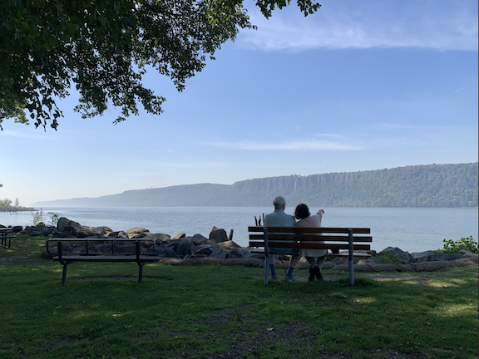
Salt Front: ~ 52
Hastings High School-Marc Zelmanowicz
43 students, 11th-12th grade, 3 adults
Latitude 40.99776°N & Longitude –73.88523°W
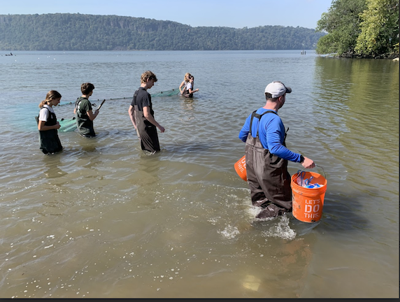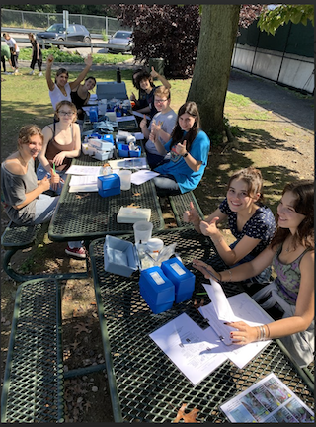
Location: Kinnally Cove, MacEachron Park, Hastings-on-Hudson, Westchester County, NY
Surrounding Land Use: 100% Industrial/Commercial
Sampling Site: Beach with altered banks, riprap on shoreline, bulkhead, grassy area
Shoreline: Sandy
Water: Calm
River Bottom: Muddy
Plants in the water: No Plants in the water
*NR = Not read/recorded

NOTE: Spotted Lantern Fly noted in sampling area
ITEM | Time | Reading |  |  | Comments
Physical
Air Temperature | 10:20 AM | 19 º C |  | 66.2 º F
Wind Speed: | 10:28 AM | Anemometer  1.5 mph |  | Beaufort  1 | Direction
Weather today | 10:30 AM | <25% Cloud Cover
Weather the past 3 days: | Warmer than usual
Tides- NR | Time | Rising, Falling, Unchanged |  | Height (cm)
Current- | Time | Cm/sec | Knots | North/South | Ebb/Flood/Slack
 | 10:30 AM  1:30 PM | 20.8  7.79 | 0.4047  0.15 |  | Ebb  Flood
Water Temperature- | 12:30 PM  2:20 PM | 20°C  22°C |  | 68°F  71.6°F
Turbidity- Long Sight Tube (120 cm) | 9:20 AM  10:00 AM | 57 cm  47.25 cm
Chemical

Standardized Salinity- High Range Quantabs- 5.8 QT units | 12:55 PM | 5,138 ppm total salinity |  |  | 5.1 ppt TS | 2844 ppm Cl-
Student Salinity- Hydrometer  Refractometer | 10:20 AM  10:40 AM | 6,500 ppm  6,000 ppm |  |  | 6.5 ppt  6 ppt
DO – Hach Drop Count Kit | Time | Temp |  |  | ppm DO | % saturation
 | 1:30 PM | 22°C |  |  | 9 ppm | 96.25%
pH – Color Match Kit | 10:30 AM  1:20 PM | 6.5  6.7
Nitrates- | 10:40 AM | 4.4 ppm* |  |  |  | * high reading
Phosphates- | 10:40 AM | 0.5 ppm
Biological
Fish- Seine (8 Hauls) | Number | Name |  |  | Length of longest | Notes
8:30 AM-2:30 PM | 4  12  1  1 | White Perch  Atlantic Silverside  Black Drum  Striped Bass |  |  | 23 cm  8 cm  20 cm  6 cm
Fish Totals | TOTAL: 18 | Diversity: 4
Macroinvertebrates | Number | Name |  |  | Length of longest
Macroinvertebrate Totals | TOTAL: 0 | Diversity: 0
Sediment Core -NR | Time | Oxid Top | H₂S Smell | Oil | Grain Size | Other Features

Boats
Commercial/  Recreational | Time | Type | Color | Southbound/  Northbound | Light/  Loaded
Commercial  Commercial | 10:10  10:12 | Barge  Trash Barge | Red/Orange  Blue | Northbound  Southbound | Loaded  Loaded

