Day in the Life of the Hudson River 10/05/2023
Dobbs Ferry Waterfront Park, Dobbs Ferry, NY
RIVER MILE: 23
Salt Front: ~ 52
EF Academy-Stephen Fleming
120 students, 11th grade, 8 adults
Latitude 41.01516°N & Longitude –73.879988°W
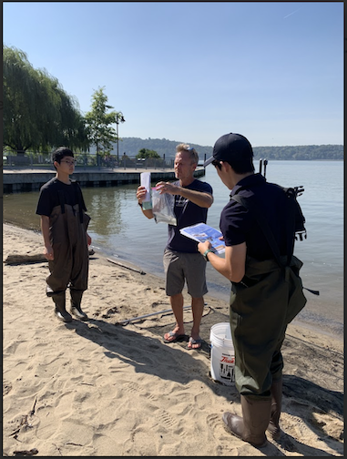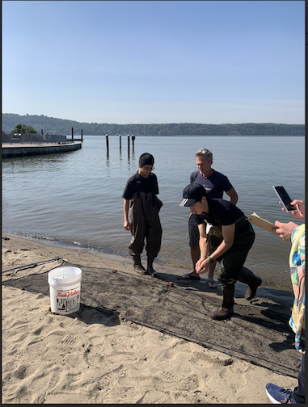
Location: Dobbs Ferry Waterfront Park, Dobbs Ferry, Westchester County, NY
Surrounding Land Use: 20% Urban/Residential, 40% Forested, 30% Industrial/Commercial & 10% Beach
Sampling Site: Marshy Beach, Concrete bulkhead, RipRaps, Grassy surrounding area, Pipe entering the water, parking lot
Shoreline: 40% Sandy, 20% Muddy & 40% Rocky
Water: Calm & Choppy
River Bottom: Muddy, Sandy & Rocky
Plants in the water: No Plants in the water
*NR = Not read/recorded
ITEM | Time | Reading |  |  | Comments
Physical
Air Temperature | 10:30 AM | 25 º C |  | 77º F
Wind Speed: | 10:30 AM | Anemometer |  | Beaufort | Direction
Weather today | 10:30 AM | <25% Cloud Cover |  | No Rain
Weather the past 3 days: | NR
Tides- Tide Stick | Time | Rising, Falling, Unchanged |  | Height (cm)
 | 10:30 AM  11:00 AM | -  Rising |  | 0 cm  33 cm
Current- | Time | Cm/sec | Knots | North/South | Ebb/Flood/Slack
 |  | 26 |  |  | Ebb
Water Temperature- | 10:30 AM  10:40 AM | 25°C  23°C |  | 77°F  73.4°F
Turbidity- Long Sight Tube (120 cm) | 10:44 AM | 65.1 cm
Chemical

Student Salinity- Refractometer | 10:30 AM | 5,000 ppm |  |  | 5 ppt
DO – | Time | Temp |  |  | ppm DO | % saturation
 | 10:30 AM | 25°C |  |  | 5 ppm | 57%
pH – | 10:30 AM | 8.4
Biological
Fish- Seine | Number | Name |  |  | Length of longest | Notes
 | 1  41  1 | White Perch  Atlantic Silverside  Bluegill |  |  | 16.5 cm  9 cm  13 cm
Fish Totals | TOTAL: 43 | Diversity: 3
Macroinvertebrates | Number | Name |  |  | Length of longest
 | 1  1 | Ctenophore sp.  Blue Crab |  |  | 12 cm  6 cm
Macroinvertebrate Totals | TOTAL: 2 | Diversity: 2
Sediment Core -NR | Time | Oxid Top | H₂S Smell | Oil | Grain Size | Other Features

Boats-NR
Commercial/  Recreational | Time | Name | Color | Southbound/  Northbound | Light/  Loaded

