Day in the Life of the Hudson River 10/05/2023
Matthiessen Park, Irvington, NY
RIVER MILE: 25
Salt Front: ~ 52
Irvington Union Free School- Amy Panitz & Alex Lengers
242 students, 11th & 12th grade, 34 adults
Latitude 41.04164°N & Longitude –73.87398°W

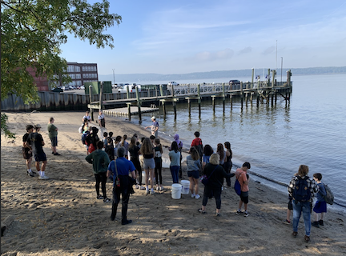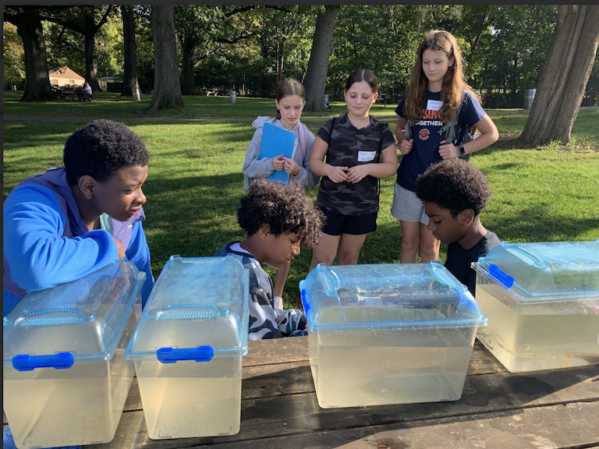
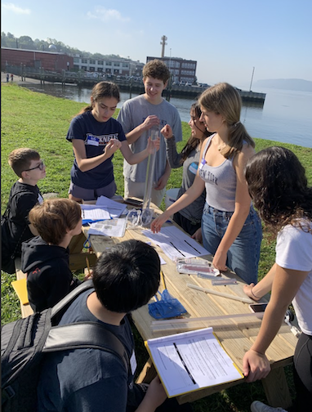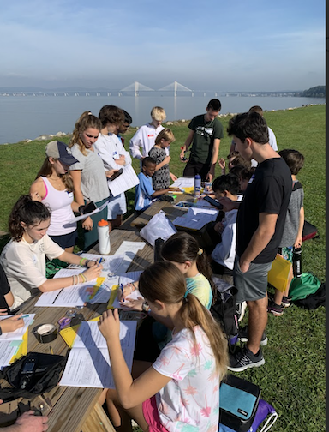
Location: Matthiessen Park, Irvington, Westchester, NY
Surrounding Land Use: 60% Industrial/Commercial & 40% Urban/Residential
Sampling Site: Beach, banks altered, riprap, wood bulkhead, pipe entering the water, area covered in vegetation
Shoreline: Rocky, RipRaps
Water: Calm
River Bottom: Muddy & Rocky
Plants in the water: No Plants in the water
*NR = Not read/recorded
ITEM | Time | Reading |  |  | Comments
Physical
Air Temperature | 9:40 AM  10:08 AM  10:36 AM  11:05 AM  11:33 AM  12:10 PM  12:34 PM | 18°C  18°C  20°C  21°C  21°C  22°C  23°C |  | 64.4°F  64.4°F  68°F  69.8°F  69.8°F  71.6°F  73.4°F
Wind Speed: | 9:40 AM  10:08 AM  10:36 AM  11:05 AM  11:33 AM  12:10 PM  12:34 PM | Anemometer  0 mph  0 mph  2.2 mph  0 mph  1.2 mph  2.5 mph  3 mph |  | Beaufort | Direction  Southeast  Southeast  Southeast  Southeast
Weather today | 9:40 AM  10:08 AM  10:36 AM  11:05 AM  11:33 AM  12:10 PM  12:34 PM | >75% Cloud Cover  >75% Cloud Cover  51-75% Cloud Cover  26- 50% Cloud Cover  26-50% Cloud Cover  <25% Cloud Cover  <25% Cloud Cover |  | No Rain all day
Weather the past 3 days: | No Rain, not a lot of wind, temperatures in the high 50s to 70s
Tides- Tide Stick | Time | Rising, Falling, Unchanged |  | Height (cm)
 | 7:15 AM  9:32 AM  10:15 AM  10:45 AM  11:15 AM  11:45 AM  12:15 PM  12:45 PM | -  Falling  Rising  Rising  Rising  Rising  Rising  Rising |  | 27 cm  23 cm  41 cm  50 cm  59 cm  74 cm  88 cm  96.5 cm
Current- | Time | Cm/sec | Knots | North/South | Ebb/Flood/Slack
*Expect the prolonged slack reading is the result of where the current was measured. It does not seem to line up with the tide. | 9:40 AM  10:08 AM  10:36 AM  11:05 AM  11:33 AM  12:10 PM  12:34 PM |  |  |  | Slack*  Slack  Slack  Slack  Slack  Slack  Ebb
Water Temperature- | 9:46 AM  10:08 AM  10:32 AM  11:02 AM  11:35 AM  12:05 PM  12:34 PM | 22°C  23°C  25°C  23°C  22°C  19°C  28°C |  | 71.6°F  73.4 °F  77°F  73.4°F  71.6°F  66.2°F  82.4°F
Turbidity- Short Sight Tube (60 cm) | 9:46 AM  10:08 AM  10:32 AM  11:02 AM  11:35 AM  12:05 PM | 15.8 cm  22.6 cm  23 cm  23.5 cm  18 cm  21.7 cm
Chemical

Standardized Salinity- High Range Quantabs –QT unit 7.2 | 9:55 AM | 4,735 ppm total salinity |  |  | 4.7 ppt TS | 2621ppm Cl-
Student Salinity-  High Range Quantabs 7.0 unit | 9:46 AM  10:08 AM  10:32 AM  11:02 AM  11:35 AM  12:05 PM  12:34 PM  11:15 AM | 6,000 ppm  10,000 ppm  3,000 ppm  6,000 ppm  3,000 ppm  5,000 ppm  3,000 ppm  4,370 ppm total salinity |  |  | 6 ppt  10 ppt  3 ppt  6 ppt  3 ppt  5 ppt  3 ppt  4.4 ppt TS | 2419 ppm Cl-
DO – Lamotte Drop Count Kit | Time | Temp |  |  | ppm DO | % saturation
 | 9:46 AM  10:08 AM  10:32 AM  11:02 AM  11:02 AM  11:35 AM  12:05 PM  12:34 PM | 22°C  23°C  25°C  23°C  23°C  22°C  19°C  28°C |  |  | 11 ppm  7 ppm  9 ppm  8 ppm  10 ppm  9 ppm  9 ppm  9 ppm | 115%
pH – Color Match Kit | 9:46 AM  10:08 AM  10:32 AM  11:02 AM  11:35 AM  12:05 PM  12:34 PM | 6  6  6  7  6  7  6
Biological
Fish- Seine (12 Hauls) | Number | Name |  |  | Length of longest | Notes
10:00 AM-12:30 PM | 24  3  33  5  1  1  2  1 | Mummichog  Hogchoker  Atlantic Silverside  Striped Bass  Northern Pipefish  Shiner*  Bluefish  Porgy (scup) |  |  | 1 cm  10.5 cm  7 cm  11 cm  6.5 cm  6 cm  9 cm  16 cm
Fish Totals | TOTAL: 70 | Diversity: 8
Macroinvertebrates | Number | Name |  |  | Length of longest
 | 8  7 | Blue Crabs  Palaemonetes Shrimp |  |  | 6 cm  5 cm
Macroinvertebrate Totals | TOTAL: 15 | Diversity: 2
Sediment Core | Time | Oxid Top | H₂S Smell | Oil | Grain Size | Other Features
NR  30 cm  NR | 12:45 PM  NR  NR | No  No  NR | No  Yes  NR | No  No  NR | Abundant: Sand  Common: Mud, Gravel, Pebbles  Rare: Clay  Abundant: Sand  Common: Mud, Gravel, Pebbles  Rare: Clay  Common: Clay, Mud, Sand, Gravel  Rare: Pebbles | Rare: Wood, Brick  Common: Brick  Rare: Macroinvertebrates, Slag

Boats
Commercial/  Recreational | Time | Type | Color | Southbound/  Northbound | Light/  Loaded
Commercial  Recreational  Commercial  Commercial  Commercial  Recreational  Recreational  Recreational  Commercial  Recreational | 9:25  9:46  9:52  10:28  10:28  10:40  10:40  11:05  11:26  11:57 | Barge  2 Boats  Tugboat  Barge  Tugboat  Speedboat  Speedboat  Speedboat  Barge  Kayak | Red/Yellow  Blue | Northbound  Northbound  Northbound  Southbound  Southbound  Northbound  Northbound

