Day in the Life of the Hudson River 10/05/2023
RM 266
NYS Warren County Canoe Access, Johnsburg on RTE 28, NY
RIVER MILE: ~66
Hudson Estuary Salt Front: ~ RM 52
Johnsburg Central School-Sara Fink
Doug Reed
5 students, 12th grade, 4 adults
Latitude 43.728065°N & Longitude –74.017928 °W
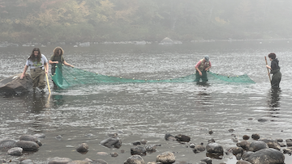 | 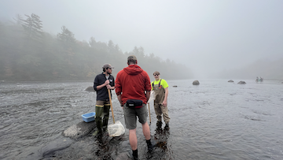 | 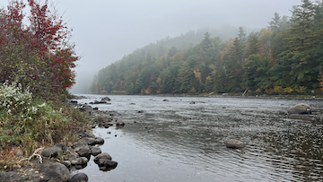

Location: Warren County Canoe Access Site, Johnsburg, NY
Surrounding Land Use: 10% Urban/Residential, 80% Forested & 10% Industrial.
Sampling Site: Forested, Rocky Beach with Canoe Access, Grassy, & Parking lot above site
Shoreline: 10% Sandy & 90% Rocky
Water: Choppy
River Bottom: 100 cm
Plants in the water: No plants
*NR = Not read/recorded
ITEM | Time | Reading |  |  | Comments
Physical
Air Temperature | 9:18 AM | 17 º C |  | 62 º F
Wind Speed: | 9:18 AM | Anemometer  0 |  | Beaufort  0 | Direction
Weather today | 9:18 AM | Foggy |  | No Rain
Weather the past 3 days: | Hot and dry, highs in the low 80s, lows in the upper 50s
Tides- N/A above the head of tide | Time | Rising, Falling, Unchanged |  | Height (cm)
Current- | Time | Cm/sec | Knots | North/South | Ebb/Flood/Slack
 | 9:29 AM | 420 | 8.17 |  | Ebb
Water Temperature- | 9:22 AM | 16°C |  | 61°F
Turbidity- Long Sight Tube (120 cm) | 9:27 AM | >120 cm
Chemical

Standardized Salinity- Low Range Quantab | 9:15 AM | Below Detection
DO – Lamotte Drop Count Kit | Time | Temp |  |  | ppm DO | % saturation
 | 9:55 AM | 16°C |  |  | 9 ppm | 95%
pH – Color Match Kit | 9:35 AM | 6
Fish-Seining | Number | Name |  |  | Length of longest | Notes
8:30-9:30 AM |  |  |  |  |  | (5 Hauls)
Fish Totals | TOTAL: 0 | Diversity: 0
Macroinvertebrates | Number | Name |  |  | Length of longest
8:30-9:30 AM | 3  2  1  5  >100  8 | Crayfish  Dragonfly Nymph  Mayfly Nymph  Stonefly Nymph  Caddisfly Larva  Whirligig Beetle |  |  | 10 cm  4 cm  1.2 cm  1.5 cm  1.5 cm  1.5 cm
Macroinvertebrate Totals | TOTAL:  >119 | Diversity: 6
Sediment Core | Time | Oxid Top | H₂S Smell | Oil | Grain Size | Other Features
No length recorded | NR | No | No | No | Common: Mud, Sand, Gravel & Pebbles  Rare: Clay | Common: Leaves & Macroinvertebrates  Rare: Living Vegetation

Boats-NR
Commercial/Recreational | Time | Name | Color | Southbound/Northbound | Light/Loaded

