Day in the Life of the Hudson River 10/05/2023
Nyack Beach, Nyack, NY
RIVER MILE: 30.4
Salt Front: ~RM 52
Blue Rock School-Charlotte Jack
23 students, 5th-8th grade, 5 adults
Latitude 41.119759°N & Longitude –73.912429°W
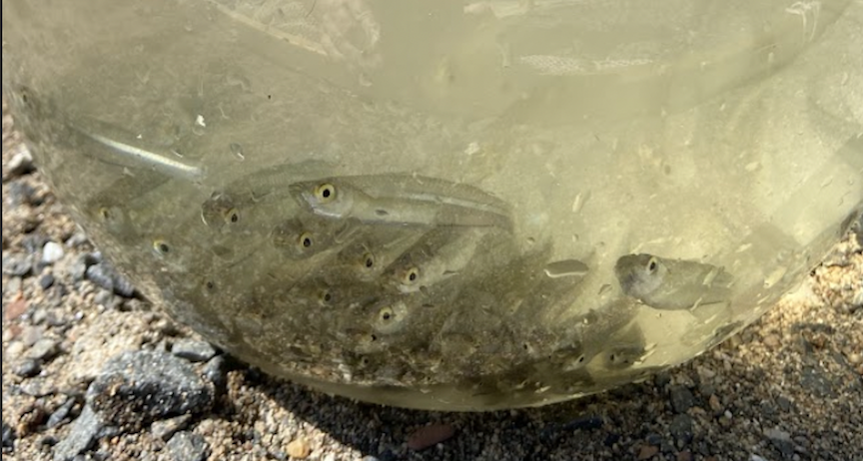

Location: Nyack South Beach, Upper Nyack, Rockland County, NY
Surrounding Land Use: 5% Urban/Residential, 45% Forested, 50% Beach
Sampling Site: Sandy beach with retaining wall enclosing it and behind a lot of trees, picnic tables, sandy and rocky at edges, covered with vegetation beyond the beach, stone wall, riprap shore, concrete docking.
Shoreline: Rip Rap, Sandy & Rocky
Water: NR
River Bottom: Sandy
Plants in the water: Submerged water celery (Valisneria)
*NR = Not read/recorded
ITEM | Time | Reading |  |  | Comments
Physical
Air Temperature | 11:00 AM | 22 º C |  | 72º F
Wind Speed: NR |  | Anemometer |  | Beaufort | Direction
Weather today | 11:00 AM | <25% Cloud Cover |  | No Rain
Weather the past 3 days: NR
Tides- | Time | Rising, Falling, Unchanged |  | Height (cm)
 | 11:00 AM  11:30 AM | -  Rising |  | 15 cm  29 cm
Current- | Time | Cm/sec | Knots | North/South | Ebb/Flood/Slack
 | 11:00 AM | 1 |  |  | Flood
Water Temperature- | 11:00 AM | 20°C |  | 68°F
Turbidity- NR
Chemical

Standardized Salinity- High Range Quantabs – 6.1QT units | 11:30 AM | 1771 ppm Cl⁻ |  |  | 3199 ppm total salinity | 3 ppt total salinity
Student Salinity- High Range Quantabs | 11:00 AM | 650 ppm Cl⁻ |  |  | 1174 ppm total salinity | 1 ppt total salinity
DO – | Time | Temp |  |  | ppm DO | % saturation
 | 11:00 AM | 20°C |  |  | 9 ppm
pH – Color Match Kit | 11:00 AM | 7.5
Biological
Fish- Seine (8 Hauls) | Number | Name |  |  | Length of longest | Notes
11:00 AM-1:45 PM | 202 | Atlantic Silverside |  |  | 13.2 cm
Fish Totals | TOTAL:  202 | Diversity: 1
Macroinvertebrates | Number | Name |  |  | Length of longest
 | 2 | Blue Crab |  |  | 11.43 cm
Macroinvertebrate Totals | TOTAL: 2 | Diversity: 1
Sediment Core -NR | Time | Oxid Top | H₂S Smell | Oil | Grain Size | Other Features

Boats-NR
Commercial/  Recreational | Time | Name | Color | Southbound/  Northbound | Light/Loaded

