Day in the Life of the Hudson River 10/05/2023
Mt. Adams Trailhead, Newcomb, NY
RIVER MILE: 300s
Hudson River Estuary Salt Front: ~ RM 52
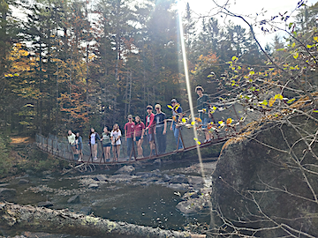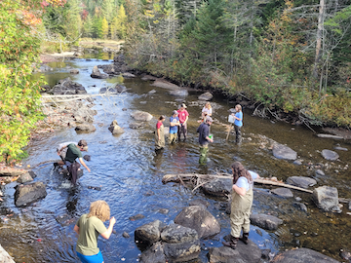
Long Lake Central School-Nicole Curtin
ESF- Jake O’Connell
16 students, 9th-11th grade, 5 adults
Latitude 44.091643°N & Longitude –74.0593°W
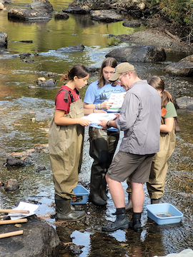 | 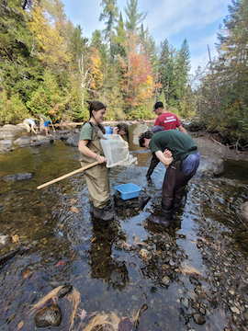 | 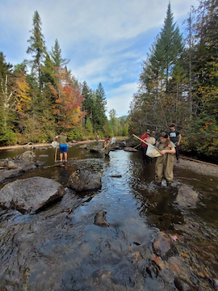

Location: Mt. Adams Trailhead, Newcomb, NY
Surrounding Land Use: 100% Forested
Sampling Site: 100% Forested
Shoreline: 25% Sandy & 75% Rocky
Water: Calm
River Bottom: 25% Sandy & 75% Rocky
Plants in the water: No Plants
*NR = Not read/recorded
ITEM | Time | Reading |  |  | Comments
Physical
Air Temperature-NR |  | º C |  | º F
Wind Speed: | 11:31 AM | Anemometer  0.04 m/s |  | Beaufort | Direction
Weather today | 11:00 AM | <25% Cloud Cover |  | No Rain
Weather the past 3 days: | Clear & unseasonably warm
Tides- N/A above the head of tide | Time | Rising, Falling, Unchanged |  | Height (cm)
Current- | Time | Cm/sec | Knots | North/South | Ebb/Flood/Slack
 |  | 38  24  29 |  |  | N/A
Water Temperature- |  | 16.9°C
Turbidity- NR
Chemical

Standardized Salinity- Low Range Quantabs | 2:35 PM | Below Detection
DO – Lamotte Drop Count Kit | Time | Temp | ppm DO | % saturation
 | 12:26 PM | 16.9°C | 4 ppm
pH – Color Match Kit | 11:45 AM | 6.2
Biological
Fish-Seining | Number | Name | Length of longest | Notes
11:00 AM-12:00 PM |  |  |  | Minnows were observed but not caught
Fish Totals | TOTAL: 0 | Diversity: 0
Macroinvertebrates- Kick Net | Number | Name | Length of longest
11:00 AM-12:00 PM | 5  3  2  1  5  1  3  1 | Dragonfly nymph  Dobsonfly (Hellgrammites)  Mayfly nymph  Stonefly nymph  Caddisfly larva  Diving Beetle  Fishfly  Cranefly
Macroinvertebrate Totals | TOTAL: 21 | Diversity: 8
Sediment Core -NR | Time | Oxid Top | Grain Size | Other Features

Boats-NR
Commercial/Recreational | Time | Name | Color | Southbound/Northbound | Light/Loaded

