Day in the Life of the Hudson River 10/05/2023
Haverstraw Bay Park, Haverstraw, NY
RIVER MILE: 38
Salt Front: ~ 52
Albertus Magnus High School-Millie Mendelson
Members of SCA
Rockland County Parks Staff
30 students, 11th-12th grade, 5 adults
Latitude 41.212559°N & Longitude –73.963759°W
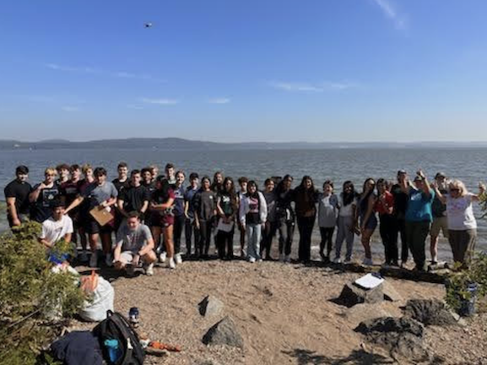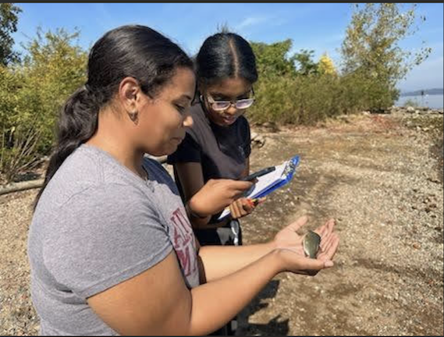

Location: Haverstraw Bay Park, Haverstraw, Rockland County, NY
Surrounding Land Use: 60% Urban/Residential, 30% Industrial/Commercial, 5% Beach
Sampling Site: Small beach, banks altered, large rip rap, boat launch, bulkhead, concrete bulkhead, covered in vegetation, grassy area, parking lot adjacent.
Shoreline: 40% Sandy, 20% Muddy & 40% Rocky
Water: NR
River Bottom: Muddy, Sandy & Rocky
Plants in the water: NR
*NR = Not read/recorded
ITEM | Time | Reading |  |  | Comments
Physical
Air Temperature | 11:05 AM  11:23 AM  12:55 PM | 21.11 º C  21.67 º C  25.56 º C |  | 70º F  71 º F  78 º F
Wind Speed: | 10:44 AM | Anemometer  4-6 mph |  | Beaufort  2 | Direction  Southeast
Weather today | 11:08 AM | 26-50% Cloud Cover |  | Drizzle
Weather the past 3 days: | Warm, humid, sunny
Tides- | Time | Rising, Falling, Unchanged |  | Height (cm)
 | 11:08 AM  12:25 PM  1:04 PM | Rising  Falling  Falling |  | 336.6 cm  302.6 cm  292.1 cm
Current- | Time | Cm/sec | Knots | North/South | Ebb/Flood/Slack
 | 10:35 AM  10:47 AM  12:32 PM | 2.71  3.4  11.55 |  |  | Flood
Water Temperature- | 10:25 AM  11:04 AM  12:13 PM  12:47 PM | 20.8°C  20.7°C  22.8°C  22.8°C |  | 69.44°F  69.26°F  73.04°F  73.04°F
Turbidity- Long Sight Tube (120 cm) -  Each reading is an average of 3 | 11:00 AM  12:10 PM  12:45 PM | 46.6 cm avg  38.5 cm avg  12.8 cm avg |  | 39.8 – 49.6 – 50.4 cm  38.4 – 36.2 – 41 cm  10.4 – 15.8 – 12.8 cm (boat? Or wind impact?)
Chemical

Standardized Salinity- High Range Quantabs | 10:32 AM | 1,107 ppm Cl⁻ /5.0 qt units |  |  | 2,000 ppm  (total salinity) | 2.0 ppt TS
Student Salinity- High Range Quantabs | 10:40 AM  11:18 AM  12:59 PM | 1,296 ppm Cl⁻ /5.4 qt units  1,020 ppm Cl⁻ /4.8 qt units 939 ppm Cl⁻ / 4.6 qt units |  |  | 2431 ppm TS  1843 ppm TS  1696 ppm TS | 2.4 ppt TS  1.8 ppt TS  1.7 ppt TS
DO – Hach Drop Count Kit | Time | Temp |  |  | ppm DO | % saturation
 | 10:45 AM  10:48 AM  11:18 AM  11:47 AM  12:29 PM  12:47 PM | 20.8  20.8  20.7  20.7  22.8  22.8 |  |  | 11 ppm  13 ppm  9 ppm  9 ppm  12 ppm  11 ppm | 120%  142%  100%  100%  128%  122%
pH – Color Match Kit | 10:33 AM  10:36 AM  11:09 AM  11:13 AM  12:22 PM  12:50 PM  12:57 PM | 7  7.5  7.4  7.4  7.8  7.6  7.6
Biological
Fish- Seine | Number | Name |  |  | Length of longest | Smallest
10:28 AM-12:50 PM | 128  6  3 | Atlantic Silverside  Striped Bass  White Perch |  |  | 8.5 cm  6 cm  20 cm | 8. 0 smallest
Fish Totals | TOTAL:  137 | Diversity: 3
Macroinvertebrates | Number | Name |  |  | Length of longest
Macroinvertebrate Totals | TOTAL: 0 | Diversity: 0
Sediment Core -NR | Time | Oxid Top | H₂S Smell | Oil | Grain Size | Other Features

Boats
Commercial/  Recreational | Time | Type | Color | Southbound/  Northbound | Light/  Loaded
Commercial  Commercial  Commercial  Recreational  Recreational  Recreational  Recreational | 11:41  10:37  11:15  10:02  10:11  12:20  12:42 | Barge  Tugboat  Barge  Sailboat  Speedboat  Yacht  Yacht | Red  White  Black  White  White  White  White | Northbound  Northbound  Northbound  Southbound  Southbound  Southbound  Northbound | Loaded  Loaded  Loaded  Light  Light  Light  Light

