Day in the Life of the Hudson River 10/05/2023
Verplanck Steamboat Dock, Westchester County, NY
RIVER MILE: 41
Salt Front: ~ 52
Mahopac High School- Scott Rizzo
33 students, 9th-11th grade, 3 adults
Latitude 41.24927°N & Longitude –73.96431°W
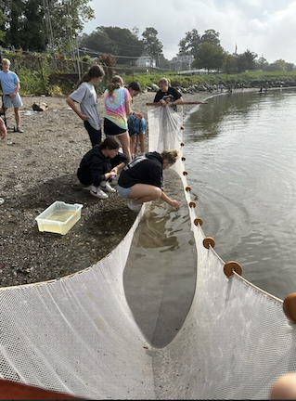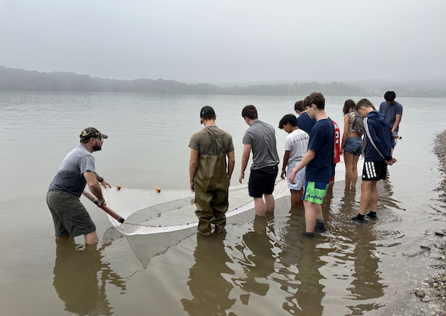

Location: Steamboat Dock Park Beach, City of Verplanck, Westchester County, NY
Surrounding Land Use: 30% Urban/Residential, 35% Beach & 35% Parking Lot
Sampling Site: Beach, pier, riprap & parking lot.
Shoreline: Sandy & Rocky
Water: Calm
River Bottom: Sandy & Rocky
Plants in the water: 10% Water Chestnuts
*NR = Not read/recorded

NOTE: Lots of Spotted Lantern Flies noted during sampling
ITEM | Time | Reading |  |  | Comments
Physical
Air Temperature | 10:42 AM  11:13 AM | 20°C  21.17°C |  | 68 º F  71 º F
Wind Speed: | 10:42 AM | Anemometer  1 mph |  | Beaufort  1 | Direction
Weather today | 8:45 AM  10:44 AM  11:19 AM | >75% Cloud Cover  26-50% Cloud  Cover  26-50% Cloud Cover |  | No Rain
Weather the past 3 days: | Sunny, fog
Tides- Tide Stick | Time | Rising, Falling, Unchanged |  | Height (cm)
 | 9:49 AM  10:06 AM  10:27 AM  10:47 AM  11:14 AM  11:28 AM | -  Rising  Rising  Rising  Rising  Rising |  | 62.5 cm  73.4 cm  75 cm  80 cm  86 cm  90 cm
Current- | Time | Cm/sec | Knots | North/South | Ebb/Flood/Slack
 | 10:07 AM  10:30 AM  10:44 AM  11:16 AM | 45.7  53.34  52.4  62
Water Temperature- | 9:30 AM  10:15 AM  11:10 AM | 20.2°C  20.2°C  20.9°C |  | 68.5°F  68.5°F  69.6°F
Turbidity- Long Sight Tube (120 cm) | 9:46 AM  10:27 AM  11:28 AM | 28.9 cm  28.6 cm  23 cm
Chemical

Standardized Salinity- High Range Quantabs | 9:30 AM | 939 ppm Cl-  863 ppm Cl- |  | 1,696 ppm TS  1,559 ppm TS |  | 1.7 ppt -4.6 units  1.6 ppt -4.4 units | Read @ LDEO  Read @ Norrie
Student Salinity- Meter/Probe | 9:30 AM  10:15 AM  11:10 AM | 1,400 ppm  1,400 ppm  1,500 ppm |  |  |  | 1.4 ppt  1.4 ppt  1.5 ppt
DO – Hach Drop Count Kit | Time | Temp |  |  |  | ppm DO | % saturation
 | 9:30 AM  10:15 AM  11:15 AM | 20.2°C  20.2°C  21.1°C |  |  |  | 8 ppm  4 ppm  10 ppm | 90%  42%  116%
pH – Color Match Kit | 9:30 AM  11:30 AM | 8  8
Nitrates- | 9:30 AM  10:15 AM  11:10 AM | 0.28 mg/l  0 mg/l  0 mg/l
Phosphates- | 10:15 AM  11:10 AM | 0.24 mg/l  0.24 mg/l
Alkalinity- | 9:30 AM | 100 mg/l
Iron (Fe)- | 10:15 AM  11:00 AM | 0.4 mg/l  0.6 mg/l
Biological
Fish-Seine (3 Hauls) | Number | Name |  |  |  | Length of longest | Notes
 | 203  7 | Atlantic Silverside  Striped Bass |  |  |  | 8.5 cm  11.4 cm | *Some Atlantic Silversides had anchor worms with egg sacs
Fish Totals | TOTAL:  210 | Diversity: 2
Macroinvertebrates | Number | Name |  |  |  | Length of longest
Macroinvertebrate Totals | TOTAL: 0 | Diversity: 0
Sediment Core | Time | Oxid Top | H₂S Smell |  | Oil | Grain Size | Other Features
 |  | No | No |  | No | Abundant: mud  Common: sand, gravel & pebbles | Common: brick

Boats
Commercial/  Recreational | Time | Name | Color | Southbound/  Northbound | Light/  Loaded
Commercial  Commercial  Recreational  Recreational  Recreational  Recreational  Recreational  Recreational | 9:51  11:34  9:35  10:12  10:46  10:51  11:04  11:07 | Flying High | Blue/White  White/Green  White  White  White  White  Grey  Blue | Northbound  Northbound  Southbound  Southbound  Northbound  Northbound  Northbound  Southbound | Light  Loaded  Light  Light  Light  Light  Light  Light

