Day in the Life of the Hudson River 10/05/2023
Donahue Memorial Park, Cornwall Landing, NY
RIVER MILE: 57
Salt Front: ~ 52
Willow Avenue Elementary School-Christine Cleeves
Trailside Museum & Zoo- Christopher O’Sullivan
NYS DEC – Tom Lake
50 students, 4th grade, 20 adults
Latitude 41.44384°N & Longitude –73.99961°W
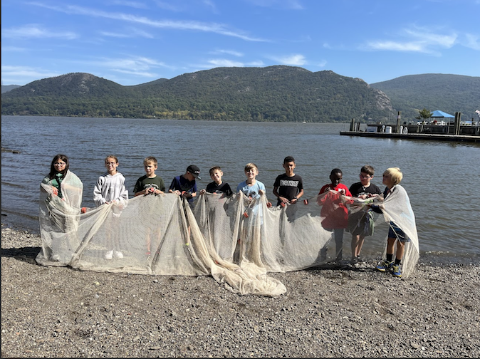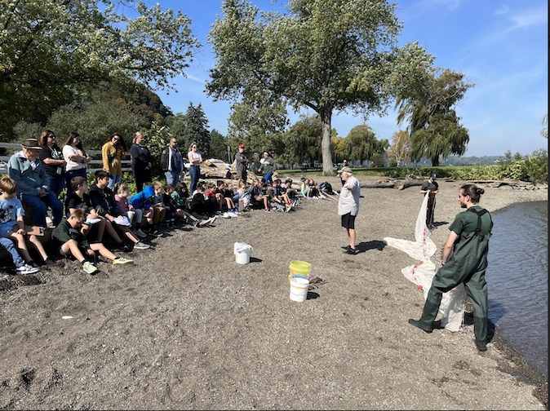
Location: Donahue Memorial Park, Cornwall Landing, Village of Cornwall-on-Hudson, Town of Cornwall, Orange County, NY
Surrounding Land Use: 15% Forested, 5% Beach, 80% Open and Grassy Area
Sampling Site: Pier, sandy beach used for seining and chemical samples. Altered banks, shoreline riprap, concrete & wood bulkheads. Sampling site near small dock used for turbidity
Shoreline: 10% Sandy, 10% Muddy & 80% Rocky
Water: Choppy
River Bottom: Muddy & Rocky
Plants in the water: NR
*NR = Not read/recorded
ITEM | Time | Reading |  |  | Comments
Physical
Air Temperature | 10:09 AM | 18 º C |  | 65 º F
Wind Speed: | 10:09 AM | Anemometer  2.8 km/hr |  | Beaufort  3 | Direction  East
Weather today | 10:09 AM | 26-50% Cloud Cover |  | No Rain
Weather the past 3 days: | Very warm for October
Tides- Tide Stick | Time | Rising, Falling, Unchanged |  | Height (cm)
 | 9:53 AM  10:16 AM  10:53 AM  11:25 AM | -  Falling  Slack  Rising |  | 53  50  50  54
Current- | Time | Cm/sec | Knots | North/South | Ebb/Flood/Slack
 | 10:28 AM  10:50 AM  11:05 AM  11:32 AM |  |  |  | Ebb  Slack  Slack  Flood
Water Temperature- | 9:50 AM  10:23 AM  10:50 AM | 19°C  20°C  20°C |  | 66.2°F  68°F  68°F
Turbidity- Long Sight Tube (120 cm) | 9:53 AM | 33 cm  43 cm |  | Avg: 38 cm
Chemical

Student Salinity- Low Range Quantabs - 1.4 QT unit | 10:00 AM  10:28 AM  10:50 AM | 34 ppm Cl⁻  34 ppm Cl⁻  27 ppm Cl⁻ |  |  | 61 ppm TS  61 ppm TS  49 ppm TS
DO – Drop Count | Time | Temp |  |  | ppm DO | % saturation
 | 12:50 PM | 20°C |  |  | 9 ppm | 95%
pH – Color Match Kit | 10:00 AM  10:22 AM  10:50 AM | 7.5  7.25  7.5
Biological
Fish- Seine (2 Hauls) | Number | Name |  |  | Length of longest | Notes
 | 40  15  1 | Blueback Herring  Striped Bass  Largemouth Bass |  |  | 6.5 cm  5.8 cm  15.3 cm
Fish Totals | TOTAL: 56 | Diversity: 3
Macroinvertebrates | Number | Name |  |  | Length of longest
Macroinvertebrate Totals | TOTAL: 0 | Diversity: 0
Sediment Core - NR | Time | Oxid Top | H₂S Smell | Oil | Grain Size | Other Features

Boats-NR
Commercial/Recreational | Time | Name | Color | Southbound/  Northbound | Light/Loaded

